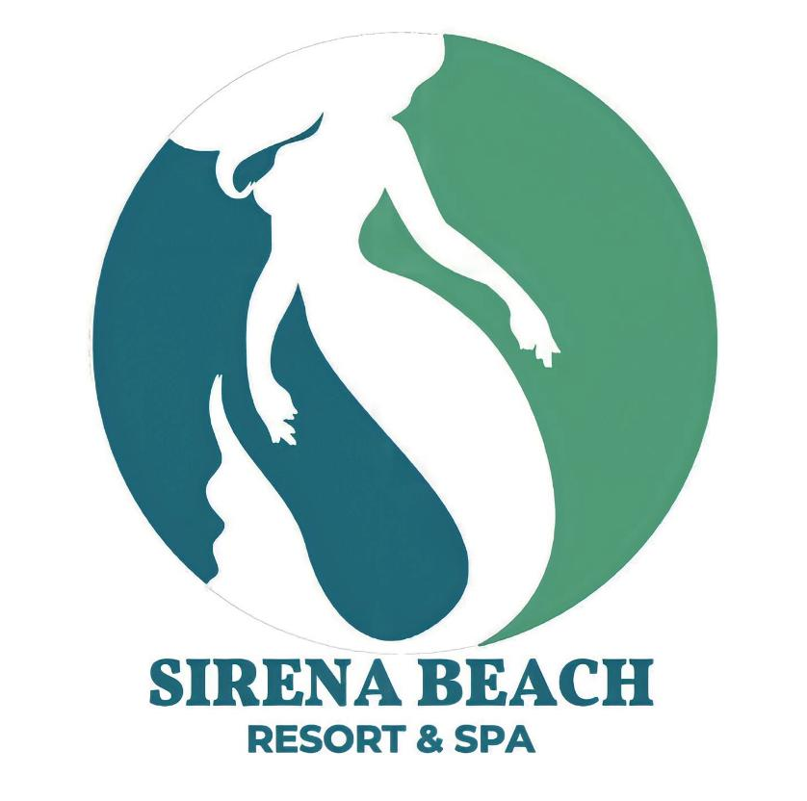

SIRENA “ALL INCLUSIVE” CONCEPT CONTAINS THE FOLLOWING PROGRAMS

Breakfast
Served at the Sirena Restaurant
From 07:00am to 10:00 Am (Hotel time)

Includes full buffet with egg station, juices,
Filter coffee, tea, herbs and hot chocolate

Late Breakfast
Served at the Panorama Beach Bar
From 10:00 am to 12:00 pm (Hotel time)
Includes croissant, Danish pastries, Crip, espresso, Cappuccino, tea and soft drinks

Lunch
Lunch is served at the following outlets
Sirena Main restaurant from 01:00 pm till 3:00pm (Hotel time)
(Dress Code: no sleeveless shirts. Shorts are allowed, but must be at or below knee level)

It includes cold salad buffet, pasta corner, hot dishes buffet with live cooking, sweet and fruits buffet, soft drinks, local wines, Local beer, filter coffee, tea, herbs and hot chocolate.

Cave beach bar from 01:00 pm to 03:00 pm (hotel time)
It includes cold salad buffet, hot dishes buffet with live cooking, sweet and fruits buffet, soft drinks, Local beer, espresso and Cappuccino.

Pizza time
- Pizza is served every day at the Cave Beach Bar
from 11:00 Am till 06:00 pm (hotel time)
- Pizza is served every day at the Panorama beach Bar
from 11:00 Am till 06:00 pm (hotel time)
* we will serve 6 kind of pizza (Magarita, Napolitano, cheese , Tuna, Salami and Vegetables)

Snacks
Snacks is serve at the following outlets
* Panorama Beach bar from 11:00 am till sunset
Selected of Beef & Chicken Sandwich with some kind of dessert

* Cave beach bar & restaurant from 11:00 am till sunset
Selected of Beef & Chicken Sandwich with some kind of dessert

Dinner

Dinner is Served at Sirena Main restaurant from 19:00 pm till 22:00 pm (Hotel time)
(Dress Code: no sleeveless shirts. Shorts are allowed, but must be at or below knee level)
It includes international buffet with pasta corner, live cooking and carving station, soft drinks, local wines,
Local beer, herbs, filter coffee, tea and hot chocolate.

Beverages
All drinks are served by glass
Mineral water, soft drinks (excluding fresh fruit juices), local beer, local wine will be served in the selected bars and restaurants, local spirits (gin, vodka, whiskey, rum, ouzo and brandy), coffee with milk, hot chocolate, filter coffee, herbs, tea, Espresso & cappuccino

Served at:

Lobby bar (located at the Lobby) From 10:00 am Till 00:00 midnights (Hotel time) Pool Bar (at the swimming pool) From 10:00 am Till sunset (Hotel time)
Panorama Beach Bar (at the swimming pool) From 10:00 am Till 00:00 midnight (Hotel time)
Cave Beach Bar From 10:00 am Till sunset (Hotel time)
Relax Beach Bar From 10:00 am Till sunset (Hotel time)

* The Panorama Beach Bar open till midnight in summer time but in winter time open till sunset

Cocktails and Long drinks: a list is available in all bars, check with our bartenders.

It is not allowed to fill up bottles from the beverage dispenser
(According to the hygiene requirements)

FOOD & BEVERAGE ITEMS THOSE ARE NOT INCLUDED:
Imported spirits and drinks in bottles
Fresh juices
Room service

Entertainment activities
Daily animation program / Mini Club

SPORTS
*Beach Volleyball, darts, bocce, Table Tennis and Gym*

Snorkeling (equipment to be rented or with your own)

*All these activities are part of the daily entertainment program, please check the time.

Services and activities available with Extra Charge
Scuba Diving, Massage, coiffeur, beauty salon, Jacuzzi, Sauna, Steam Bath, salt room, Turkish bath and Limousine service.

IMPORTANT INFORMATION

The room key and the towels cards should returned back at to the Reception the end of your holiday. Stay In case of losing towel card or breaking key card a charge of 10 Euro will be charged on your room account.
It is not allowed to take any food or beverages outside the restaurants; if you have any special requirements please contact the F&B Manager.

Cash Payment only accepted at the Reception desk,, please sign of the check then pay at the Reception

