Quick Facts

597 Rooms

6 Shimmering Pools

5 Dining Options

6 Bars

Dreams Sunny Beach Resort & Spa is situated in the most pleasant part of Sunny Beach resort on the Black Sea, a holiday area with many other hotels, entertainments and shops. The 8 km-long, wide beach of fine sand slopes gently into the sea and is perfect for children. Hotel guests enjoy their dedicated area of the beach which gives the 5 * feeling all around. The place is a unique combination of clean mountain air, sea climate and beautiful nature - a microclimate extremely favourable for recreation and entertainment. Breath-taking views over the bay of Sunny Beach allow for a direct view over the ancient town of Nessebar – a UNESCO heritage site.
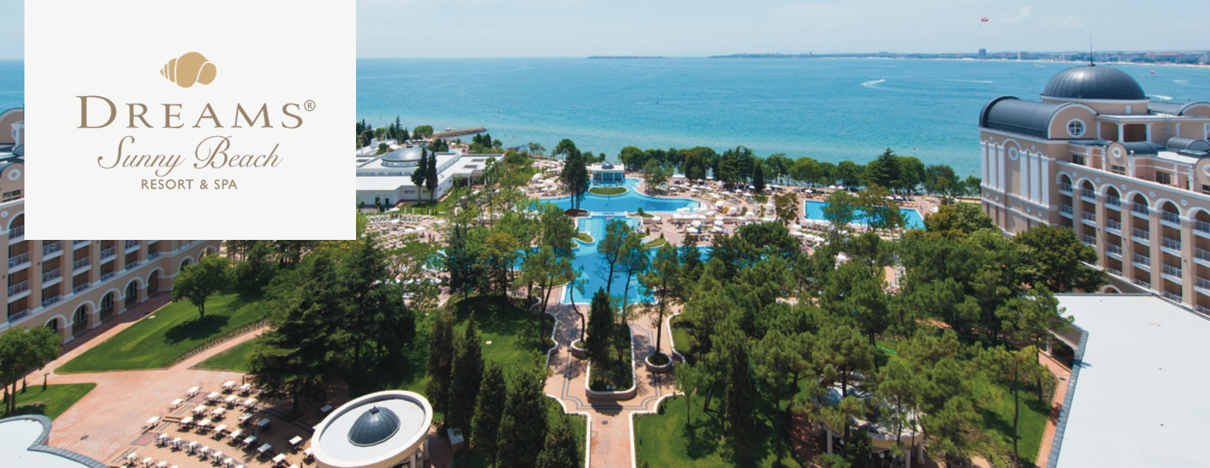

Dreams Sunny Beach is Bulgaria’s first Dreams Resort, situated on the seafront in Sunny Beach. The property has 597 rooms – double, family and suites in a10 floors building. All rooms have private bathroom with shower, bathroom amenities, vanity mirror, hairdryer, telephone, central air conditioning, satellite TV, minbar, safe, balcony or terrace. Most guest rooms are with sea views.

Resort Address

8240 Sunny beach

Bulgaria

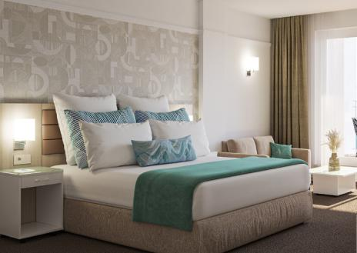

The Preferred Club

Dreams Sunny Beach Resort & Spa offers the possibility of living a luxury experience that includes exceptional services exclusively for Preferred Club clients, both in rooms and in common areas. Among these services, there are exclusivities such as: private Preferred Club Lounge, access to exclusive solarium with sunbeds, premium minibar and much more.

Restaurants Bars

World Café – International buffet restaurant Moments – Lobby bar

Himitsu – specialised in Asian cuisine Manatees – Pool bar

Sofia Gastro – Premium Bulgarian restaurant Half-Time – Sports bar

Tides – Buffet poolside grill Showtime – Entertainment theatre bar

Seaside Grill – Beach buffet restaurant Coco Café – Premium coffee, pastries and

(Shared with Secrets Sunny Beach Resort & snacks

Spa) Preferred Club Lounge – Exclusive lounge for

Preferred Club guests
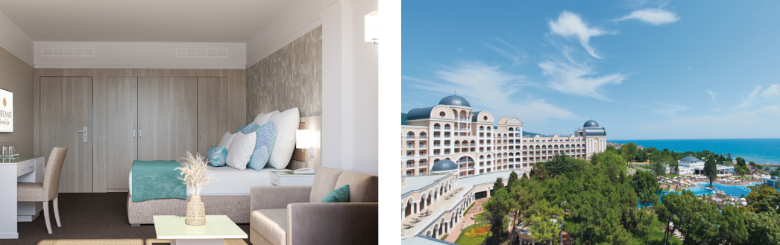

Unlimited-Luxury® for couples and couples with children

- Breakfast, lunch, dinner and snacks served every day (including a selection of drinks)

- Welcome drink and refreshing towels

- Unlimited natural fruit juices and soft drinks in our bars, during opening hours

- Unlimited international and local premium spirits in our bars, during opening hours

- 24-hour concierge service

- Minibar replenished daily with soft drinks, bottled water and beer

- Unlimited access to gourmet a-la-carte restaurants, no booking required

- Room service available 24 hours a day of a selection of dishes, wines and beverage (additional service charge applies)

- Poolside waiter service

- Unlimited daytime activities and live evening entertainment

- Enjoy free Wi-Fi and free local landline phone calls with Unlimited Connectivity

- No wristbands required

Room Name | View | Quantity
Double Park View | Park | 16
Double Sea View | Sea | 230
Double Deluxe Park View | Park | 10
Double Deluxe Sea View | Sea | 18
Double Deluxe Frontal Sea View | Frontal Sea | 39
Family |  | 4
Preferred Club Double Frontal Sea View | Frontal Sea | 3
Preferred Club Double Deluxe Frontal Sea View | Frontal Sea | 2
Preferred Club Junior Suite Park View | Park | 4
Preferred Club Suite Frontal Sea View | Frontal Sea | 1

Dreams Spa

Dreams Sunny Beach Resort & Spa offers you an exclusive Spa, offering unforgettable health, beauty and well-being experiences. Let our highly qualified team of expert professionals give you the best advice to help you relax.
The Spa facilities include: whirlpool bath and children’s section • sauna • steam bath • hairdresser • beauty salon • cabins for treatments and massages • Revive Bar – self-service bar.

Activities and Entertainment

Dreams Sunny Beach offers excellent services and facilities to guarantee an unforgettable experience. Take a dip in our 5 outdoor pools, one indoor pool, work out in the fully equipped fitness centre opened 24/7, or enjoy the activities and shows provided by our entertainment team.

Fun Fun for Kids and Teenagers

For our younger guests, fun packages are available in our Explorer’s Club, a place where children will enjoy hours of games and activities organised by our Kid’s Club staff, while teenagers can enjoy the Core Zone Club which offers leisure activities, arcade machines, games, karaoke and many more age-appropriate activities. We also have a wide range of live music, musical tributes, bands, shows, themed parties and many unforgettable surprises.

Additional Services

Wedding services • Romance packages • Multifunctional sports court • Karaoke • Car rental • Pet-Friendly.

Meetings & Groups

Dreams Sunny Beach Resort & Spa has the facilities required to ensure every event is a success. Our team of specialists is ready to make sure that your event runs smoothly. With the variety of bars and restaurants available all of your requirements will be meet smoothly and just on time.

Name of the meeting rooms | Size | Height | Theater | Classroom | Banquet Cocktail U-Shape
 | (sg m) | (m) | Pax | Pax | Pax | Pax | Pax
Meeting Room 1 (2nd floor) | 75 | 2,6 | 50 | 25 | 50 | 40 | 24
Meeting Room 2 (2nd floor) | 75 | 2.6 | 50 | 25 | 50 | 40 | 24

Information subject to change. See website for most updated information.

11/22

