LUNA BLANCA RESORT & SPA

GENERAL INFORMATION ABOUT THE HOTEL & ULTRA ALL INCLUSIVE CONCEPT
2024 SUMMER

CATEGORY | 5***** | ADRESS | Kumköy bulv. No:89 • Side / Antalya
CONSTRUCTION COMPANY | ERŞA İNŞAAT TUR. TİC. A.Ş. | TELEPHONE | + 90 242 777 0 333
LAND AREA SİZE | 12.000M2 | FAX | + 90 242 777 0 339
OPENING DATE | 2014 | EMAIL | info@lunablancahotel.com
HOTEL BUILDING | 6 FLOOR | WEB | www.lunablancahotel.com

Situated in Antalya, Side, Kumköy just 300 m from the beach, 65 km from Antalya airport and 70 km from Antalya city centre. With a different architecture, our hotel coming to the fore with 600 sunbeds on the private golden sand beach and a selection of swimming pools really is a paradise to relax. Built on a land area of 12,000 m2, our hotel has main building with 6 floors, 314 rooms 3 elevator.

The ‘Ultra All Inclusive’ concept has been specially designed and reflects all the features of Turkish hospitality. We offer our guests upon arrival ‘’Welcome Stand’’, rich food (designated hours) and drinks are continues 24 hour.

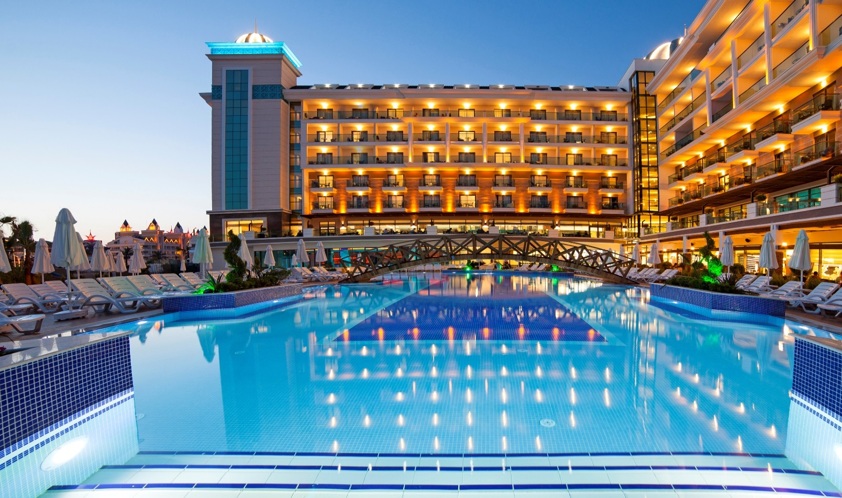
All rooms are with laminate flooring, central air condition, safe, satellite Led TV and music, minibar, telephone, card lock system, smoke detector, shower, hair dryer, 220v power sockets. There are special rooms for physically handicapped guests. There are also wireless internet connection in all rooms and units of the hotel.

STANDARD ROOM ( Max capacity are 3+1, 2+2 people)

There are 243 rooms, 145 with seaside and 98 land views. The room size without balcony is 27 m2; 1 double bed,1 single bed and Sofa. There are laminate parquet flooring, central air condition, satellite LED TV, safety deposit box, minibar, kettle, reading lamp, shower & WC, hair dryer in the room.

FAMILY ROOM (Max capacity are 4 people)

There are 55 rooms only with land views. The room size without balcony is 35 m2; 2 separate rooms with door and only with 1 bathroom; 1 double bed and 2 single beds. There are laminate parquet flooring, central air condition, satellite LED TV, safety deposit box, minibar, kettle, reading lamp, shower & WC, hair dryer in the room.

COMFORT FAMILY ROOM (Max capacity are 4+1 , 3+2 people )

There are 13rooms. The room size without balcony is 50 m2; 2 separate rooms with door. This room type has been specially designed according to the other rooms and has a seating group and 2 spacious bathroom. There are laminate parquet flooring, central air condition, satellite LED TV, safety deposit box, minibar, kettle, reading lamp, shower & WC, Coffee Machine, hair dryer in the room.
SUITE ROOM (Max capacity are 4+1 , 3+2 people )

There are 5 Rooms.The room size without balcony is 50 m2; 2 separate rooms with door. This room type has been specially designed according to the other rooms and has a seating group and 2 spacious bathroom. There are laminate parquet flooring, central air condition, satellite LED TV, safety deposit box, minibar, kettle, reading lamp, shower & WC, Coffee Machine, hair dryer in the room.
DISABLED ROOM (Max capacity are 3 people )

There are 3 disabled rooms in the hotel. The room size is 35 m2. The rooms can meet all the needs of physically disabled guests. The rooms are on the entrance, 1st and 2nd floors. To all hotel’s unit transportation is possibility with elevators. Also hangers height are 1,20 cm. There are a sliding wardrobe in the rooms. The door’s width is 101 cm and also hand control for condition is available.

CONFERENCE HALL

Featuring the latest technology, an ideal place to hold meetings. Can accommodate up to 120 people for dinner and 170 people for meeting. Projection equipment, rostrum, lavalier, sound system and platform are free. 192m2/height 285 cm

TV ROOM

The room can accommodate up to 50 people. Tables are provided and this room can also be used to play board games and card games. Dimensions 104m2/height 295 cm

POOLS

There are 2 outdoor swimming pools who wants to live full of fun, 1 slide pool (3 band), 1 children’s swimming pool and 1 indoor pool.
1. Outdoor Swimming Pool | Size 382 m² | Depth 140 cm
2. Outdoor Swimming Pool | Size 325 m2 | Depth 140 cm
3. Slide Pool | Size 72 m2 | Depth 120 cm
4. Indoor Swimming Pool | Size 80 m2 | Depth 140 cm
5. Outdoor Children’s Swimming Pool | Size 25 m2 | Depth 40 cm
6. Indoor Children’s Swimming Pool | Size 6 m2 | Depth 40 cm

SPA & WELLNESS CENTRE

A delightful experience, the splendid SPA & Wellness centre provides a relaxing and restorative atmosphere, for guests to completely unwind. The exceptional setting, professional therapists and treatments on offer, will eliminate any frustrations from the outside world, replacing them with serenity and calmness. Featuring Massage and Beauty rooms, Sauna, Turkish Bath ( Hamam ), Steam bath, Jacuzzi, Fitness room and Indoor Swimming Pool..

SPORTS AND ACTIVITIES

SPORTS ACTIVITIES
Table Tennis, Beach Volleyball, Aerobics, Water Gymnastics, Boccia, Darts, Fitness Center, Entertainment , 3 water slides (certain hours)

GAME CENTER
Billard, Play Station, Machine Games, Big Screen, Table Games, Backgammon, Card Games etc.

CHILDREN ACTIVITIES
There are Mini Club ( 04 - 12 ), Mini Disco. (10:00-12:00/14:00-17:00) mini disco starting 20:30 /Sunday is closed.
NOT INCLUDED SERVICES IN ALL INCLUSIVE
CONCEPT (PAID SERVICES)
INCLUDED SERVICES IN ALL INCLUSIVE CONCEPT (FREE OF CHARGE)

Mini Bar ( Beer&soft drik) | Room Service
Safety Deposit Box | Laundry Service
W-fi from 3 mb | Premium Wi-fi
Sunbeds and mattress | Baby Sitter & Baby stroller
Beach - Pool Towels | Doctor
Mini Club ( 04- 12 years), Playground | Spa & Wellness Center ( Massage, Skin Care etc.)
Beach Volleyball, Aerobics, Water gym, Boccia, Dart ,Table tennis | Game Room ( Billiards , Play Station , Pinball, Game Machines)
Fitness Center, Hamam & Sauna | Hotel Shops - Hairdresser
Live Music and Shows (in certain days) | Telephone and Fax
Certain hours; Patisserie, Ice Cream, Waffles, Turkish Pancake and Backed Potatoes | All kinds of fresh pressed fruit juices, Hookah
Open Buffet, Breakfast, Late breakfast, Lunch, Dinner, Night Soup and Midnight Mini Buffet, Diet Buffet | Champagne ( imported ) and high quality wine ( per bottle )
Food & Beverages (certain hours and places)  Local and certain imported alcoholic and non-alcoholic drinks | Speciality drinks ( Old stored Whiskey, Bourbon Whiskey,  Brandy, etc)
Reservation Italian and Fish A la Carte Restaurants are available. 1 time using in one week is free. | In 7 days 2nd time using A la Carte Restaurant
Beach Shuttle Service 09:00-18:00 | Watersports
Outdoor parking

FOOD & BEVERAGES

BREAKFAST
Turquoise Restaurant | 07.00 | 10.00 | Open buffet (Vejeterian & Diabet)
LATE BREAKFAST
Viola Restaurant | 10.00 | 11.00 | Open mini buffet
LUNCH
Turquoise Restaurant | 12.30 | 14.00 | Open buffet (Vejeterian & Diabet)
Caretta Beach Bar | 12.00 | 16:00 | Snack buffet + Baked potato
Caretta Beach Bar | 11:00 | 15:45 | Turkish Gözleme
Caretta Beach Bar | 12.00 | 16:00 | Ice cream & Waffle
Moonlight Pool Bar & Snack | 12.00 | 16.00 | A la Carte Snack
Moonlight Pool Bar & Snack | 11:00 | 17:00 | Ice cream & Waffle
Moonlight Pool Bar & Snack | 12.30 | 15.45 | Turkish Pancake
Patisserie | 11:00 | 18.00 | Cakes and cookies varieties
DINNER
Turquoise Restaurant | 18:30 | 21.00 | Open buffet
Viola Restaurant | 22:00 | 05:00 | Midnight buffet/ Mini Buffet
A LA CARTE RESTAURANTS
Anchor Restaurant | 19.00 | 21.30 | A la Carte Fish, with Reservation
Stella Restaurant | 19.00 | 21.30 | A la Carte Italian, with Reservation
BARS
Lobby Bar | 24 Saat |  | Soft & lokal alcohol drink / (some Import drink 10:00-02.00)
Moonlight Bar | 10.00 | 24.00 | Soft & lokal alcohol drink
Caretta Beach Bar | 10.00 | 18.00 | Soft & lokal alcohol drink
ROOM SERVICE
Reception Service | 24 Saat |  | Included
Patient or disable guests | 24 Saat |  | Included
Room Service | 24 Saat |  | Paid Service
Minibar Service | 10.00 | 16.00 | Included (Daily)

CONCEPT PRINCIPLES

- All drinks are served by the glass. (No Bottle)
- Drinks are served to the table.
- Service staff are authorised to refuse to serve alcohol to any guest if they feel they are disturbing others.
- A’la Restaurant reservation is required by guest relation desk. Reservation cost per person.
- Availability of the A ’la Carte restaurant may vary according to the daily booking request.
- Alcohol is served to over 18 year old’s only
- All activities and bars in the outdoor area may vary according to weather . Bars and Restaurants throughout the hotel will open and close at the times specified.
- Smoking within enclosed areas is strictly forbidden
- We kindly request that you wear the all-inclusive hotel band provided at check in, at all times during your stay.
- Due to health conditions, using the pool with a burkini is prohibited.
- Daily towel change requests and Linen change is done twice a week.

