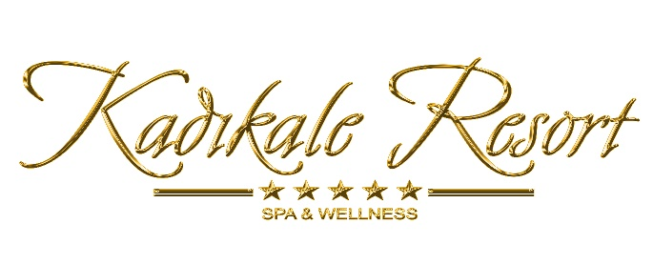

OUR ACTIVITIES 2024
( ULTRA ALL INCLUSIVE )

ROOMS

238 STANDARD ROOMS

INDIVIDUAL AIR-CONDITION, BALCONY OR TERRACE, MINI BAR (filledsoftdrink on arrivalday), HAIRDRYER, SATELLITE TV, SAFE BOX, DIRECT DIAL TELEPHONE, BATHTUB

20 SELECT ROOMS

NEW STYLE DECORATION, INDIVIDUAL AIR-CONDITION, MAIN BUILDING, MINI BAR (filledsoftdrink on arrivalday), HAIRDRYER, SATELLITE TV, SAFE BOX, DIRECT DIAL TELEPHONE, SHOWER.

19 FAMILY ROOMS

2-BEDROOM, INDIVIDUAL AIR-CONDITION, BALCONY OR TERRACE, MINIBAR (filledsoftdrink on arrivalday), HAIRDRYER,SATELLITE TV, SAFE BOX, DIRECT DIAL TELEPHONE, BATHTUB.

5 HONEYMOON ROOMS

INDIVIDUAL AIR-CONDITION, BALCONY AND LARGE TERRACE, SEAVIEW, MINI BAR (filledsoftdrink on arrivalday), HAIRDRYER,SATELLITE TV, SAFE BOX, DIRECT DIAL TELEPHONE, BATHTUB.

3SUITE

1 BEDROOM & 1 LIVING ROOM, INDIVIDUAL AIR-CONDITION, BALCONY OR TERRACE, MINI BAR(filledsoftdrink on arrivalday), HAIRDRYER,SATELLITE TV, SAFE BOX, DIRECT DIAL TELEPHONE, BATHTUB.

8 KING SUITE

2 BEDROOMS & 1 LIVING ROOM,1 BATHROOM, INDIVIDUAL AIR-CONDITION, BALCONY OR TERRACE ,SEAVIEW, MINI BAR(filledsoftdrink on arrivalday), HAIRDRYER,SATELLITE TV, SAFE BOX, DIRECT DIAL TELEPHONE,JACCUZI .

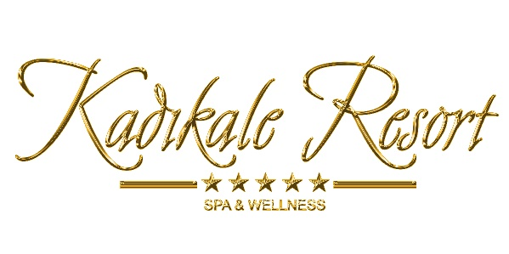

MAIN RESTAURANT
( BUFFET, CHILDREN BUFFET, DIET BUFFET )
BREAKFAST 07:30 – 10:00
LATE BREAKFAST 10:00 – 11:00
LUNCH 12:30 – 14:00
DINNER 19:30 – 21:30
NIGHT SNACKS 23:00 – 03:00

ITALIAN A’LA CARTE RESTAURANT
DINNER (ITALIAN CUISINE) 19:30 – 21:30
(Servingfrom 01/05 to 30/09)
(FREE OF CHARGE -RESERVATION NEEDED A DAY BEFORE)
AQUARIUM A’LA CARTE RESTAURANT
DINNER (SEA FOOD) 19:30 – 21:30
(Servingfrom 01/05 to 30/09)
(FREE OF CHARGE -RESERVATION NEEDED A DAY BEFORE)

BARS
LOBBY BAR 24 HOURS OPEN
POOL BAR 09:00 – 24:00
BEACH BAR 10:00 – 18:00
DISCO BAR 24:00 – 03:00
(ALCOHOL AND NON ALCOHOLIC IMPORT AND LOCAL BEVERAGES DETERMINED BY THE HOTEL MANAGEMENT ARE FREE OF CHARGE)

OTHER FOOD & BEVERAGE SERVICES
SNACK BAR 12:00 – 18:00
- Hamburger
- Cheesburger
- ChickenDoner
- Gozleme
- Spaghetti
- pizza
PATISSERIE 10:00 – 18:00
ICE CREAM 15:00 – 17:00
(Servingfrom 01/06 to 30/09)

FRUIT TIME 15:00 – 16:00(At theBeachBar)(Serving in July&August)

TERRACE CAFE 18:00 - 24:00 (coffie ,tea ,sorftdrinksandcookies)

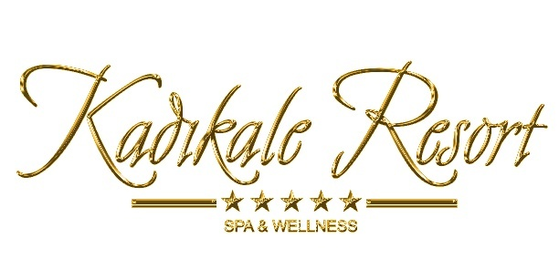

CONGRESS&MEETING
75-PEOPLE CAPACITY MEETING ROOM
BARCOVISION
PROJECTION SCREEN( 150 cm x 200 cm )
OVERHEAD PROJECTOR
FLIPCHART - DESK

SPA & WELLNESS
VITAMIN BAR
TURKISH BATH
THERMAL BATH
SAUNA
STEAM ROOM
**THERMALMUD BATH
** SKIN CARE
**HYDRO THERAPY
** AFFISIONSHOWER MASSAGE
** VARIETY OF WORLD MASSAGES
(CLASSIC MASSAGE, ANTI-STRESSMASSAGE,
NIFERTITY MASSAGE, THAI MASSAGE,
BALI MASSAGE, SHIATSU MASSAGES, HOT STONE MASSAGE
INDIAN HEAD MASSAGE, SPORT MASSAGE,
FOOT REFLEX MASSAGE)
** MEDICAL MASSAGES
(FULL BODY AND BACK MASSAGE)
** MANUEL THERAPY
** AROMA THERAPY
** BALNEO THERAPY
** UNISEX HAIRDRESSER
** DOCTOR

SWIMMING POOLS
2 ADULT SWIMMING POOLS
2 CHILDREN POOLS
1 POOL WITH 2 WATER SLIDES ( MINI AQUAPARK )
2 WATERFALL POOLS

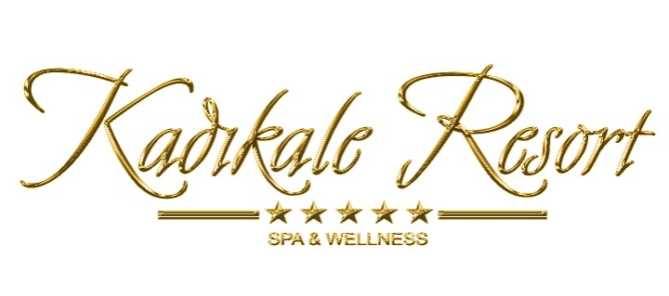

BEACH
PRIVATE BEACH AND DECK
** PRIVATE CABANAS

WATER SPORTS
CANOO
PEDALO
WATER BALL
** JET SKI, RINGO, BANANA, WATER SKI, PARASAILING, FLYFISH, WINDSURF
** SCUBA DIVING

OTHER SPORTS
2 TENNIS COURTS
BASKETBALL
BEACH VOLEYBALL
MINI FOOTBALL
MINI GOLF
TABLE TENNIS
GARDEN CHESS
AEROBIC, GYMNASTIC, JOGGING,STEP AEROBIC

OTHER ACTIVITIES
WI-FI ALL HOTEL
FITNESS CENTER
MINI CLUB
CHILDREN PLAYGROUND
ALL DAY LONG ANIMATION ACTIVITIES
** SHOPPING CENTER( JEWELLERY , MARKET , BOUTIQUE , LEATHER )
** SHUTTLE SERVICE
** SAFE BOX IN ROOMS
LOCATION
3 KM TO TURGUTREIS CITY CENTER
18 KM TO BODRUM CITY CENTER
50 KM TO BODRUM-MILAS AIRPORT

** EXTRA CHARGES

