RIVIERA ZEN HOTEL
CONCEPT & GENERAL INFORMATION (ALL INCLUSIVE) SUMMER
Period | 01 APRIL -31 OCTOBER
Location | ALANYA
Category | HOTEL 4 STARS
Concept | All Inclusive
Number of rooms | 109
Number of beds | 218
Telephone | 0242 5137597 ( Pbx )
Web Page | www.zen.riviera.com.tr
Mail Address | info@riviera.com.tr
Address | Güzel yalı cad Kum Sok No:32
 | 07400 Alanya / Antalya
DISTANCES
Beach | Beach Front
Alanya centrum | 1 km
Antalya | 160 km
Antalya Airport | 130 km
Alanya-Gazipaşa Airport | 4O km
Hospital | 1 km
Pharmacy | 100 m
Bus Station | 1,5 Km
Main Road | 5O m
ATM Machine | 100 m
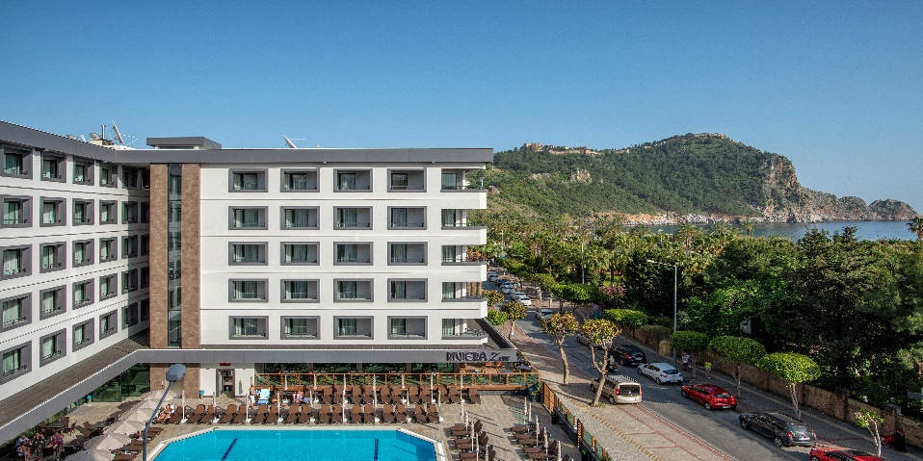

Riviera ZEN Hotel is located in famous Cleopatra beach.
You may reach to Alanya city center with varıous entertaınments possibilities
in a few walking minutes.We have 1 swimming pool with separated child pool We are providing free parasols, sun chairs for our customers at the pool

Riviera ZEN Hotel is like a paradise on the world for the families and
very peaceful place to refresh your self.

Building:This well-known hotel with it’s continud guests has 109 rooms in 5 floors and 1 building. Offer a comfortable lobby with reception.lift.lobby bar,tv-corner,Alacarte restaurant,main restaurant with non smoking area , Terrace.

Rooms:The rooms with tile floor,safe (with free of charge). Shower / wc, hair dryer,
satellite tv, minibar, wi-fi, airconditioner, direct-dial telephone and balcony

Our All Inclusıve Concept is available between 10:00-23:00 foods and drinks are included.
ALL drinks and foods are extra before and after.

We don’t serve alcohol under 18 according to law.
All drinks served in glass and there is no service in bottle.

Hotel may refuse serving alcohol to the customers who are drunk and disturbing others.
Please make your check out until 12:00 o clock and our all inclusive service finish at 12:00 o clock departure day.

FREE HOTEL SERVICE:
Local drinks (cin, rakı, votka, beer, wine, soft drinks..etc)
fitness center, Wi-fi , Safe , sunbeds and parosols (at the pool area).

WITH EXTRA CHARGE SERVICE
EVERYTHING AT THE BEACH (Sunbeds and Parasols, all of the drinks and meals)
All import drinks (Bacardi, Malibu, campari, whisky .. etc) All cocktails, fresh orange juıce,
A’la Carte Restaurant, mini bar, box and bottle drinks, laundry service , room service ,
dry cleaning , massage , peeling , phone call ,

FOOD AND BEVERAGE SERVICE

SERVICES TYPE OF SERVICE PLACE TIME
BREAKFAST OPEN BUFFET RESTAURANT 07:30-10.00
LATE BREAKFAST OPEN BUFFET RESTAURANT 10:00-10:30
LUNCH OPEN BUFFET RESTAURANT 12:30-14:00
DINNER OPEN BUFFET RESTAURANT 19:00-21:00
CAKE SERVICE OPEN BUFFET POOL BAR 15:30-16:30
ICE CREAM SERVICE SELF SERVICE POOL BAR 15:30-16:30
BEVERAGE SERVICE WITH GLASS POOL BAR 10:00-23:00
RESTAURANT 10:00-23:00
LUNCH PACKET EVERYDAY RECEPTION (ORDER) 10:00-20:00

