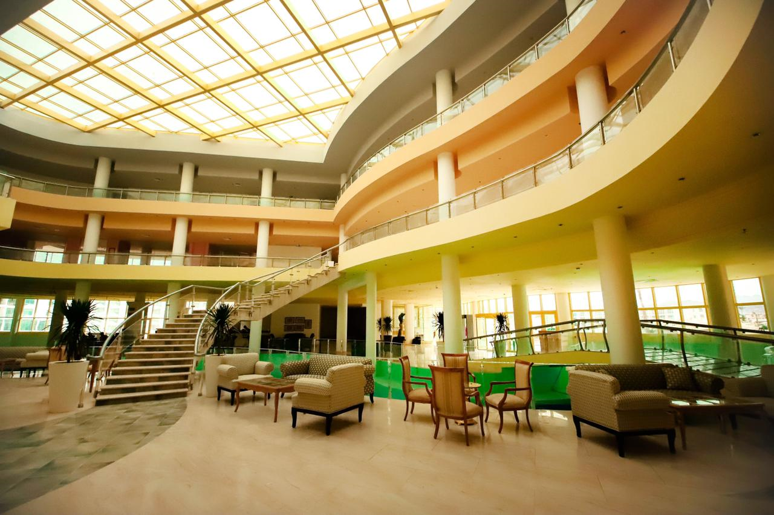



**Raouf Hotels International (Sun Hotel) - Sharm El Sheikh**

Raouf Hotels International (Sun Hotel) is the embodiment of fun! It’s a bright, colorful and relaxing hotel. Guests of Raouf Hotels International (Sun Hotel) have access to a large, private sandy beach in the Nabq Bay nature and wild life.

The hotel is part of three five-star standard hotels situated in the specular coastline of Nabq. The hotel is located just minutes from Sharm el sheikh international airport and 25 minutes from the vibrant downtown nightlife of Naama-Bay.

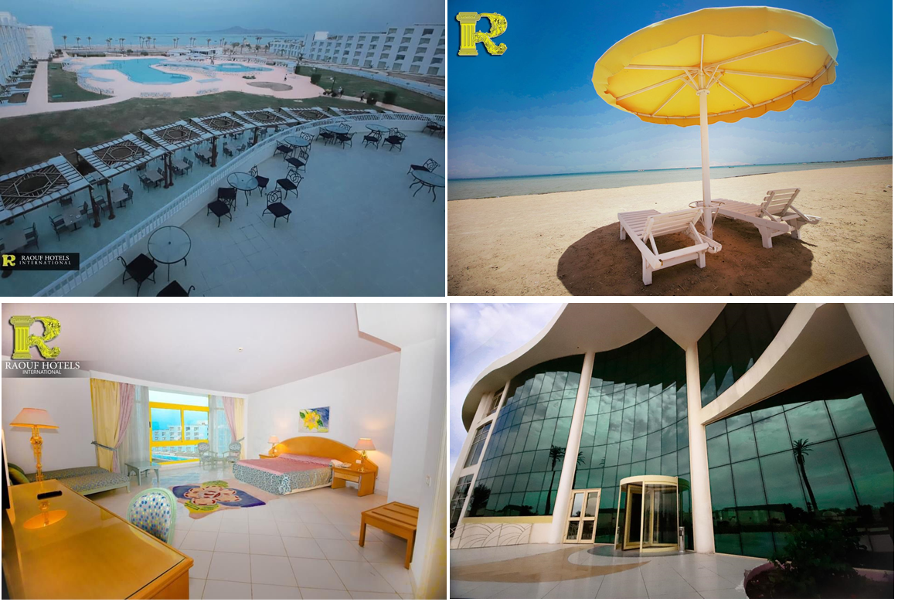

**Raouf Hotels International (Sun Hotel) - SharmElshiekh**





**Location:**

12 Km (15 min. drive) to Sharm

El Sheikh International Airport

23 Km to Naama-Bay

500 km to Cairo

**Leisure Facilities:**

360m Ling private beach

Swimming pool (heated winter)

Water sport center

Scuba diving

Kid’s Pool

Kid’s Club

Kid’s playground

Tennis court

Bowling center

Volleyball court

Cinema & theatre

Internet Café

Limousine Service

24-hours room service

Medical Service

Laundry service

Spa with 17 treatment rooms and Thalassotherapy treatment

**Dining & Entertainment:**

Sun flower Restaurant – Main restaurant

Cadillac Restaurant Mediterranean diners.

The Pearl –Seafood Restaurant

Venezia – Italian Restaurant

Asia Pagoda –Far East Cuisine

Splash Bar – Lobby Bar.

Sun Pool Bar – Pool Bar.

Champagne Bar.

**Room Facilities:**

288 comfortable and spacious guest rooms that include 30 suites and 44 connection rooms, all rooms have views of the pool, sea view Rooms are also equipped with:

Air-conditioned with individual control

Bathroom with bathtub & bidet

Satellite TV.

Direct dial telephone

Internet connection

Mini bar

Hairdryer

Electric shaver point

In-room safe Box

Suites have separate living/seating areas.

Non-smoking rooms available

Standard rooms are 36m2

Suites are 80m2

**Address**:

AL Salam Road, Nabq-Bay

Sharm El Sheikh, South Sinai, Egypt

Tel:+2 (069) 3710100

Fax:+2(069) 3710109

E-mail: [sales@raouf-hotels.com](mailto:sales@raouf-hotels.com)

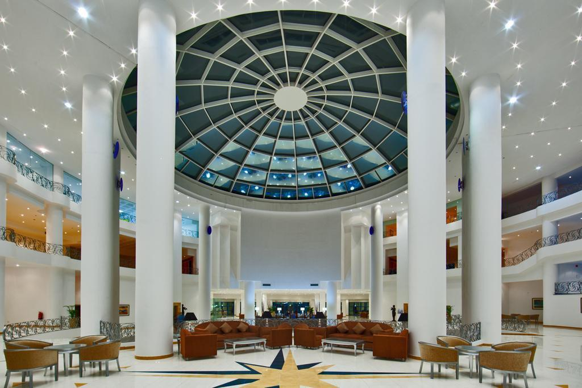

**Raouf Hotels International (Star Hotel) - Sharm El Sheikh**

The Star Hotel shines bright both day & night. This is more than a hotel, it is the Entertainment Capital of Sharm El Sheikh with its 2 cinemas: Hollywood 1, seats 250 while Hollywood 2 seats 200. The Grand Galaxy Theater for live performances, concerts, weddings & conferences, it seats 1200. Check in and experience the life of a movie star in these glamorous rooms. A total of 280 rooms include 28 suites and 56 Family/Connected rooms.

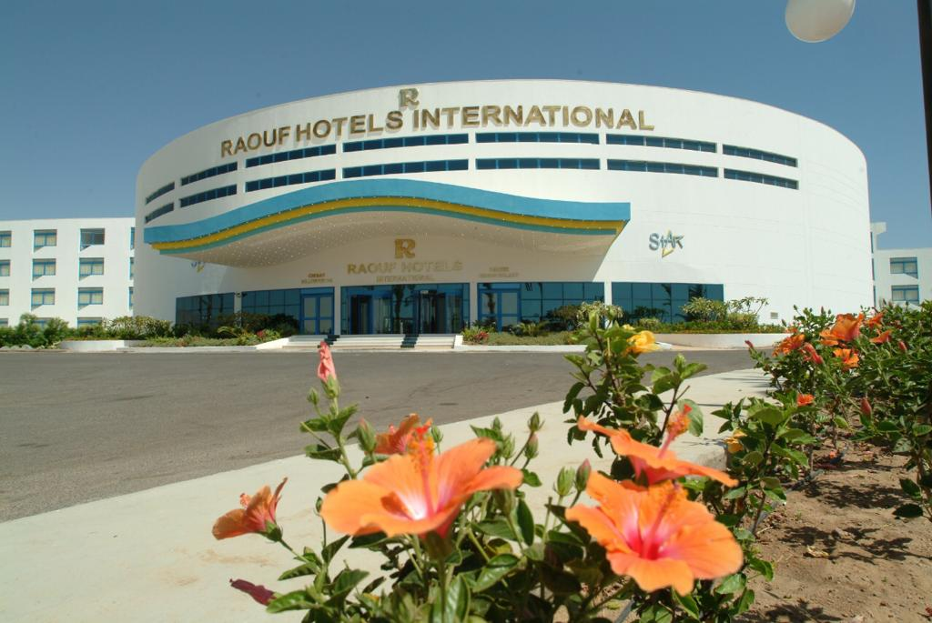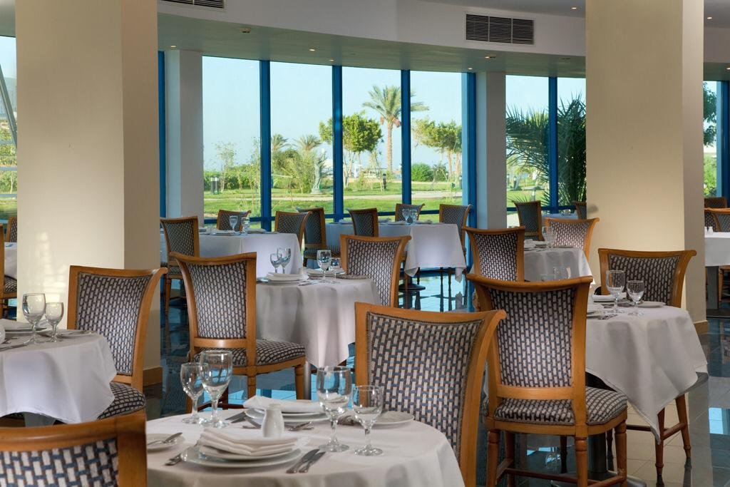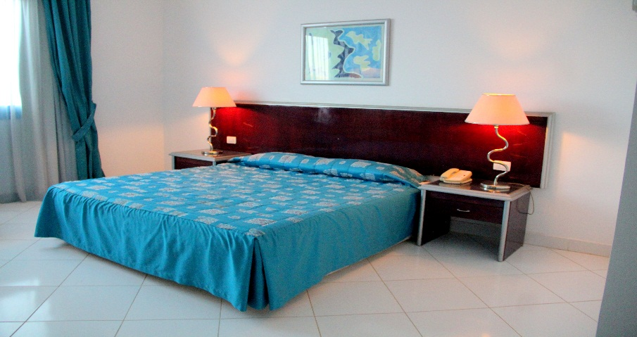

**Raouf Hotels International (Star Hotel) – Sharm Elshiekh**





**Location:**

12 Km (15 min. drive) to Sharm

El Sheikh International Airport

23 Km to Naama-Bay

500 km to Cairo

**Leisure Facilities:**

300m Ling private beach

18,000 Meter lake , flowing through the lobby and around the hotel

Swimming pool

Water sport center

Scuba diving

Kid’s Pool

Kid’s Club

Kid’s playground

Tennis court

Bowling center

Volleyball court

Cinema & theatre

Internet Café

Limousine Service

24-hours room service

Medical Service

Laundry service

Spa with 17 treatment rooms and Thalassotherapy treatment

**Dining & Entertainment:**

Starplex Restaurant – Main restaurant

The Beverly Hills Restaurant Claifomian cuisine Dine a-alcarte

The Pearl –Seafood Restaurant

Venezia – Italian Restaurant

Asia Pagoda –Far East Cuisine

Show Time Bar – Lobby Bar.

Sun Pool Bar – Pool Bar.

Monroe Bar.

**Room Facilities:**

280 comfortable and spacious guest rooms that include 28

suites and 56 connection rooms, all rooms have views of the pool, sea view Rooms are also equipped with:

Air-conditioned with individual control

Bathroom with bathtub & bidet

Satellite TV.

Direct dial telephone

Internet connection

Mini bar

Hairdryer

Electric shaver point

In-room safe Box

Suites have separate living/seating areas.

Non-smoking rooms available

Standard rooms are 36m2

Suites are 80m2

**Address**:

AL Salam Road, Nabq-Bay

Sharm El Sheikh, South Sinai, Egypt

Tel:+2 (069) 3710100

Fax:+2(069) 3710109

E-mail: [sales@raouf-hotels.com](mailto:sales@raouf-hotels.com)