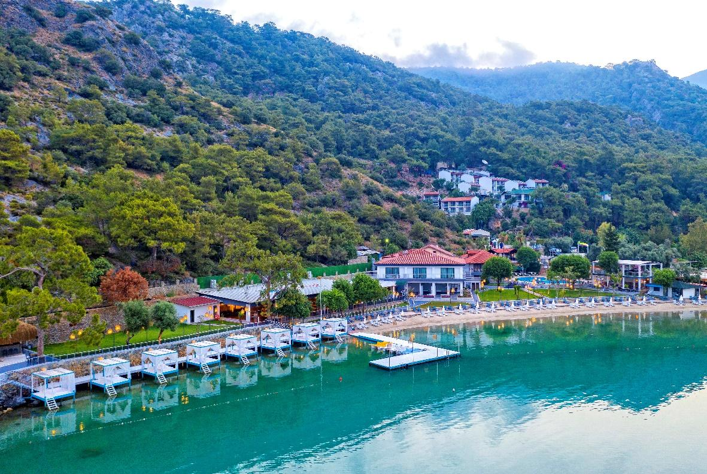

LOCATION & PLACEMENT
Club Hotel Meri is the first and only established Hotel for accomodation in Ölüdeniz Lagoon with wonderfull surrounded by pine, olive, lemon and myrrh trees. Mostly all rooms have amazing sea and lagoon view.

General ınformatıon
Club Hotel Meri has been fully renewed in 2020. All rooms have toilet, shower cubicle, hairdrier, telephone with direc dial facility, satellite TV, airconditioning, kettle and mini-bar.
Also Hotel has luxury caravans in it’s own private garden which is zero meter distance to the sea. Clup Hotel Meri provides a lift service from the top to the hill.
Our Hotel has one main ındoor and outdoor Restaurant. Pool-bar, Lounge Bar, one pool for kids, one reception lobby, market, photographer, hairdresser, doctor (on call with an extra cost). Besides there are hammam, sauna, massage (extra cost), darts, billards, table tennis, safebox (at reception).
! No pets allowed.

Rooms & suıtes
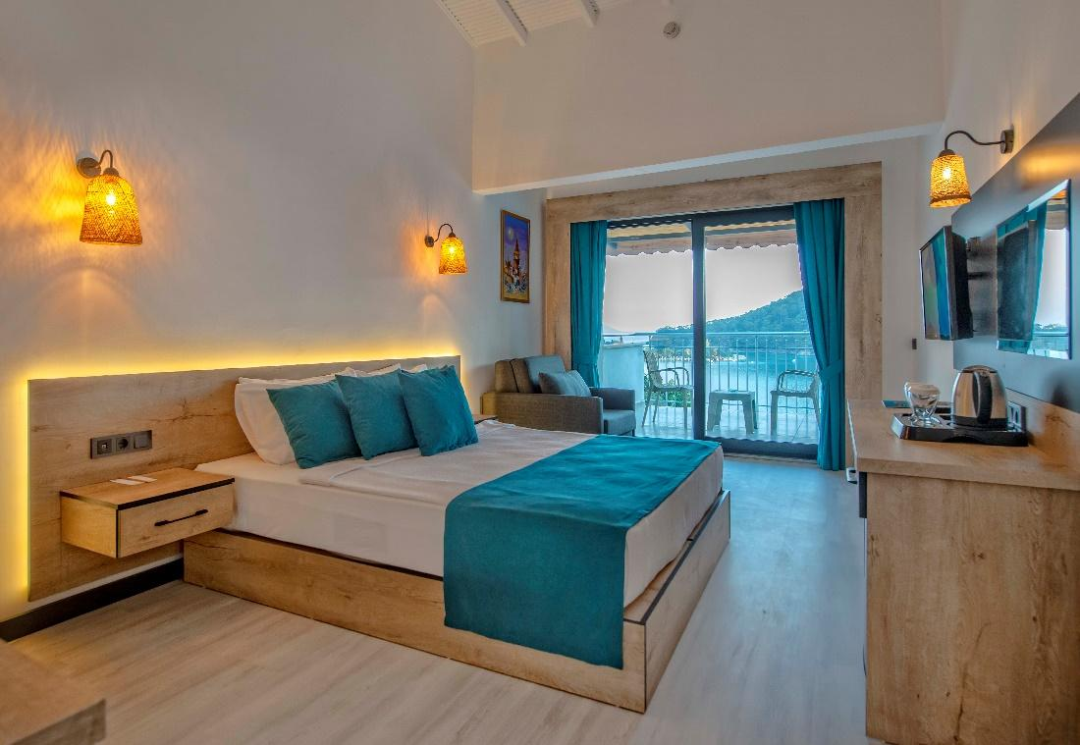
The Hotel Meri has a total of 138 rooms. Guests can choose from an impressive portfolia of 8 rooms types; rooms that offer immense comfort and have been created to meet the demonds of even the most demanding of customers.
STANDART SEAVIEW ROOM : 17 m² in the main buildings, standart rooms have a maximum capacity of 2+1 or 3 people. Standart rooms have laminated floors and balcony with seaviews. This room will offer you a comfertable stay in Ölüdeniz: air conditioning, TV, tea & coffee set with kettle, minibar and hairdrier.
ECO ROOM: 17 m² in the main buildings, eco rooms have a maximum capacity of 2+1 or 3 people. They have also laminated floors, balcony without seawiev and airconditioning, TV, tea&coffee set with kettle, minibar and hairdrier. They don’t have seaview.
SUPERRIOR TERRACE ROOM: 25-30 m² in the main-buildings, superior terrace rooms maximum capacity of 2+1 or 3 people. They have also laminated floors, big terraced with seaview over the lagoon, airconditioning, TV, tea&coffee with kettle and mini-bar.
FAMILY ROOM: 30 m² in the man buildings, familyrooms max capacity of 2+1 or 2+2 people in some large room. These rooms have the some features as the superrior terrace rooms. They have also tea&coffee laminated floors, air conditioning, TV, minibar, hairdrier.
FAMILY ROOM ( WITH 2 BEDROOM) : 40 m² in the main buildings they designed in a modern style, have 2 bedrooms. These rooms max capacity of 2+2 or 2+3 people. They have also TV, airconditioner, minibar, hairdrier, tea&and coffee set with kettle.
POOL-SIDE ROOMS: 25 m² modern styled with garden or pool view. Room properties, telephone, bath/shower, wc, airconditioner, hair drier, tea&coffee set with kettle, mini-bar, balcony.
Pool-side rooms have max capacity of 2+1 or 2+2 people.
BEACH ROOMS: 15-20 m² beach rooms located next to the beach. There is direct sea view of Ölüdeniz Lagoon. Beachrooms have max capacity of 2 or 2+1 people. They have telephone, shower, wc, airconditioning, hairdrier, tes&coffee set with kettle, minibar and balcony.

RESTAURANT & BARS
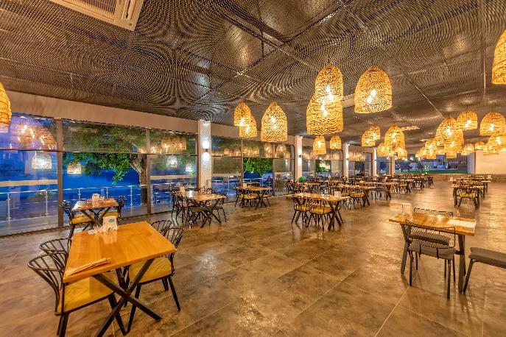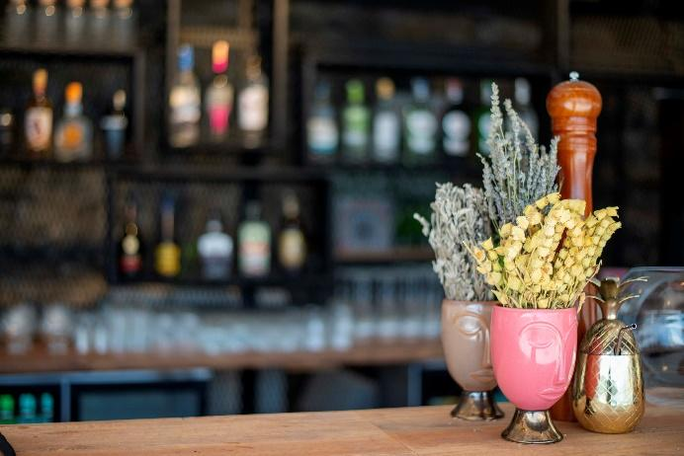
This all day dining restaurant provides guests open buffet with delicious international and local dishes in an attractive environment.
Breakfast: 08.00 – 10.00
Lunch: 12.30 – 14.30
Dinner: 19.00 – 21.00
Snacks : 15.30 – 16.30 / 16.30 – 17.30

Pool-Bar: 10.00 – 23.00
Lounge-Bar: 10.00 – 23:00
Paid actıvıtıes
*Safe-box
*Massage
*Loundry
*Doctor
*Import Drinks
*Beach Towels
*Ice Cream
*Canoos and sea bicycle

