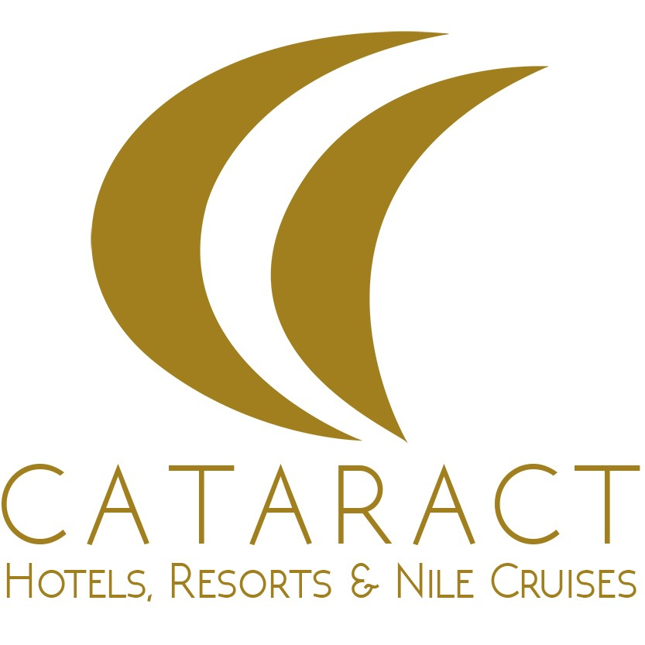

-Room Only System (without any meals or drinks)
-Half Board system (Breakfast and Dinner without any drinks)
-Soft All Inclusive System (All meals and Soft Drinks)
-Hard All Inclusive System ( All meals and drinks except bottled water, premium or imported alcoholic beverages, canned beverages, Turkish coffee , fresh juices, room service , Laundry & All service from Lounge Bar.

Meals:

Breakfast: from 07:00 till 10.00 " 150 LE per person"
Lunch: from 13:00 till 14:30 "220 LE per person"
Dinner: from 19:30 till 22:00 "250 LE per person"

Bars:

-Pub Bar 222 at Cataract resort from 10:00 till 23:00
-Beach bar at Cataract beach from 10:00 till 17:00
-Anchor bar from 17:00 till 23:00

-Beach & Swimming pools from 08:00 till 18:00
-It is forbidden to take a shisha inside the hotel

-WI-FI & Safe boxes are available only at the lobby and free of charge.
-Hotel is not responsible for any valuable things outside the safe box.

Kindly note:
• Dress code at the lobby and during meals is smart casual, no bare foot, no swim ware.
• Any damage in the room caused by Tattoo (Hannah) will be charged to the room account.
• If lost the room Key charge will be 650 LE, safe box key charge 100 $ , Key card 5 $ and the Beach towel 220 LE.
• It is important to drink enough quantities of water especially during summer season to avoid dehydration.
• Changing environment, over exposure to sun and plenty of alcohol drinks may cause stomach problems.
• It is not allowed to reserve sun beds in advance with towels or personal items.
• Check-out time is at 12:00 noon (kindly hand back room key and bracelets to reception desk) and check-in time is at 14:00 hrs, for late check-out please contact the reception for availability.
• For any farther information, please contact reception desk by dialing number 3 for Cataract Layalina and 4 for Cataract Resort

