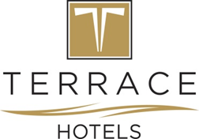

***TERRACE BEACH RESORT***

***FACT SHEET SUMMER 2023***

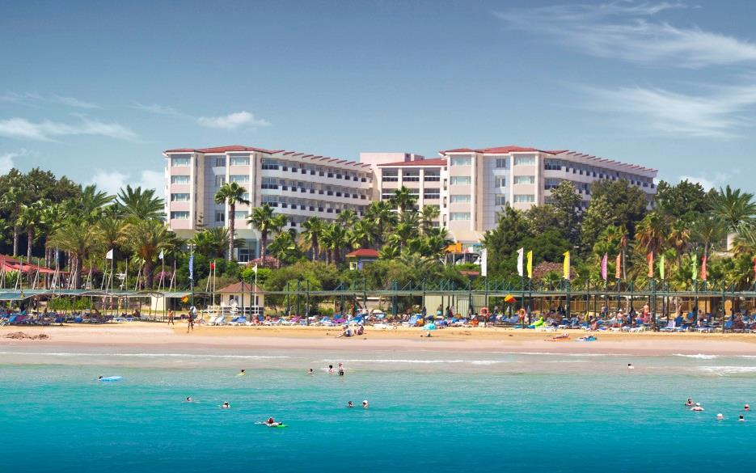

**GENERAL**

|  |  |  |
| --- | --- | --- |
| **Hotel Name** | **:** | TERRACE BEACH RESORT |
| **Owner** | **:** | Melas Turizm İşl. Tic. A.Ş. |
| **Category** | **:** | 5 Stars |
| **Location** | **:** | Kumköy – Side, Manavgat, Antalya, Türkiye |
| **Distance** | **:** | Antalya 65km, Airport 55km, Manavgat 13km, Side 4km, Kumköy 200m |
| **Phone** | **:** | 00 90 242 756 17 17 (Pbx) |
| **Fax** | **:** | 00 90 242 756 17 26 |
| **Web** | **:** | [www.hotelterrace.com](http://www.hotelterrace.com) |
| **Mail** | **:** | [info@hotelterrace.com](mailto:info@hotelterrace.com) |
| **Postal address** | **:** | 4.Sokak No.2, 07600 Ilıca / Manavgat / ANTALYA / TÜRKİYE |
| **Construction year** | **:** | 1990 |
| **Renovation** | **:** | 2016/2017 |
| **Total area** | **:** | 15.000 m2 |
| **Number of rooms** | **:** | 270 |
| **Beach width** | **:** | 120 m |
| **Beach location** | **:** | Directly on the fine sandy beach |
| **Electricity** | **:** | 220V |
| **Check in / Check out** | **:** | Check in 14:00, Check out: 12:00 |
| **Hotel concept** | **:** | All Inclusive |

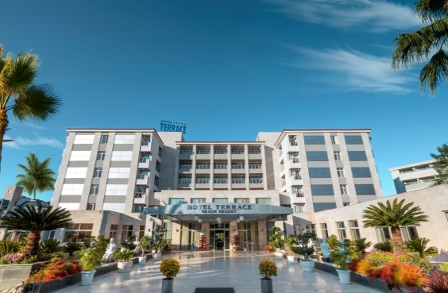

|  |  |
| --- | --- |
|  | Room with sea, side and country view |
|  | 2 Disabled-friendly rooms (side sea view) |
|  | 3 elevators |
|  | Main, 2 A'la Carte and Beach Restaurant |
|  | Several bars |
|  | Patisserie |
|  | Lobby in pleasant atmosphere with reception |
|  | TV room |
|  | Soft Animation |
|  | Mini Club |
|  | Fresh water pool, indoor pool, separate children's pool |
|  | Waterslides |
|  | Spa & Wellness area |
|  | Beach chairs and mats, umbrellas and beach towels |
|  | Conference rooms |
|  | Laundry and ironing service |
|  | Hairdresser and shops |
|  | Medical care |
|  | Wireless Internet access throughout the hotel |
|  |  |
|  |  |
|  |  |

*-1-*

**STANDARD ROOM**

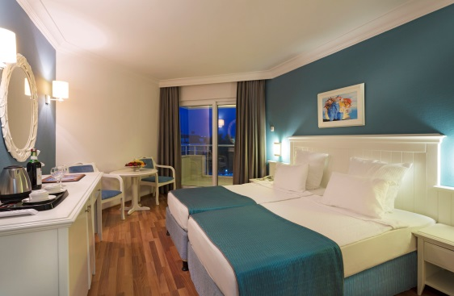

|  |
| --- |
| * 24 m2, Friendly furnished with Shower/WC, hairdryer, music channels on LCD satellite TV, direct dial telephone, minibar replenished daily with water, soft drinks and beer, safe, Wi-Fi, air conditioning (centrally controlled by the hour), kettle with tea and coffee, laminate floor and balcony. With sea view or side sea view and also as single room bookable.   *Occupancy, maximum 3 adults or 2 adults + 1 child* |

**ECONOMY STANDARD ROOM**

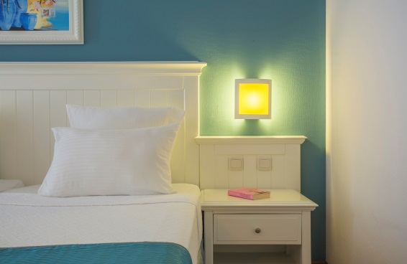

|  |
| --- |
| * 20-24 m2, Same equipment as in the double room, but is in the mezzanine floor and is accessible by stairs. The view is on the land side.   Single room same features as double only a little smaller and country side.  Occupancy; max. 3 adults or 2 adults + 1 child. |

**FAMILY ROOM – Land view**

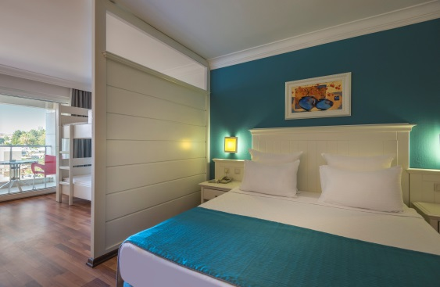

|  |
| --- |
| * 28 m2, a spacious room with the same features as the double room, 1 Shower/WC, with optical separation-bunk bed.   Occupancy; max. 3 adults + 1 child or 2 adults + 2 children |

**FAMILY ROOM – Sea view**

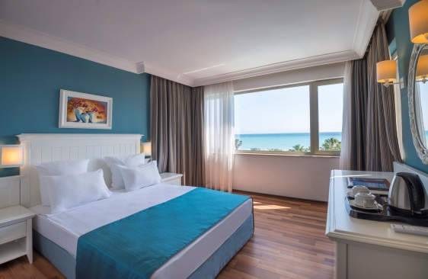

|  |
| --- |
| * 38 m2, a spacious room with the same features as the double room, 1 Shower/WC and with separated room.   Occupancy; max. 3 adults + 1 child or 2 adults + 2 children |

**BEACH**

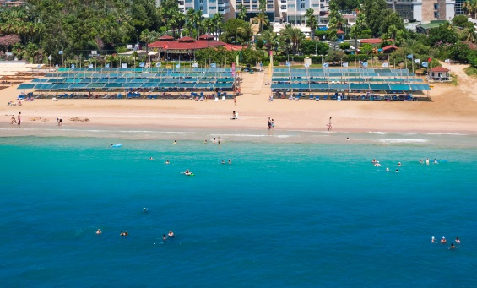

* 120 m wide, gently sloping sandy beach, sunshade, beach

chairs and mats for free. Beach towels in the SPA area

available for free. Beach bar open only by weather depending.

*-2-*

**POOL**

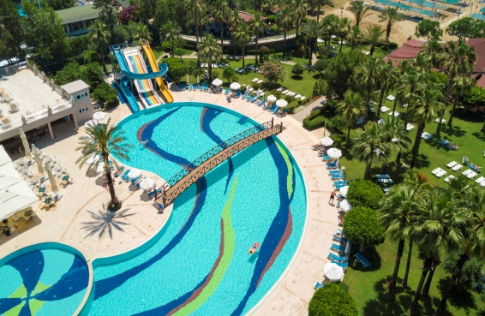

* 900m2 large and 1.40m deep freshwater pool accessible with

Stairs, separate children's pool (0.35 m deep) available.

3 Water slides (by the hour), indoor heated pool 100m2

large and 1.40 m deep with separate children's pool

(0.35 m deep), open in the winter season. Beach chairs and mats,

umbrellas and beach towels.

**SPORTS**

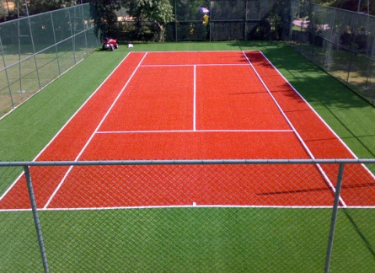

* Soft Animation (6 days a week), aerobics, aqua-gym, fitness

center, waterslides (by the hour), Beach volleyball (weather

permitting), Boccia, darts, Table tennis, Floodlight for tennis,

basketball. Various Watersports on the beach and horse

riding are offered by local Operators.

**CHILDREN**

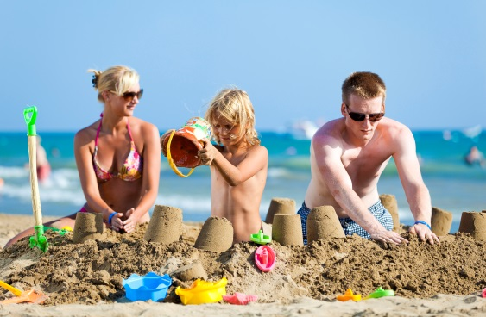

* Children's entertainment (6 days a week), mini-club (4-12

years) and playground (outdoor area). Baby cots, child seat

in Restaurant (limited). Buggy service for a fee.

**ACTIVITIES INCLUDED**

* WI-FI internet connection
* Safe
* Mini Club
* Turkish bath, sauna, steam room, Fitness Center
* Table tennis, darts, boccia
* Beach Volleyball (weather permitting)
* Aerobics, Aqua-Gym,
* Tennis court & equipment (hard court)
* Basketball
* Waterslides (by the hour)
* sunshade, beach chairs and mats, beach towels

**ACTIVITIES AGAINST FEE**

* Imported drinks, freshly squeezed fruit juices, cocktails and bottled drinks
* A’la Carte Restaurant (p.P.10 €)
* Phone, Fax, Photocopy
* Umbrella (against bail)
* Floodlight for tennis court
  + Spa & Wellness (as well as Far Eastern massages)
  + Room service
  + Medical care
  + Laundry and ironing service
  + Bathrobe and pillows types on request for availability
  + Buggy rental (per day 5 € / subject to availability)
  + All shops
  + Water sports and horse riding (private providers)

*-3-*

**EAT & DRINK**

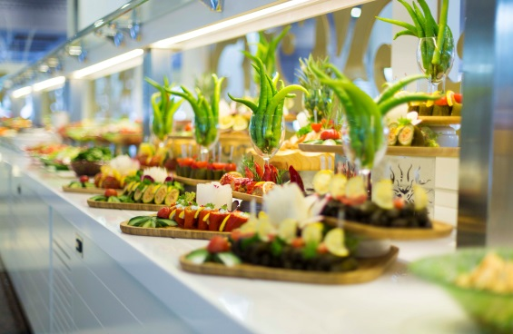

* Breakfast-, Lunch and dinner with rich buffet.
* Late risers – breakfast.
* Theme nights, gala dinners all 14 days.
* Snacks at the Beach Bar: (Snack Bar and Pool Bar

weather-related open).

* Patisserie with daytime pastries and cake.
* Afternoon coffee and cake.
* From 10:00 - 24:00 hours will be in the bars and

restaurants local alcoholic and non-alcoholic drinks

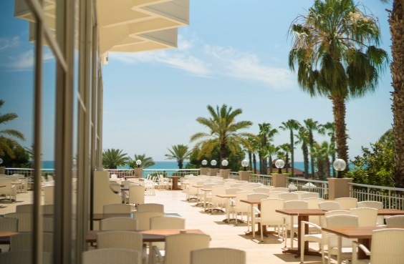included served.

* Ice hour
* Minibar replenished daily with water, soft drinks and beer
* Import drinks, freshly pressed fruit juices, cocktails

and bottled drinks are for a fee.

* Two á la carte restaurant: "Sultan" Turkish Kitchen and

"Turkuaz" Mediterranean cuisine (with reservation / for

a fee) available.

* **Under the age of 18, NO ALCOHOL is served.**
* **For reasons of hygiene, no meals may be taken**

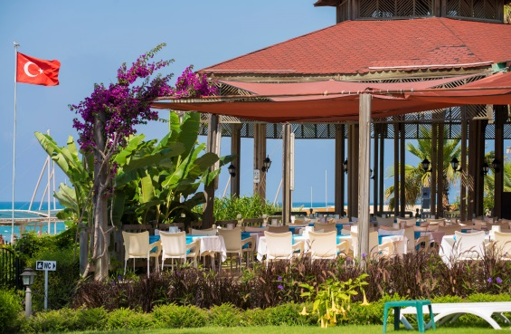**out of our restaurants**

* **Adequate clothing is required in the restaurants.**

**Restaurants and Bars**

* Riviera Main Restaurant Breakfast and dinner with

open buffet.

* 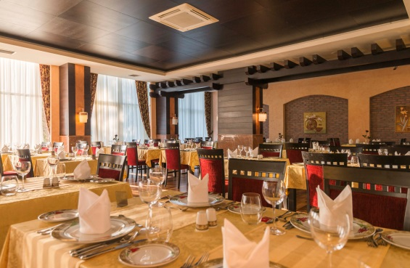Marmaid beach restaurant (lunch open buffet and

snack service).

* Baby corner (Microwave, bottle warmers and high

chairs (after Availability) available.

* Sultan and Turkuaz A'la Carte Restaurant (by

appointment / for a fee / Our A'la Carte restaurants

serve our guests from a certain number of reservations).

* Lobby Lounge Bar, Siesta Pool Bar, Beach Bar.

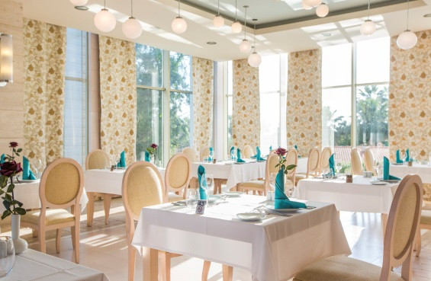**The service of the Lobby Bar is from 24:00 to 10:00**

**for a fee.**

*-4-*

**HONEYMOON**



* Specially prepared VIP Setup for Honeymoon

Room

* Fruit and Turkish desserts
* Once for 2 persons breakfast in the room – (Turkish

breakfast, on a day the guest prefers it)

* A bottle wine (local)
* Bathrobe – slippers
* Greeting card

**PAVİLLİON CONCEPT**

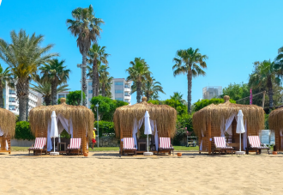

The Guest can make the Reservation at

Guest Relation or Reception.

**FOOD CORNER**

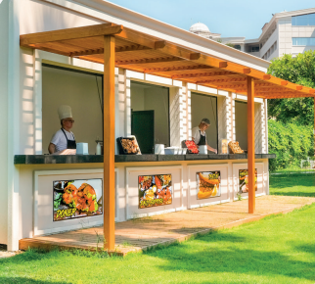

Every day we have 4 kinds of fresh,hot,delicious,eat in

our new dining corner

**İCE CREAM AND FRUİT STAND**

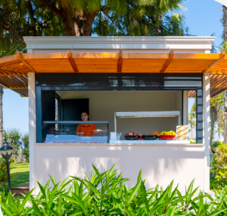

From 10 o'clock in the morning to 18 o'clock in the evening,

ice cream and our fruits offered.

*-5-*

**CHİLDREN’S POOL**

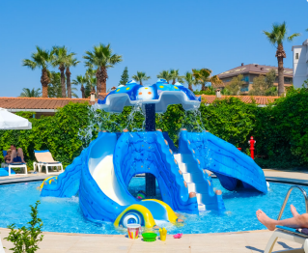

Renovated Children's Pool

**SHOPS**

* Mini market, silver, gold, optician, hairdresser, boutique and photographer shops.

**OTHERS**

* **Rooms must be vacated by 12:00. Food and drinks are available until 16:00, from 16:00 for a fee.**
* An extension until 16:00 is possible on request at the reception and costs 20.- € per room.
* In our facility, there is a bracelet application for the safety of our guests and so that they can benefit from the services offered.
* Pets are not accepted.
* Credit cards: Master, Visa, Euro
* Quality certificates: ISO 9001, ISO 22000, HACCP
* **We reserve the right to change the restaurant, bar, activities and opening times according to the weather conditions.**

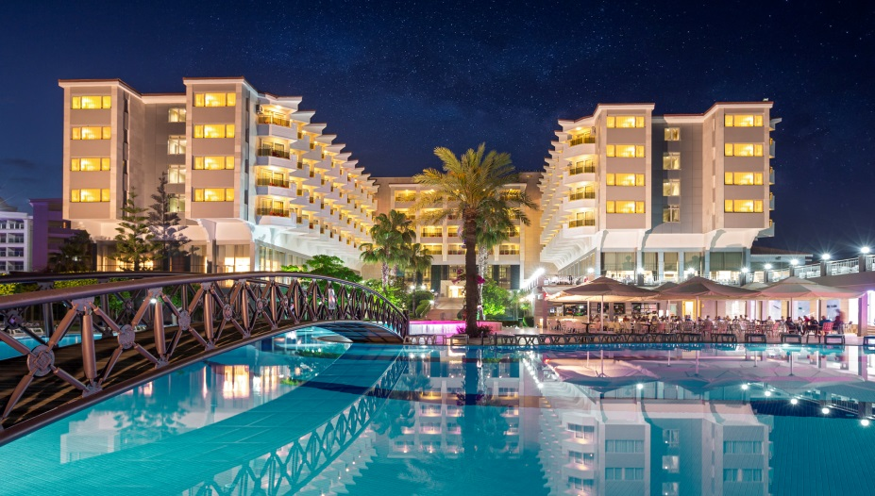

***www.hotelterrace.com***

*-6-*