SERENİS HOTEL
FACT SHEET

GENERAL INFORMATION
Antalya | 60 km | Opening Date | 2012
Antalya Airport | 55 km | Renovation | 2018
Manavgat | 7 km | Category | Hotel
Side | 3 km | Star | 5
Dolmuş | 100 m | Saison | 2023
Beach | 500 m | Aufzug | 3
Cash Machine | 200 m | Floor | 8
Adress | Ilıca Mahallesi 11. Sokak No: 1A/1 07330 Manavgat Antalya | Consept | All Inclusive
Web site | www.serenishotel.com | Area | 20.000 m²
E mail | info@serenishotel.com | Air Conditioning | General System
Telephone | +90 242 756 15 00 | Total Room | 358
Fax | +90 242 756 10 60 | Total Pax | 766
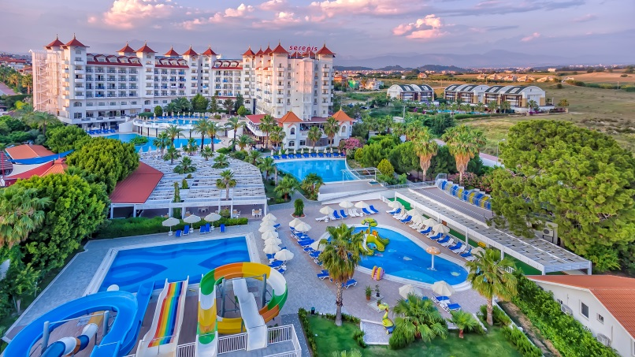

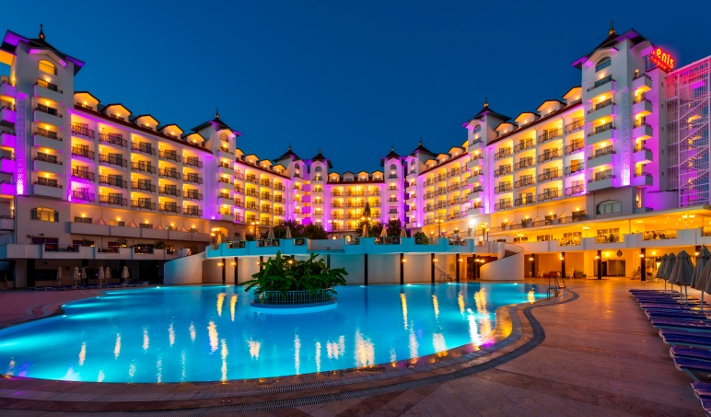
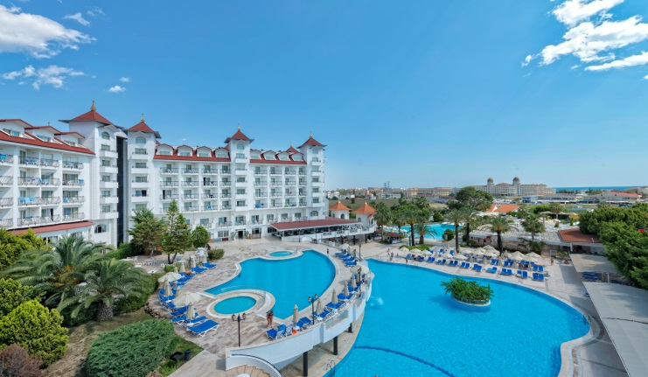

ROOM TYPES
 | Land View Room Types |  |  |  |  | Sea View Room Types
 | Standard Room | Economy Room | Family Room | Duplex Room | Disabled Room | Standard Room | Family Room
Number of rooms | 223 | 4 | 37 | 16 | 3 | 55 | 20
Bedroom | 1 | 1 | 2 | 1 | 1 | 1 | 2
Livingroom |  |  |  | 1
Area | 25 m² | 25 m² | 32 m² | 45 m² | 25 m² | 25 m² | 32 m²
Pax Min/Max. | 2+1+B/3 | 1/2 | 2/4 | 2/5 | 2+1+B/3 | 2+1+B/3 | 2/4
Balcony | ✔ | ✔ | ✔ | ✔ | ✔ | ✔ | ✔
Intermediate Door |  |  | ✔ |  |  |  | ✔
Couch |  |  |  | ✔
Shower / WC | ✔ | ✔ | ✔ | ✔ | ✔ | ✔ | ✔
Hair Dryer | ✔ | ✔ | ✔ | ✔ | ✔ | ✔ | ✔
Heating/Cooling | ✔ | ✔ | ✔ | ✔ | ✔ | ✔ | ✔
Telephone | ✔ | ✔ | ✔ | ✔ | ✔ | ✔ | ✔
Minibar (daily/soft drinks/free) | ✔ | ✔ | ✔ | ✔ | ✔ | ✔ | ✔
Laminate Floor | ✔ | ✔ | ✔ | ✔ | ✔ | ✔ | ✔
Safe (Chargable) | ✔ | ✔ | ✔ | ✔ | ✔ | ✔ | ✔
Energy Card | ✔ | ✔ | ✔ | ✔ | ✔ | ✔ | ✔
Satelite LCD TV | ✔ | ✔ | ✔ | ✔ | ✔ | ✔ | ✔
Wifi (Chargable) | ✔ | ✔ | ✔ | ✔ | ✔ | ✔ | ✔
220 Volt | ✔ | ✔ | ✔ | ✔ | ✔ | ✔ | ✔
Reading lamp near the Bed | ✔ | ✔ | ✔ | ✔ | ✔ | ✔ | ✔
Make up mirror in the Bathroom | ✔ | ✔ | ✔ | ✔ | ✔ | ✔ | ✔
Coffee Tea Set | ✔ | ✔ | ✔ | ✔ | ✔ | ✔ | ✔
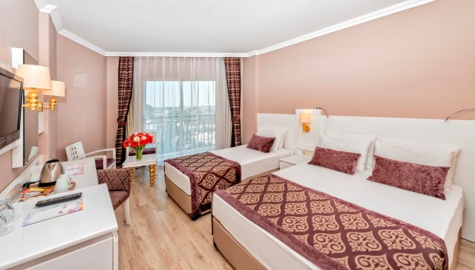
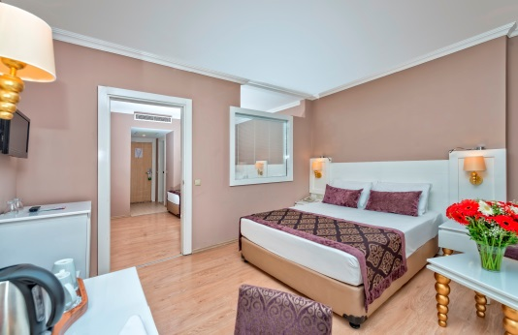

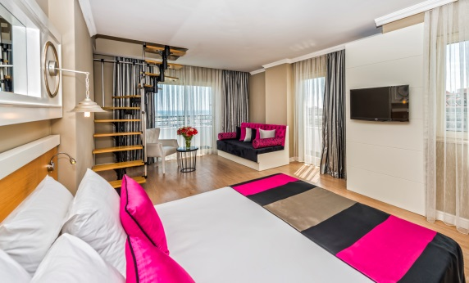
Standard Room Duplex Room Family Room

DISABLED ROOMS
 | Width | Height | Yes | No
Room Door | 87 cm
Room Bath Door | 87 cm
Make- up Desk |  | 74 cm
Bed |  | 52 cm
Sink |  | 80 cm
Bath Mirror with Slope |  |  | ✔
Toilet |  | 48 cm
Elevator Door | 90 cm
Balcony |  |  | ✔

MEETING ROOMS
 | Area | Cocktail Layout | Cinema Layout | Lectern | Sound System | Projection | Microphone
Meeting Room | 458 m² | 250 pax | 250 pax | ✔ | ✔ | ✔ | ✔
Meeting Room | 53 m² |  | 20 pax | ✔
Meeting Room | 53 m² |  | 20 pax | ✔
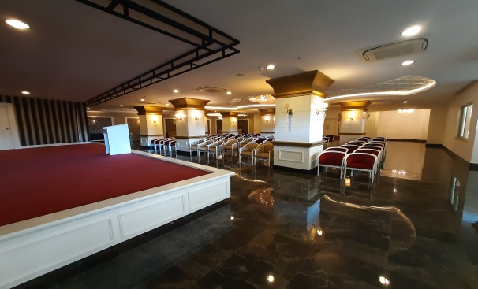
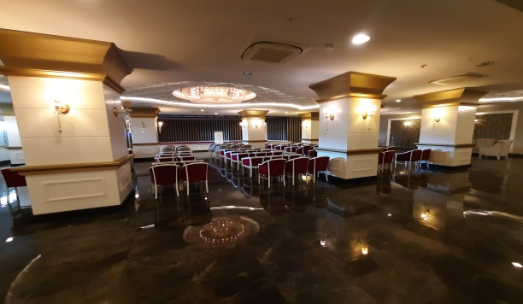

Meeting Room

FOOD AND BEVERAGE
 | Service Hours | Service Location
Breakfast | 07:00 - 10:00 | Restaurant
Late Breakfast | 10:00 - 10:30 | Restaurant
Flatbread | 10:30 - 16:00 | Pool bar
Snack | 12:00 - 15:30 | Beach Bar
Snack | 12:00 - 15:30 | Pool bar
Lunch | 12:30 - 14:00 | Restaurant
Ice Cream | 15:00 - 16:00 | Pool bar
Tea/Coffee | 16:00 - 17:00 | Pool bar
Ottoman/Italien/Mexican | 19:00 - 21:00 | A la Carte Restaurant
Dinner | 19:00 - 21:00 | Restaurant
Midnight Soup | 23:30 - 24:00 | Restaurant

RESTAURANTS
 | Number | Area | Indoor Capacity | Outdoor Capacity | Explanation
Main Restaurant | 1 | 700 m² | 310 pax | 550 pax
Ottoman Restaurant | 1 | 130 m² | 50 pax |  | One reservation for 7 days accomidation
Italian Restaurant | 1 | 90 m² | 45 pax |  | One reservation for 7 days accomidation
Mexican Restaurant | 1 | 70 m² | 32 pax |  | One reservation for 7 days accomidation
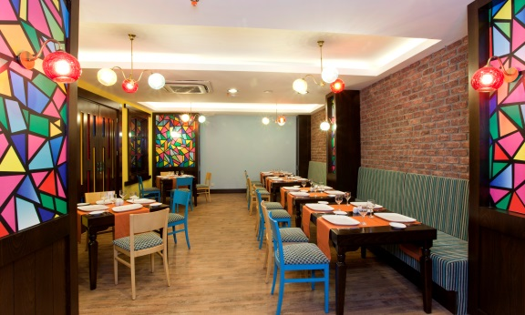
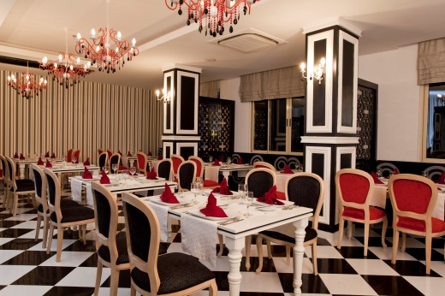
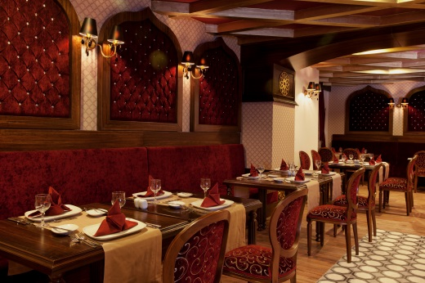

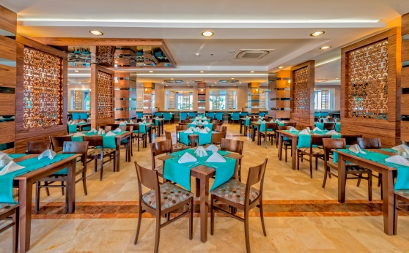
Italian Mexican Ottoman

Main Restaurant
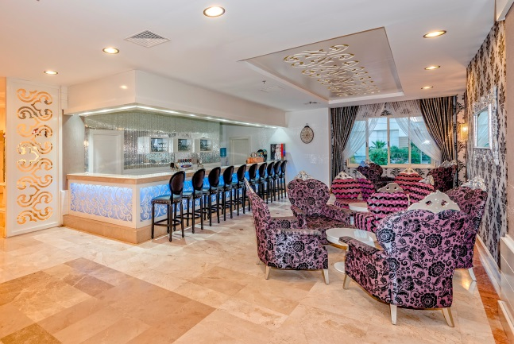
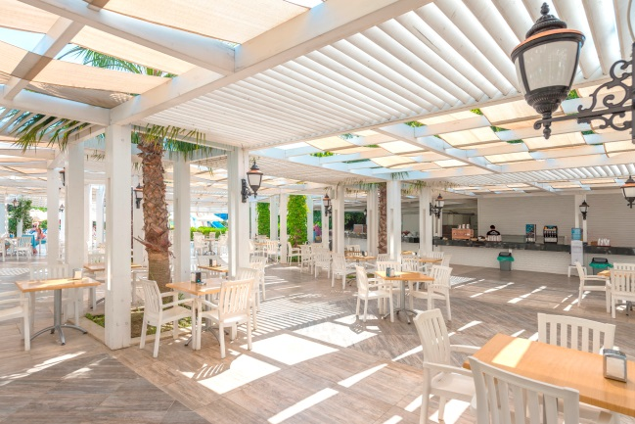

Pool Bar Lobby Bar
BARS
 | Number | Service Times | Width | Capacity
Restaurant Bar | 1 | 12:30-14:00 / 19:00-21:00
Lobby Bar | 1 | 10:00-24:00 | 50 m² | 30 pax
Pool Bar | 1 | 10:00-24:00 | 750 m² | 280 pax
Beach Bar | 1 | 10:00-18:00 |  | 200 pax
POOLS
 | Area | Depth | Heating | Waterslides
Big Pool | 975 m² | 150 cm
Relax Pool | 450 m² | 140 cm
Wave Pool | 576 m² | 170 cm
Aquapark Pool | 150 m² | 120 cm |  | ✔
Indoor Pool (beginning and end of the saison) | 77 m² | 140 cm | ✔
Child Pool | 180 m² | 35 cm |  | ✔
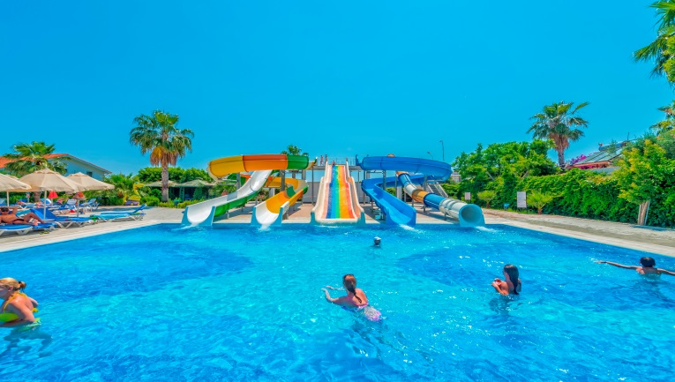
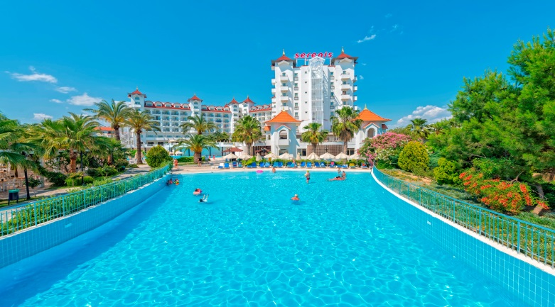

Wave Pool Aquapark Pool
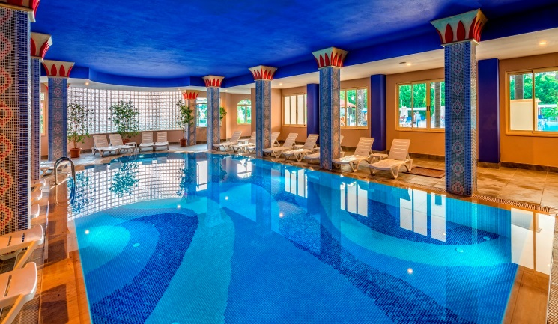
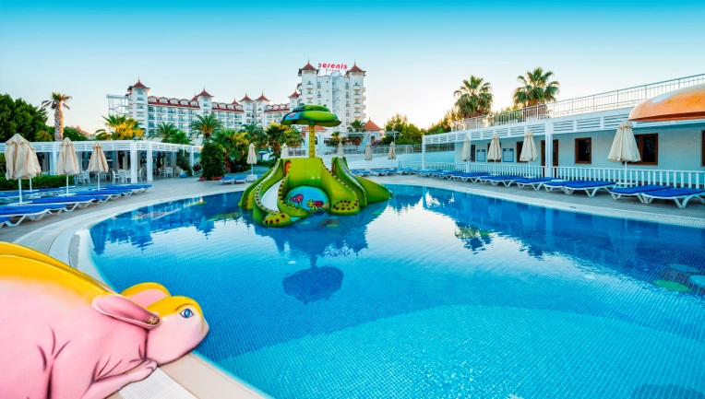
Child Pool Indoor Pool

BEACH
 | Yes | No | Chargable | Free
Private Beach | ✔ |  |  | ✔
Beach Bar | ✔ |  |  | ✔
Shallow Sea | ✔
Sand | ✔
Rock |  | ✔
Sunbeds, Umbrellas ans **Towels | ✔ |  |  | ✔
Water Sports |  | ✔ | ✔
MINI CLUB
 | Yes | No | Area | Free
Mini Disco | ✔ |  |  | ✔
Child Pool | ✔ |  |  | ✔
Mini Club | ✔ |  | 180 m² | ✔
4-12 years | ✔
Baby Sitting |  | ✔
Palyground |  | ✔
Children Slide | ✔ |  |  | ✔
Certain Times | ✔

ANIMATION
 | Yes | No | Explanation
Daily Activities | ✔
Evening Shows | ✔
Theme Evenings | ✔
Spoken Languages |  |  | Turkish, English, German, Russian
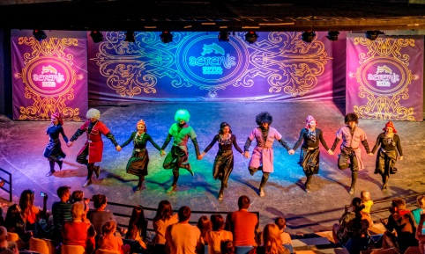

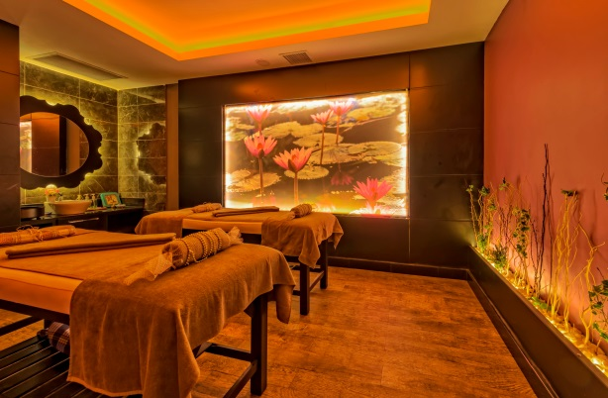
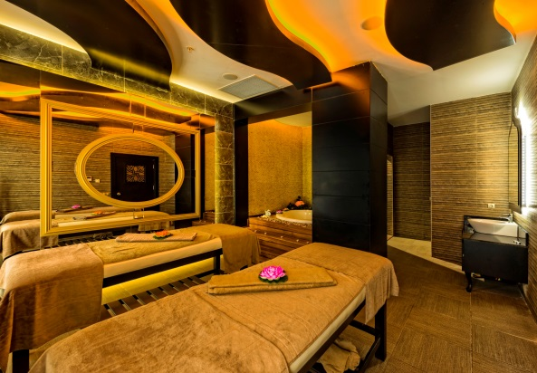
Animation

Massage Room SPA CENTER Massage Room
 | Yes | Chargable | Free
Turkish Hamam | ✔ |  | ✔
Sauna | ✔ |  | ✔
Fitness Center (min. 16 years) | ✔ |  | ✔
Massage | ✔ | ✔
Peeling | ✔ | ✔
Facemask | ✔ | ✔

HEALT CARE
 | Yes | Chargable | Free | Service Times
Doctor | ✔ | ✔
Nurse | ✔ | ✔ |  | 09:00 – 16:00

ACTIVITIES
 | Yes | No | Chargable | Free | Explanation
Waterslides | ✔ |  |  | ✔ | 5 piece, certain times
Game Center | ✔ |  | ✔ |  | Private
Billard | ✔ |  | ✔
Spa Center | ✔ |  | ✔ |  | Private
Table Tennis | ✔ |  |  | ✔
Massage | ✔ |  | ✔
Dart | ✔ |  |  | ✔
Boccia | ✔ |  |  | ✔
Aerobic | ✔ |  |  | ✔
Rent A Car | ✔ |  | ✔ |  | Private
Water Sports | ✔ |  | ✔ |  | Beach, Private
Wifi | ✔ |  | ✔ |  | Free at the Lobby
Wifi (at the Beach) | ✔ |  | ✔
Safe | ✔ |  | ✔
Dry Cleaning | ✔ |  | ✔
Healt Services | ✔ |  | ✔
**Towels | ✔ |  |  | ✔ | İn day, 2.change chargable
Champagne, Wine | ✔ |  | ✔
Import Drinks, Bottle Drinks | ✔ |  | ✔
Fruit Juice | ✔ |  | ✔
Pet |  | ✔ |  |  | Unacceptable
Parking | ✔ |  |  | ✔
Credit Card | ✔ |  |  |  | Visa, Mastercard
Market | ✔ |  | ✔
Silver Shop | ✔ |  | ✔
Hairdresser | ✔ |  | ✔
Photo | ✔ |  | ✔

HONEYMOON CONSEPT
Fruit and wine on arrival date to the room
Upgrade room on availability
Room decoration
One time breakfast to the room (contact with Guest Relation)
At the A la Carte restaurant priority booking

- Hotel Management reserves its right to make any amendments and/or cancellations on above programmed without any prior notice
- Alcoholic drinks will not serve for children’s under 18 years

