JADORE DELUXE

General information
Opening date | : May the 1st 2016
Category | : 5 Stars
Company | : Emeç Turizm Inş. Tic. Ltd. Şti.
Tax number | : 3330754962
Season | : 12 Months
Catering Offer | : Ultra All Inclusive
Address | : Kümeevler Mevkii No:35Titreyengöl
City | : SIDE /ANTALYA
Phone | : +90 242 777 0911
Fax | : +90 242 777 0912
E-Mail | : info@jadorehotel.com
Website | : www.jadorehotel.com

Distances and Transportation
Antalya Airport : 70 km
Antalya City Center : 80 km
Distance to the Sea : 350 m
Nearest Town Center : 5 km (Manavgat), 7 km (Side)
Transportation :VIP Transfer, Bus, Taxi

Credit cards
Visa, MasterCard ,Euro Card

Reception
- Registration on the seating areas in the lobby
- Table reservations in the main restaurant for guests with disabilities
- Free bathrobe and umbrella service on rainy days (with deposit)

Languages
Turkish, German, English, Russian

Beverage Concept for Ultra All Inclusive :
- Local/İmport alcoholic and non-alcoholic beverages 24 hours inclusive. Import drinks are in Ultra all inclusive concept until 01:00.
- Selection of table wine in the main restaurant
- Freshly squeezed fruit juices (chargeable & just at Breakfast)

Service Time
Bars | Beverages | Summer Season
 |  | 1. April - 31. October
Lobby Bar | Local/Import beverages | OPEN 24 HOURS
Lounge Bar | Local/Import beverages | 09:00 - 24:00
Pool Bar | Local beverages | 10:00 –18:00
Beach Bar | Local beverages | 10:00 -18:00 / 20:00-01:00
Disco Bar | Local beverages | 23:30 - 01:00
Snack Pool Bar | Local beverages | 12:00 – 16:00

Imports Drinks Lobby Bar

Local Drinks Lobby Bar : Efes Beer, New Raki, Sırdem Raki, Tekirdag Raki
Coca Cola, Fanta, Sprite, Americano, Cafe Latte, Cappuccino, Latte Macchiato, Hot Chocolate,
Turkish coffee and soft drinks.

Minibar
- Still water (one big bottle),
- Sparkling water (2 bottles),
- Fruit juices (2 packs),
- Coca Cola/ Fanta

Mini bar refills ones a day till 17:00 pm.

Food&Beverage
Restaurants | Type | Buffet type | Supplement | Summer Season
 |  |  |  | 1. Mai – 31. October
 |  |  |  | Service Time | Chargeable / Free of charge
Main Restaurant | Breakfast | Open  buffet | Diet buffet, different varieties of tea | 07:00 - 10:00 | Free of charge
 | Late breakfast | Open  buffet |  | 10:00 - 10:30 | Free of charge
 | Lunch | Open  buffet | All drinks are served at the table, Diet buffet | 12:30 - 14:00 | Free of charge
 | Dinner | Open  buffet | Theme nights, diet buffet, all drinks are served at the  table | 18:30 - 21:00 | Free of charge
 | Night snack | Open  buffer |  | 21:30 – 07:00 | Free of charge
 | Patisserie | With beverage service | Seductive pastries | 11:00 – 18:00 | Free of charge
Ice cream | Snack Bar | Open  Buffet |  | 14:00 - 17:00 | Free of charge
Snack | Beach | Snack |  | 12:00 - 16:00 | Free of charge
Gözleme/ baked potatoes | Pool/Beach | Snack |  | 11:00 – 15:30 | Free of charge
Room Services | Dishes and beverages | Menu |  | 24 hours | Chargeable
Cafe Break | Beach | Snack |  | 16:00 – 17:00 | Free of charge
Pastry (Lokma,Pişi) | Beach | Snack |  | 16:00 – 17:00 | Free of charge
SHOU / Far  Eastern  Cuisine | A la carte dinner | A la Carte |  | 19:00 - 21:00 | Free of charge (with reservation)
GONDOLA /  Italian cuisine | A la carte dinner | A la Carte |  | 19:00 – 21:00 | Free of charge (with reservation)
OTTOMAN /  Turkish Cuisine | A la carte dinner | A la Carte |  | 19:00 – 21:00 | Free of charge (with reservation)
PEPE /  Mexican Cuisine | A la carte dinner | A la Carte |  | 19:00 – 21:00 | Chargeable (with reservation)

Food Services :
- 4 A’la Carte Restaurants, (three of them are free of charge and one is chargeable) in seven night stay, an a la Carte visit is for free (with reservation and availability)
- non-alcoholic and alcoholic beverages
- Gözleme, Pişi (Turkish pastry)
- Baby Chair and a buffet for children in the main restaurant
- Dietary corner

Jadore accommodation

Number of Rooms | : 380
Main building | : 7 Floors
Number of beds | : 960

Room Types | Standard Room | Standard Large | Family Room | Honeymoon Room
Size | 34 m² | 34-36 m² | 38-40 m² | 34-40 m²
Electronic key card system | √ | √ | √ | √
Slippers (one time on arrival) | √ | √ | √ | √
Cosmetics | √ | √ | √ | √
Vanity mirror | √ | √ | √ | √
Hairdryer | √ | √ | √ | √
Shower | √ | √ | √ | √
Digital Safe (extra charge) | √ | √ | √ | √
Wi-Fi (free of charge) | √ | √ | √ | √
Direct dial telephone | √ | √ | √ | √
LCD TV | √ | √ | √ | √
Air Conditioning | √ | √ | √ | √
Balcony, Chairs, Table | √ | √ | √ | √
Luggage space | √ | √ | √ | √
Hygiene package in the bathroom | √ | √ | √ | √
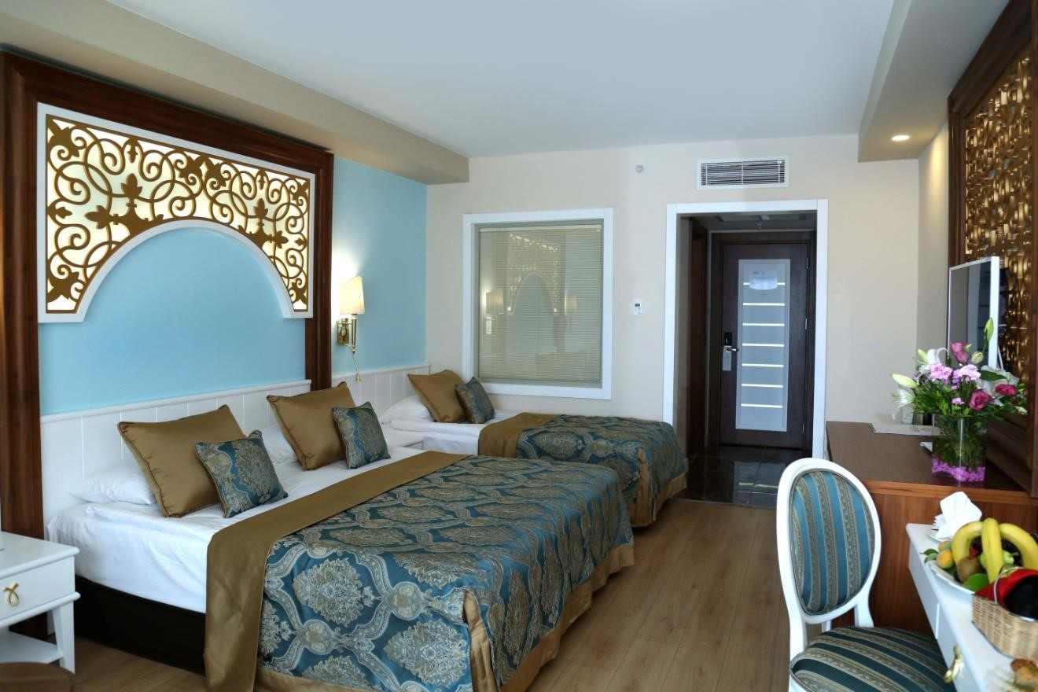

Accommodation
Room Types | Standard Room | Standard Large | Family Room | Suite | Honeymoon Room
Pillow menu (two types) | - | - | - | √ | √
Minibar  (Non-alcoholic drinks for free) | √ | √ | √ | √ | √
Set-Up for Coffee- and Tea facilities | √ | √ | √ | √ | √
Room Service (chargeable) | √ | √ | √ | √ | √
A la Carte  Restaurants  (With Reservation) | √ | √ | √ | √ | √
Pavilions + Shell (chargeable) | √ | √ | √ | √ | √
Laundry and ironing service  (chargeable) | √ | √ | √ | √ | √

Jadore Honeymoon Services Free of charge
- If we have contact details from the guests or the travel agency, the honeymooners will be contacted a week before arrival for having the possibility to make any special requests or surprises for each other. Also, guests will be informed about free and paid services. Otherwise, guests will be informed in detail about our services on arrival at our hotel.
- Scented candles and incense in the bathroom
- Special room decoration (red satin sheets etc.)
- Fruit basket, champagne / wine in the room.
- Breakfast in the room (on the desired day).
- Reservation is free for a desired A la carte restaurant.
- (Our honeymoon concept is valid only if you provide us a marriage certificate which is not older than six months).

For a Fee
- SPA honeymoon ceremony
- Transfer from airport to hotel and from hotel to airport with a VIP car service.
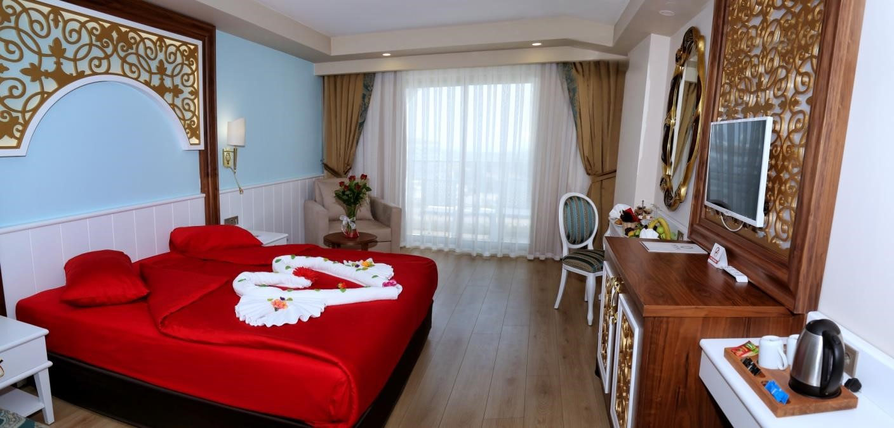

Aqua Park
- 5 slides

Swimming Pools
Pool | Outdoor area | Indoor area | Sun sail | Sea water | Fresh water | depth (cm) | m²
Indoor swimming pool |  | √ |  |  | √ | 140 | 100
Swimming pool | √ |  |  |  | √ | 140 | 557
Children’s pool | √ |  | √ |  | √ | 40 | 60
Aqua Park | √ |  |  |  | √ | 120 | 100
Relax pool | √ |  |  |  | √ | 140 | 100

Note: Indoor pool open in winter time, Relax Pool open in summer time.

Entertainment (free of charge)
- Every week Gala night
- Every week foam party
- Live Music occasionally
- Beach parties (once a week dependent on weather)
- Pool games and daily competitions, daily sports activities
- Acrobatic dance groups, Mini Disco and Shows

We ask you to appear for dinner and theme night with appropriate clothing.

Chargeable
- Water pipe on terrace
- Doctor, shopping
- Water sports on the beach from external suppliers (depends on weather and seasonal)

Sports and further activities (free of charge)
- Wireless
- Fitness center
- Table tennis
- Beach volleyball
- Aerobic
- Water aerobics
- Boccia
- Dart
- Mini-Library
- Shuttle servis to the beach

Activities for children
Club | Supplement | Activity | For free/ Chargeable | 1. April – 31. October
1 - 3 years | Playroom, Corner for baby food preparation, changing table, highchair in the restaurant, | Stroller | Chargeable | 24 hours
 |  | Babysitter | Chargeable | 24 hours (with reservation)
4 - 7 years | Playroom, playground, Craft activities, water park, children's  pool, mini disco, children's buffet n the main restaurant | Competitions, games, pirate day, activities in the aqua park | For free | 10:00 – 12:30 14:30-16:30
8 - 11 years(Junior)
 |  | Mini-Disco | For free | 21:00 - 21:45

Spa-Wellness (free of charge)
- Indoor swimming pool (seasonal)
- Fitness centre
- Turkish Bath (Hamam)
- Sauna
- Steam bath
- Salt room
- Ones a day beach towel changing service for free

Chargeable
- Massage and treatments (Hamam)
- Beauty Salon
- Face and body care
- Manicure and Pedicure
- VIP area with different treatments

Conference and seminar rooms
There are 2 conference rooms available. The height of them is more than 3,8 meters.
- 1 conference room with a size of 600 m² (in the form of gala for 300 people, theater style for 400 people)
- 1 conference room with a size of 83 m²

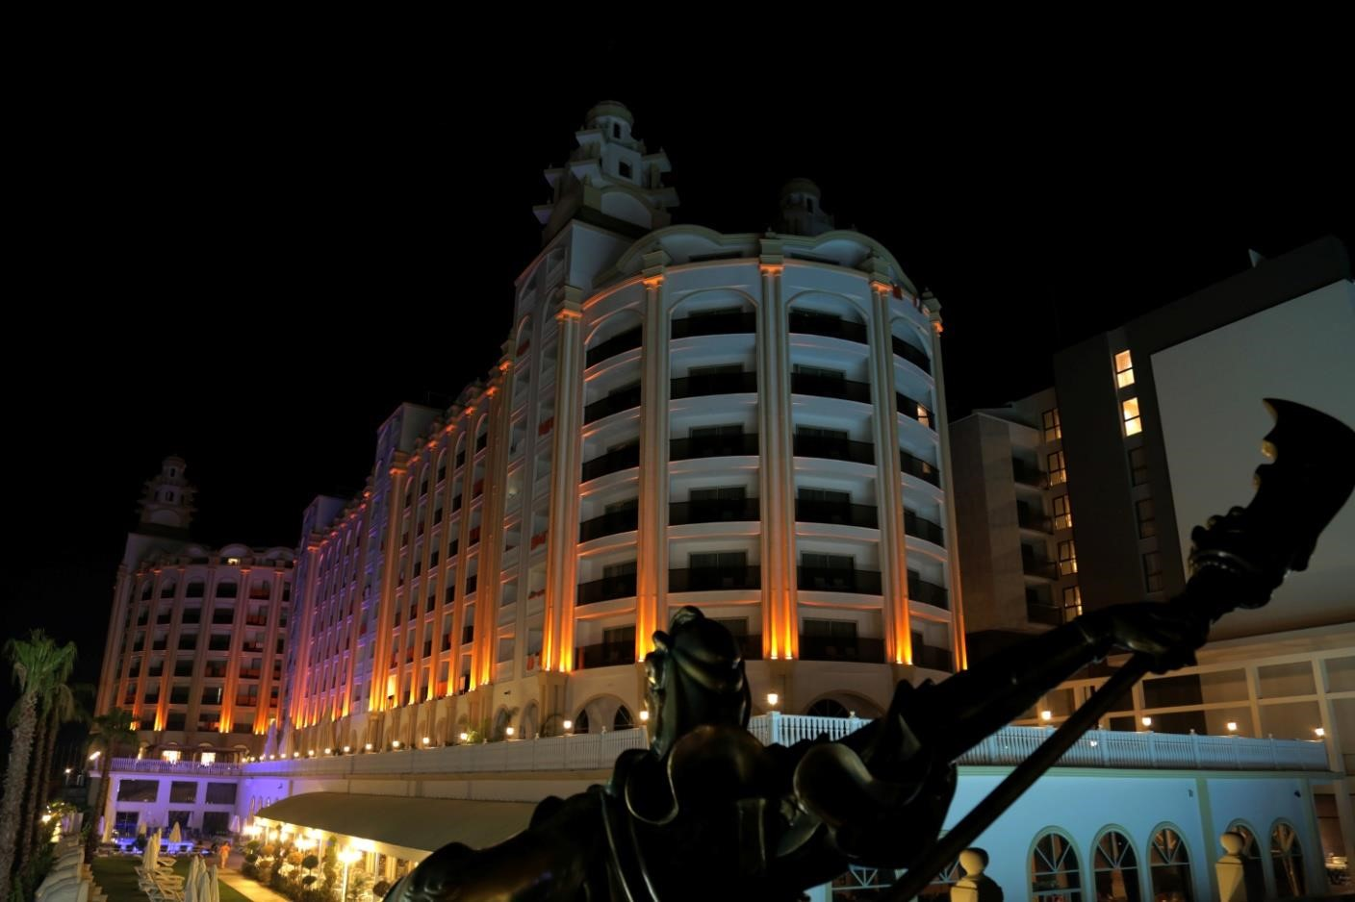
The J'adore Deluxe Hotel & Spa Management reserves the right to all of the specified services to change without any obligation to provide information on second and / or third parties, due to seasonal conditions.

