RIVIERA HOTEL &SPA
CONCEPT &GENERAL INFORMATION (ALL INCLUSIVE) SUMMER
Period | 01 APRIL -31 OCTOBER
Location | ALANYA
Category | HOTEL 4 STARS
Concept | All Inclusive
Number of rooms | 193
Number of beds | 418
Kids Age | 0-11,99
Telephone | 0242 5137597 ( Pbx )
Fax | 0242 5115800
Web Page | www.riviera.com.tr
Mail Address | info@riviera.com.tr
Address | Güzel yalı cad No:32
 | 07400 Alanya / Antalya
DISTANCES
Beach | Beach Front
Alanya centrum | 1 km
Antalya | 160 km
Antalya Airport | 130 km
Alanya-Gazipaşa Airport | 4O km
Hospital | 1 km
Pharmacy | 100 m
Bus Station | 1,5 Km
Main Road | 5O m
ATM Machine | 10 m
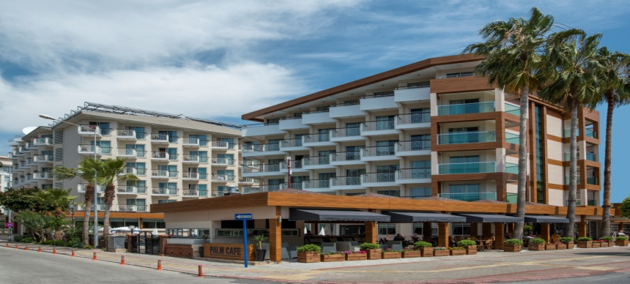

Riviera Hotel is located in famous Cleopatra beach.You may reach to Alanya city center with varıous entertaınments possibilities ın a few walking minutes.
We have 2 swimming pool with separated child pool and one indoor pool .We are providing free parasols, sun chairs
for our customers. Riviera Hotel &Spa is like a paradise on the world for the families and very peaceful place to refresh your self.

Buildings:This well-known hotel with it’s continud guests has 193 rooms in 5 floors and 3 buildings. Offer a comfortable lobby with reception.lift.lobby bar,tv-corner,Alacarte restaurant,main restaurant with non smoking area , Terrace,Paml café and Relax bar.

Rooms:The rooms with tile floor,safe (with charge).bath/wc,hair dryer,satellite tv,minibar,wi-fi,airconditioner,direct-dial telephone and balcony

Our All Inclusıve Concept is available between 10:00-23:00 foods and drinks are included.Aii drinks and foods are extra before and after.

We don’t serve alcohol under 18 according to law.
All drinks served in glass and there is no service in bottle.

Hotel may refuse serving alcohol to the customers who are drunk and disturbing others.
Please make your checkout until 12:00 o clock and our all inclusive service finish at 12:00 o clock departure day.

FREE HOTEL SERVICE:
Local drinks (cin,rakı,votka,beer,wine,soft drinks..etc) table tennis fitness center
turkish bath Beach volleyball Wi-fi sunbeds and parosels (at the pool area).

WITH EXTRA CHARGE SERVICE
All import drinks (Bacardi,Malibu,campari,whisky .. etc) fresh orange juıce box and bottle drinks laundry service room service dry cleaning hairdresser massage peeling phone call mini bar safe box A’la carte sunbeds and parasols (at the beach side)

FOOD AND BEVERAGE SERVICE
SERVICES TYPE OF SERVICE PLACE TIME
BREAKFAST OPEN BUFFET RESTAURANT 07:30-10.00
LATE BREAKFAST OPEN BUFFET RESTAURANT 10:00-10:30
LUNCH OPEN BUFFET RESTAURANT 12:30-14:00
DINNER OPEN BUFFET RESTAURANT 19:00-21:00
CAKE SERVICE OPEN BUFFET LOBBY BAR 15:30-16:30
ICE CREAM SERVICE SELF SERVICE RELAX BAR 15:30-16:30
BEVERAGE SERVICE WITH GLASS PALM CAFE 10:00-23:00
RELAX BAR
LOBBY BAR
RESTAURANT
LUNCH PACKET EVERYDAY RECEPTION (ORDER) 10:00-20:00

