XPERIA SARAY BEACH HOTEL ****
Saray Beach Hotel is situated in Alanya, at the world famous Turkish Riviera. It is the pearl of the Mediterranean coast where sun, sea and sand come together with a fantastic historic impressions. Saray Beach Hotel is located directly on the famous Cleopatra Beach. Antalya Airport is 120km, Gazipasa Airport is 40km away.
Check-in time: | 14:00
Check-out time: | 12:00
Number of floors: | 6
Number of rooms: | Total 70 rooms
Room categories: | 40 Standard Rooms + 8 Economic Triple Rooms + 3 Economic Double Rooms + 6 Connection Room + 2 Club Suite Connection Rooms + 1 Handicapped Room + 1 Suite Room + 6 Xperian Deluxe 90 + 2 Xperian Deluxe 90 Large Terrace + 1 Xperian Deluxe Loft 180
Year of Construction: | 1999
Last Renovation: | 2018
ROOMS: All rooms have 82 screen Flat TV, satellite, Wi-Fi, Mini-bar,Kettle (Coffee and Tea), Safe Box, Direct-dial telephone, Air-Condition, Guest Amenities, Balcony, Bathrooms with shower, WC and hairdryer.

40 Standart Rooms: This room type can accomodate max 2 person. All rooms have balcony and landview + partial seaview. This room type is 18 m² + 2 m² balcony.
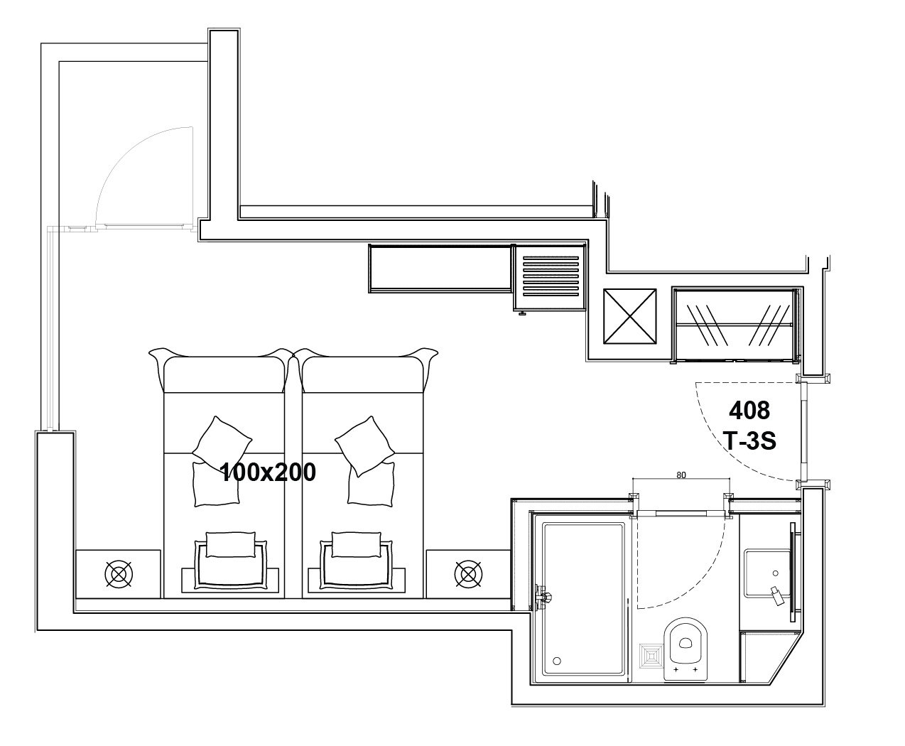
6 Economic Triple Rooms:This room type can accomodate max 3 person. Room has 1 king size french bed for 2 person and 1 twin bed for 1 person. This room type is 25m² has french balcony and landview.
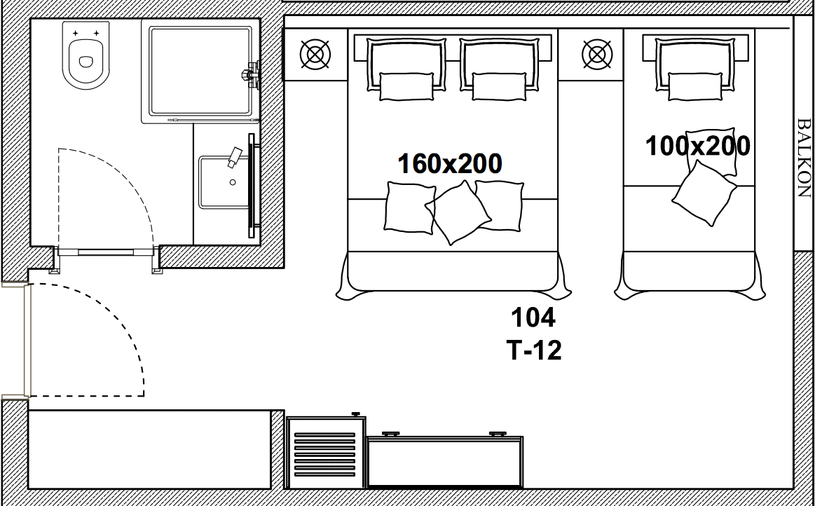

2 Economiv Triple Rooms:This room type can accomodate max 3 person. Room has 3 seperated twin bed, french balcony, landview. This room type is 26m²
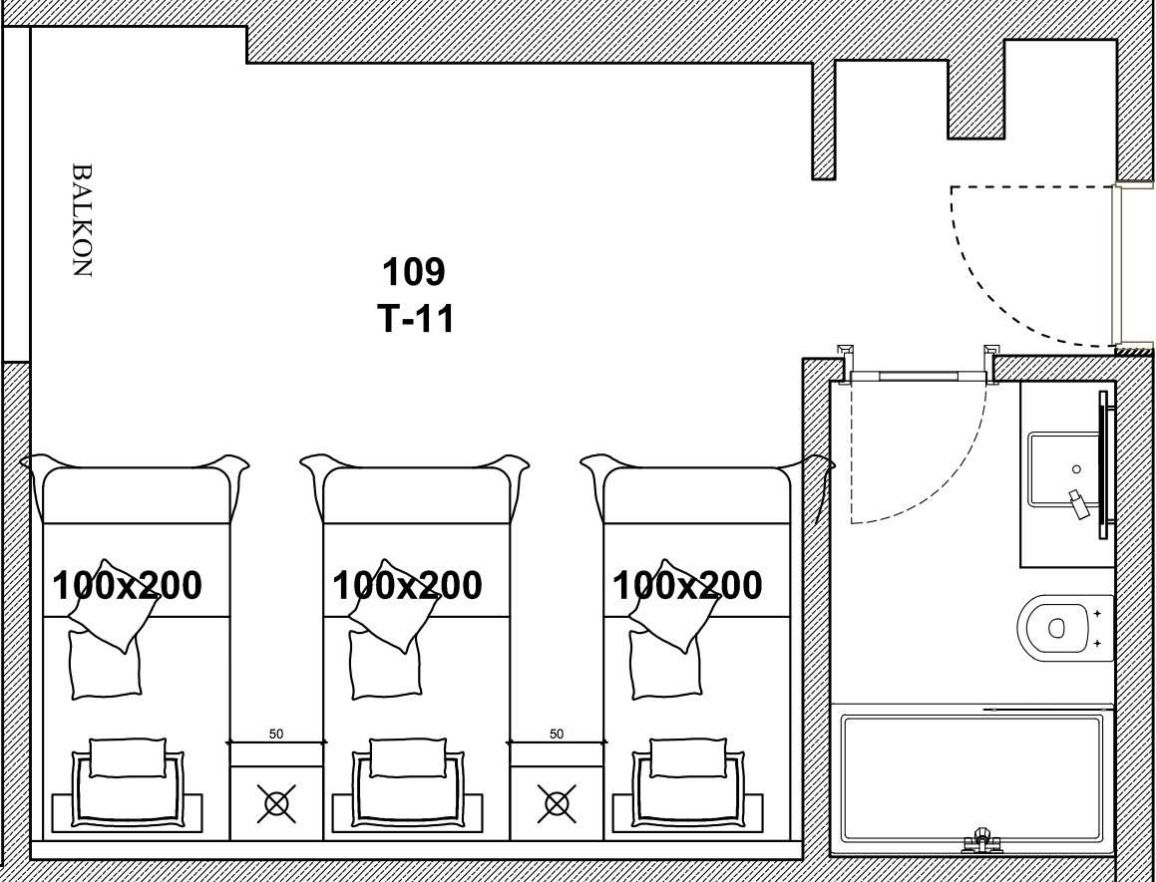

3 Economic Double Rooms: This room type can accomodate max 2 person. Room has 1 Queen bed, french balcony, landview. This room type is 18m²

6 Connection Rooms: This room type can accomodate max 5 person, Room has 1 King size french bed for 2 person, 1 sofa bed for 1 person, connected room has 2 seperated twin beds for 2 person, french balcony, landview. This room type is 48m².
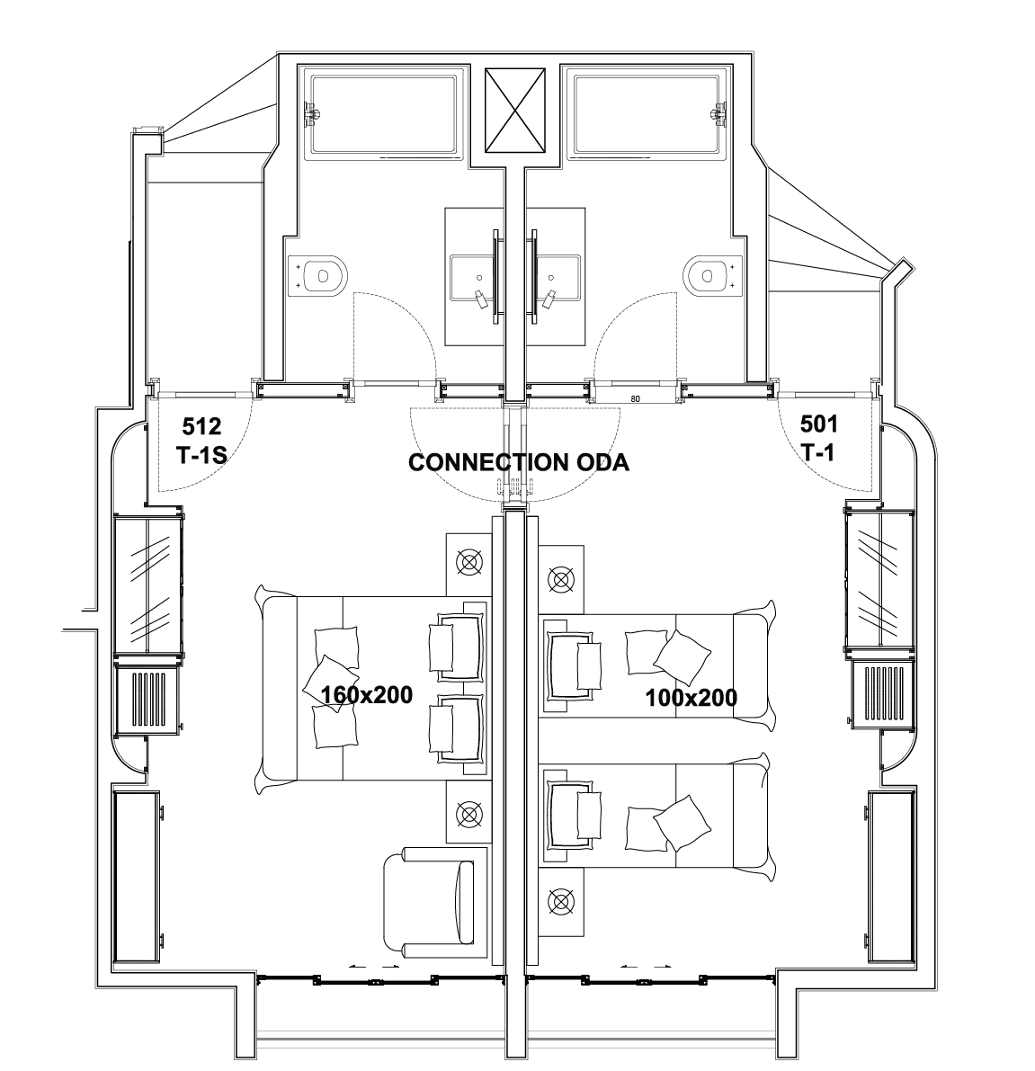
1 Club Suite Room + 1 Connection Rooms: This room type can accommodate 4 adults+3 children or 6 adults. Clup Suite room has 1 King size french bed for 2 person and 1 sofa bed for 1 person, living room has 1 sofa bed for 2 person, connection room has 2 seperate beds for 2 person. Room has french balcony and landview. This room type is 59m²
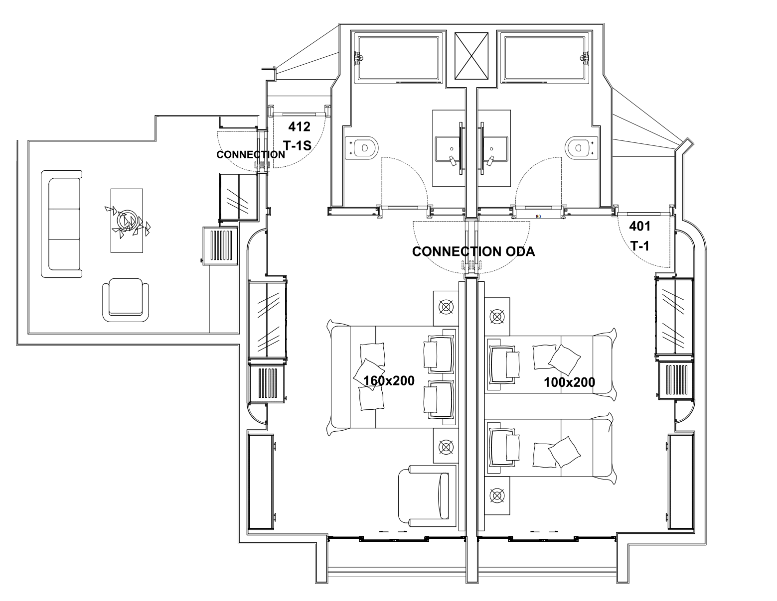
2 Club Suite Room: This room type can accommodate 4 adults + 1child. Club Suite room has 1 King size french bed for 2 person and 1 sofa bed for 1 person, living room has 1 sofa bed for 2 person. Room has french balcony and landview. This room type is 31m²
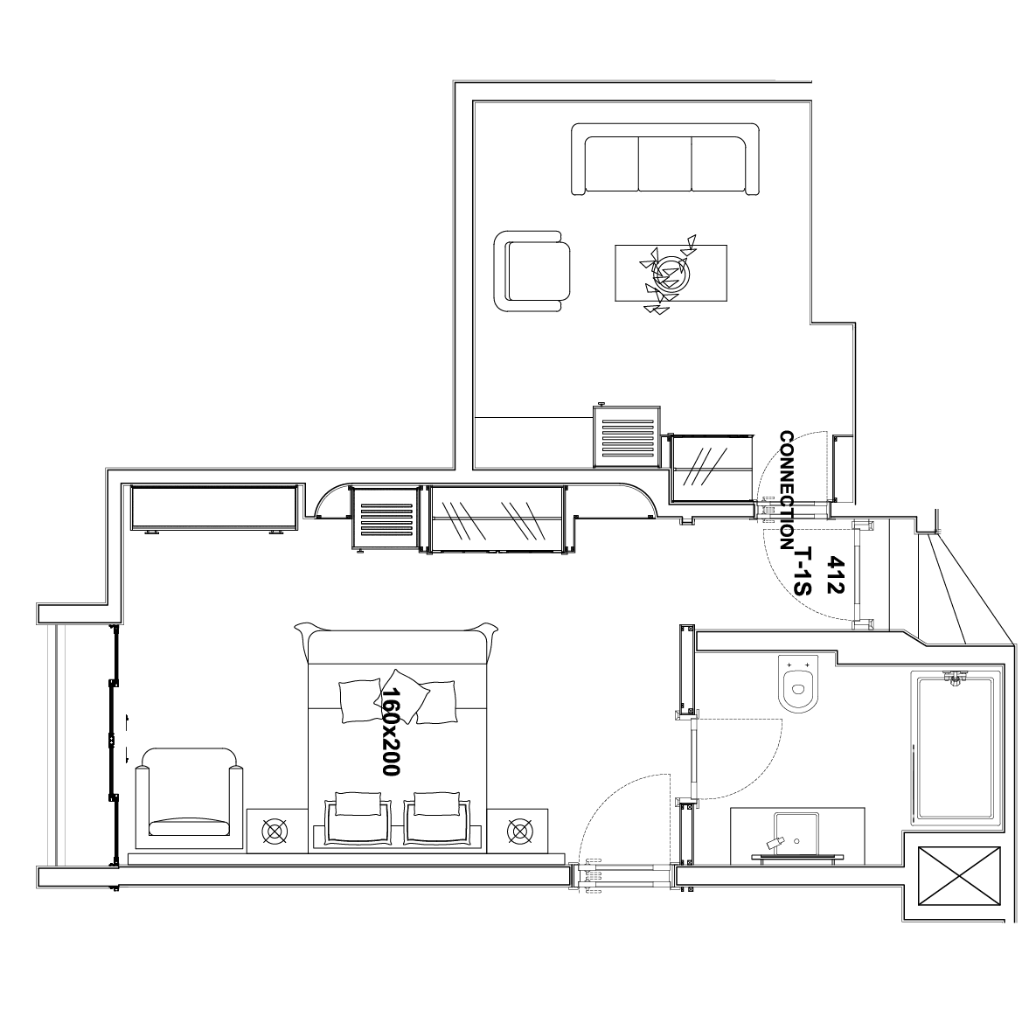

1 Suite Room: This room type can accommodate max 4 pax. Room has 1 King size french bed for 2 person, 1 sofa bed for 2 person. Room has french balcony and landview. This room type is 30m²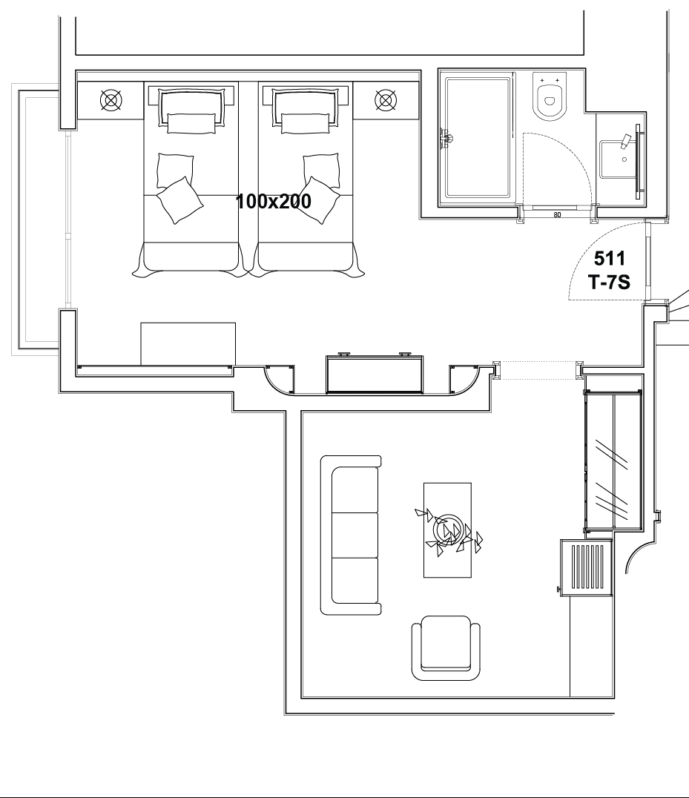
1 HandicappedRoom: This room type can accomodate max 2 person. Room has1 King size french bed, french balcony, landview. Shower, toilet and room facilities are made for handicapped guest. This room type is 26m²
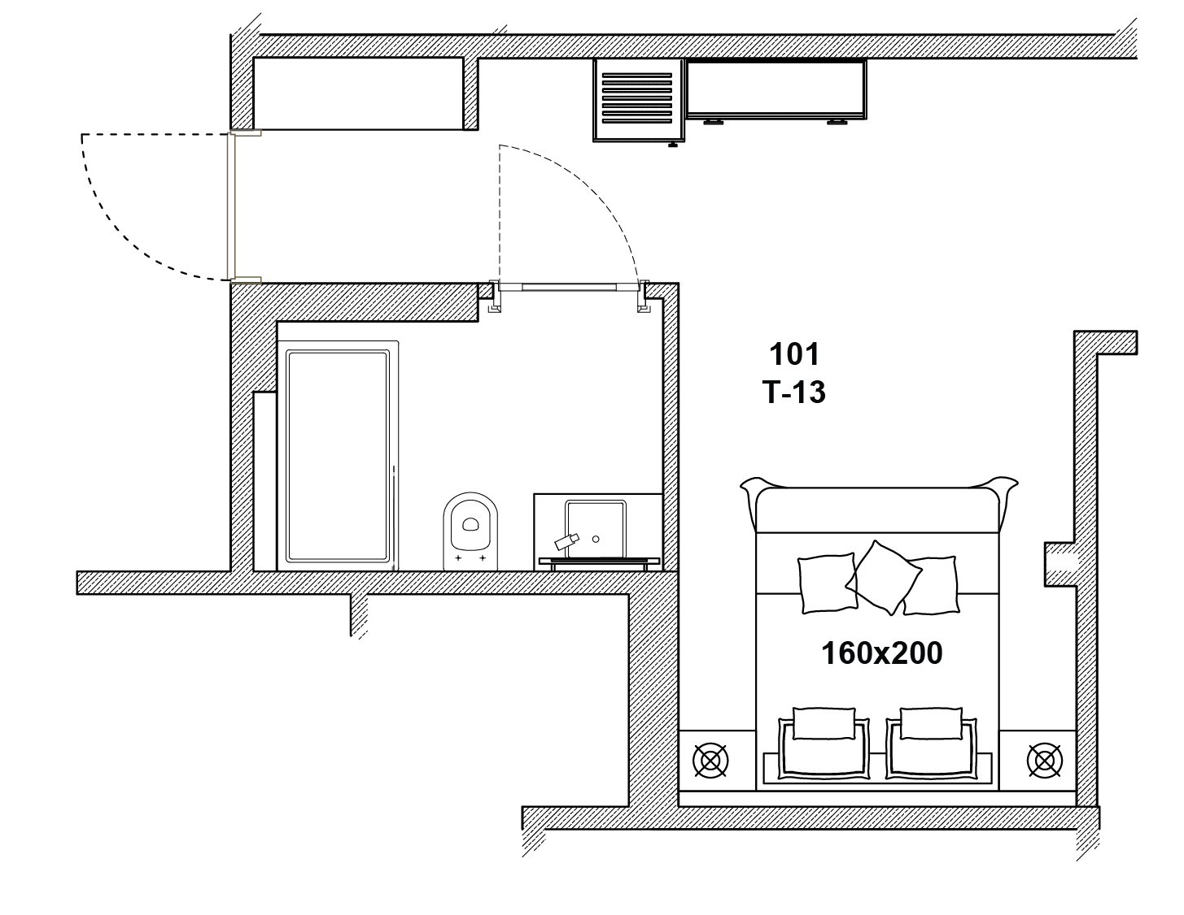

6 Xperian Deluxe 90: This type can accomodate max 3 person. Room has 1 King size french bed for 2 person and 1 sofa bed for 1 person. Rooms have balcony and directly sea view. This room type is 25m² + 5m² balcony.
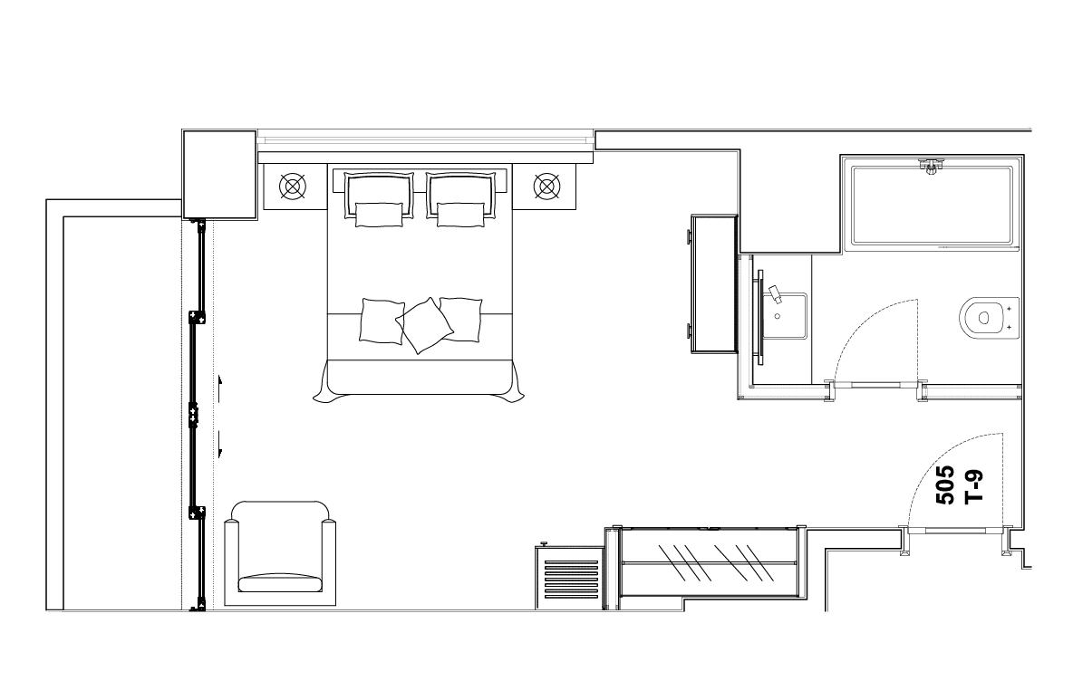
2 Xperian Deluxe 90 XL: This room type can accomodate max 4 person. Room has 2 seperate twin bed for 2 person, 1 sofa bed for 1 person and 1 additional bed for 1 person. Rooms have sun terrace with 3 sun chairs, 3 armchairs, 1 umbrella and 1 swing. directly sea view. This room type is 30m²+ 51m² terrace .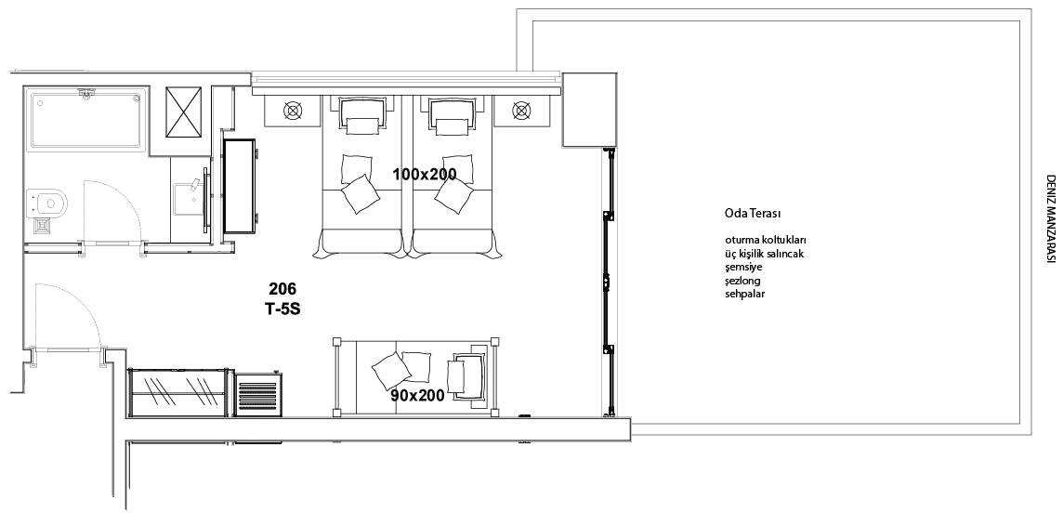

1 Xperian Deluxe Loft180 :Max4 pax, 1 Imperial Size Bed (180x200) for 2 adult sand 1 sofa bedfor 2 adults. Mezzanine, Jacuzzi in room, kitchenette, 3 bathroom, seaview. This room type is 55m² entrancefloor + 25m² mezzazine + 11m² balcony.

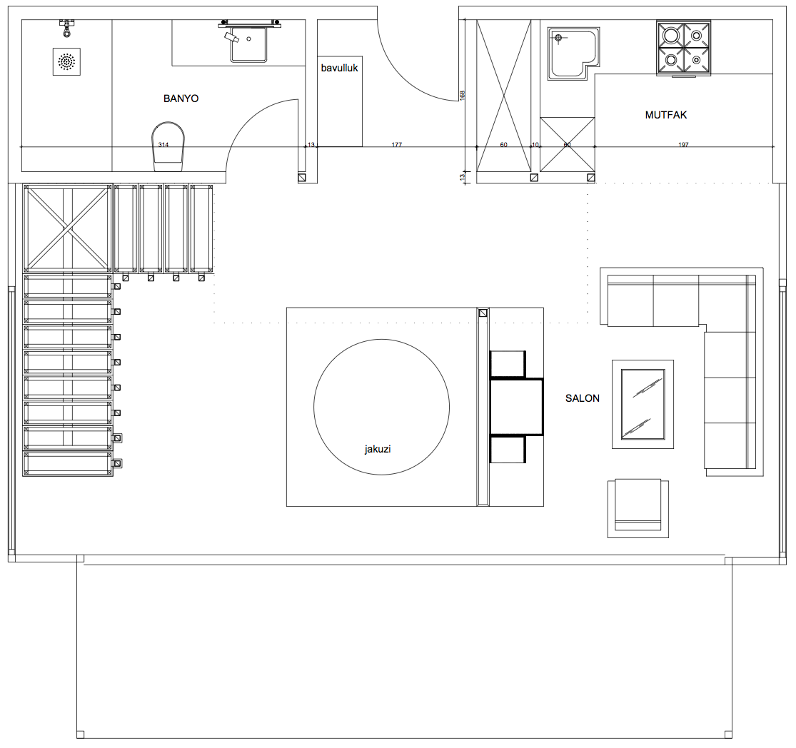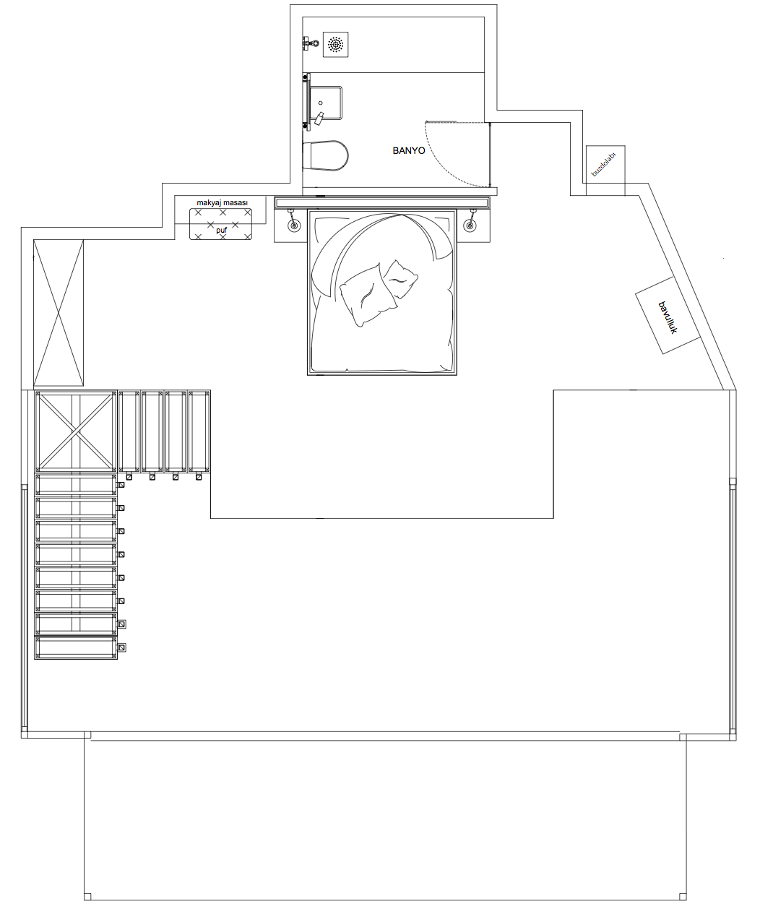
ACTIVITES
FREE:Outdoor swimming pool with separated children’s pool, Children Playground, Turkish Bath, Jacuzzi, Wireless, Minibar, Table-tennis, Dart, Game Cards, Backgammon and Chess, Beach Volleyball, Sunbeds and sunchairs on the pool and at the beach,300m away to public basketball area. Entertainment day and night. Animation show every night.

EXTRA:Spa & Massage (sauna,steambath, massage rooms, Thalasso therapy and therapy room, Fish Therapy), Internet Corner, Coiffeur, Meeting Room, watersports island available every day.
RESTAURANTS & BARS
MAIN RESTAURANT: Capacity of 150 guests. breakfast, lunch and dinner served in a buffet style.
Breakfast: 08.00-10.00 - Lunch: 12.30-14.00 - Dinner: 19.00-21.00

BEACH LIFE A’LA CARTE RESTAURANT: Mediterranean tastes are available at the restaurant with a beautiful sea view. Working hours between 20.00 and 01:00.

BEACH BAR: Working hours between 10.00 and 24.00.

LA COSTO STEAKHOUSE RESTAURANT: Steakhouse with capacity of 100 guests .Working hours between 10:00 and 02:00

SNACK BAR: Working hours between 11:00 and 18:00.

MIDNIGHT SNACK BAR: Working between 23.00 and 24.00

POOL BAR: Working between 10:00 and 18:00.

TERRACE CAFE: soft drinks, coffee and tea are served. Working between 10:00-24:00 hrs.

TV SALON & LOBBY BAR:Flat-screen TV, separate Bar, Internet Corner, Guest Information from Tour Operators is also located in the Info Salon.

MEETING ROOM: Capacity of 25 guests, included video and audio system for speacial meetings.

Xperia Hotels reserves the right to make changes to the concept without informing the 2nd and 3rd individual/corporations.

- 24-hour Reception and Welcome service
- Luggage room service
- Safebox service (extra)
- 24 Hours Room Service
- Wi-Fi (all public areas and in rooms)
- Pillow Menu
- Telephone (international calls are extra)
- Exchange & Post service
- Wake-up service
- Laundry, Dry-cleaning and Iron service (extra)
- Doctor (extra)
- Speacial gifts for Honeymoon or Wedding Anniversary guests.
- If your daily excursion or check out time is before breakfast time, please make order for a Breakfast package the day before at the Reception until 21:00.

SarayMah. Atatürk Cad. No:151 07400 ALANYA / TÜRKİYE Tel:+90.242.512 60 80 Fax:+90.242.519 08 51
http: www.xperia.com.tr e-mail: saraybeach@xperia.com.tr
e-mail for reservation: reservation@xperia.com.tr

