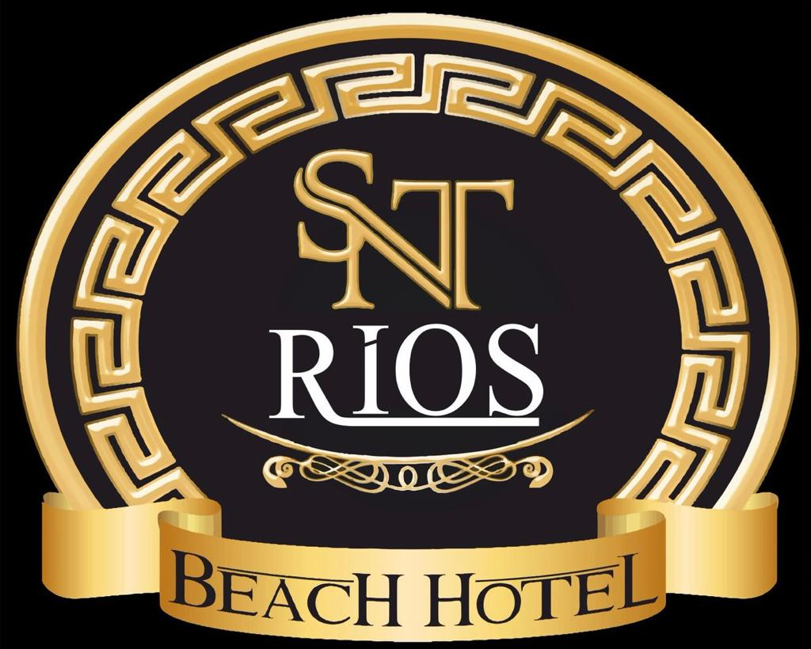
INFORMATION FORM & CONCEPT

Facility Name : RIOS BEACH HOTEL
Facılıty Category ( Agency Based) : 4* Hotel
Official Document : Ministry of Tourism Simple Accommodation Certificate
Certificate / Blue Flag : No
Hotel Status : All Inclusive – ( 10:00-21:30 )
Address : Beldibi region, Bashkomutan Atatürk Str. No : 516 Beldibi-Kemer/Antalya
Phone Number : 0(242) 824 95 96
Hotel Location : İmperial Sunland on the right side, Rama Hotel on the opposite side.
Airport Distance : 50 Km.
The closest Residential Area : Kemer 10 Km.
To Antalya City Centre : Antalya 35 Km.
Distance to the beach : 30 m. 1. min. Walking distance. there is a way
E-mail : info@riosbeachhotel.com reservation@riosbeachhotel.com
Website : www.riosbeach.com
Construction year : 1996
Latest Renovation : 2023 ( All rooms and public areas )
Hotel Area (m2) : 4500 m2
Room Capacity : 95 Standard Rooms + 25 Family Rooms Total 120 rooms – 300 beds
Bed Distribution (Rooms) : 95 Standard Rooms have 1 Large Bed or 2 Small Beds.
There is no possibility of extra beds in standard rooms
There are 4 beds in 25 Family rooms.

Speaking Languages : Turkish, English, Russian
Transfer : Taxi, Minibus ( SURCHARGE )
Check In and Out of the Room : Check in : 14:00 - Check out : 12:00
Other : 220 Volts are available at the facility. There are an elevator and a generator available.
: Pets are not accepted.

ROOM FEATURES
Total Number of Rooms : 95 Standard Rooms + 25 Family Rooms
Standard Room area (m2) : Standard Room : 20 – 24 m2 Family Room : 30-35 m2
Maximum Number of People : 95 Rooms maximum 2 People ( No possibility to put an extra bed )
25 Rooms for a maximum of 4 people.

IMPORTANT NOTE : Since there is no possibility to put EXTRA beds in standard rooms, the guest should be informed about this situation during booking.

Balcony and/or Terrace : All rooms have a balcony. 3 rooms have a french balcony.
Bathroom : All rooms have bathtub, hairdryer, sink, toilet.
Floor Information : The floor of all rooms is Laminate Flooring.
Other Room Features : In all rooms we provide LCD TV screen and satellite broadcasting, Minibar ( EMPTY , can be FILLED ON REQUEST FOR A FEE), Split Air Conditioning, Safe Box (FOR A FEE ), Hair Dryer, Seating group (Chair & Coffee Table ), Comfortable beds, Bedside Lighting, Wardrobe, Internet in All Rooms (FOR A FEE)

ROOM CLEANING SERVICE : All rooms are cleaned decently every day from 09:00 to 16:00. Bed linen and Bath towels are changed every 3 days.

FOOD & BEVERAGE SERVICES
Restaurant : Indoor Restaurant with a capacity of 200 people Outdoor Restaurant with a capacity of 200 people

MEAL DETAILS : ALL INCLUSIVE
Breakfast : Open Buffet 07:30 – 09:30 Main Rest.
Lunch : Open Buffet 12:30 – 14:00 Main Rest.
Dinner : Open Buffet 19:00 – 20:30 Main Rest.
Tea and Cake Service : 17:00 – 17:30 by the Pool

Room Service : NONE

RESTAURANTS & BARS
Service & Restaurant Bar : Unlimited Local Alcoholic - All Non-alcoholic drinks 12:30 – 14:00 / 19:00 - 20:30
Pool Bar : Unlimited Local Alcoholic - All Non-alcoholic drinks 10:00 – 12:30 / 14:00 – 19:00
20:30 – 21:30
Beach Bar ( SURCHARGE ) : All Alcoholic and Non-alcoholic drinks (SURCHARGE ) 10:00 – 23:00

LOCAL BEVERAGE DETAILS

FREE OF CHARGE : Vodka - Beer, Wine, Soft Drinks, Tea& Coffee, Cola-Fanta-Sprite, Water.
WITH CHARGE : ALL LOCAL FOREIGN ALCOHOLIC AND NON-ALCOHOLIC BEVERAGES, Fresh Orange Juice, Turkish Coffee, Energy Drinks, except for 10:00-21:30 hours charge

POOL INFORMATION
Outdoor Pool : 300 m2 - 1,40 cm
Working Hours : 08:00 – 19:00
Heating System : NONE
Children's Pool : 25 m2 - 0,50 cm

BEACH DETAILS
Private Beach : Yes
Beach length : 80 m
Distance to the hotel : 30 m
Beach Feature : The beach is sand and there are small stones in the sea.
Other : Umbrella, Sunbed
Beach Towel : No
Is there a way between the beach and the Hotel : Yes

FOR CHILDREN
Children's Animation : No
Baby Chair in the Restaurant : Yes
Playground : Yes

ANİMATION
Daytime Activities : Water and Darts, Fun competitions
Night Shows : Evening shows, Turkish Night every 3 weeks

PAID/FREE ACTIVITIES AND SERVICES
Aerobics ( Free ) Massage & Pouch -Foam ( Surcharge) with Reservation
Hamam Entrance ( Free ) at Certain Hours Safe Deposit Box ( Surcharge)
Sauna ( Free ) at Certain Hours Wi-Fi in the Entire Hotel ( Surcharge)
Umbrella ( Free ) Water Ski ( Surcharge)
Sunbeds ( Free ) Doctor & Nurse ( Surcharge) with Call
Chess ( Free ) Market ( Surcharge)
Darts ( Free ) Fresh Fruit Juice ( Surcharge)
Baby Chair ( Free ) Ice Cream ( Surcharge)
Elevator ( Free ) Turkish Coffee ( Surcharge)
TV / Satellite ( Free ) Minibar ( Surcharge)

NOTE : All drinks (Including Water) at the Beach Bar are charged. Working hours are indicated above.

The Hotel Management may change the content and hours of the Concept mentioned above at any time.
As the RIOS BEACH HOTEL family, we wish you a good holiday.

Management

