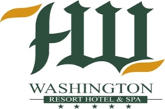
WASHINGTON RESORT & SPA
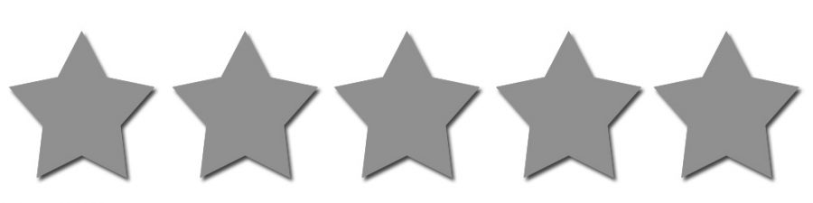

ULTRA ALL INCLUSIVE CONCEPT SUMMER 2025

ROOM
- Mini bar arrangement on the 1st day cans of beer and soft drinks *Efes®, Pepsi® and Cappy® Juice*; still water and sparkling water are replenished only first day
- Kettle + Tea & coffee set is refilled only fırst day
- Safe box free of charge (hotel doesn’t take any liabilities on guest’s belongings and valuables)

INTERNET
Wi-Fi at lobby is free of charge

OPEN BUFFET MAIN RESTAURANT “AMBER RESTAURANT”
Breakfast 07:00-10:00 (main restaurant Amber)
Late Breakfast 10:00-10:30 (main restaurant Amber)
Lunch 12:30-14:00 (main restaurant & terrace)
Dinner 19:00-21:00 (main restaurant & terrace & Botanic area)
Midnight snack 23:30-02:00 (main restaurant Amber)
Diet Buffet / Show cooking during breakfast/lunch/dinner *depends on Chef / Detox drink corner (main restaurant Amber)

DRINK SERVICE IN MAIN RESTAURANT
Breakfast Fruit juices / Hot beverages
Late Breakfast Fruit juices / Hot beverages
Lunch Soft & Hot beverages, local alcoholic drinks*
Dinner Soft & Hot beverages, local alcoholic drinks*
Midnight Dinner Soft drinks & water
* Alcoholic drinks according to the Concept

A’LA CARTE RESTAURANTS working from 01/06 till 30/09
(available for minimum 7 days stay / booking at least 2 days prior / according to schedule) Participation fee per person is 5 euros. Only people aged 7 and over are admitted.

- FISH restaurant (Fish/seafood cuisine) 19:00-21:00
- OSMAN restaurant (Turkish cuisine) 19:00-21:00
- ITALIAN restaurant (Italian cuisine) 19:00-21:00

A’LA CARTE RESTAURANTS Drinks service
Available local alcoholic drinks, soft drinks / hot drinks 19:00-21:00

BARS
LOBBY BAR 00:00-00:00 Import and local alcohol, soft drinks / hot drinks / alcoholic & non-alcoholic cocktails are available
BEACH BAR 10:00-18:00 Soft / Hot beverages & Local
alcoholic drinks*
POOL BAR 10:00-24:00 Soft / Hot beverages & Local
alcoholic drinks*
DISCO BAR 23:00-01:30 (3 days in a week) Soft beverages, Local alcoholic drinks and cocktails are free
* Alcohol drinks according to the Concept

SNACKS DURING THE DAY
- Snack Bar Restaurant 12:30-16:00
- Patisserie (hot beverages / types of coffee drinks /
Turkish coffee) 11:00-24:00
- Patisserie (sweet & salt pastries / biscuits / custards and puddings) 11:00-18:00
- Gözleme 11:30-16:00
- Ice cream (pool bar area) 13:00-16:00
- Import alcoholic drinks available in the lobby bar are included in the Concept
Johnnie Walker red label / J&B-Bell’s / Martini Bianco / Martini Rosso / Martini Dry-Campari / Smirnoff Vodka / Istanblue Vodka / Gilbey’s Vodka / Gordon’s gin / Gilbey’s gin / Captain Morgan / White rum / Baileys / Tequila Omega / Bottles of Wine / Champagne / Cocktails
- Orange juice is served for breakfast
- In Patisserie from 10⁰⁰ till 24⁰⁰ Turkish coffee is served
- Efes® beer and Pepsi® beverages are available in all bars
- Theme cuisine nights (Turkish / Fish )

FOR CHILDREN
- Mini Club 04-12 years
- Mini Disco / Mini Shows / playground
- 2 Children swimming pool
- Daily animation for children

SPORT AND FITNESS
- Turkish bath and sauna
- Aerobics, water gym, gymnastic, yoga, water polo
- 4 tennis court with concrete (hard) ground
- 2 swimming pools (2 with water slides)
- Basketball, beach volleyball, table tennis, boccia, darts
- Indoor swimming pool with Jacuzzi (seasonally)
- Fitness Center

ENTERTAINMENT
- Animation events and evening shows daily
- Disco at 23:00 till 01:30 / 3 days per week

ADDITIONAL FACILITIES
- Pool / beach sunbeds, umbrellas / tents, beach towels (every change is free)
- Conference halls and equipment (except LCD projector)
- Wireless Internet in the rooms and all areas

PAID SERVICES
Laundry and ironing services
- Special occasions organization / Birthday cake
- Billiards / Aero hockey / play stations
- Wi-Fi / Phone / Fax
- Doctor and Health Service
- SPA center treatments
- Hookah / fresh squeezed fruit juice
- Water sports (Jet Ski, banana, parasailing etc.)
- Alcoholic and non-alcoholic beverages not included in the Concept
- Room Service 24 /7 (Menu)
- Tennis court with lightening and equipment
- Shopping Center (market, shoes/bags, boutique, home textile, jeweler, hairdresser, leather, photo etc.)

NOTE
- pull down the beach sunbeds lower the line of beach bungalows is prohibited
- the beach décored swings can be used only for taking the photos
- if you have any allergies be sure to let us know while check-in
- iron is not provided
- you will be charged for any damage to the room
- please do not take food from the restaurant to the room
- Swim Up Room

