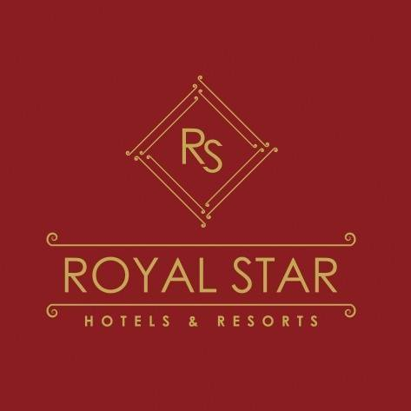
ALL INCLUSIVE INFORMATION
Dear Guest,

Thank you for choosing Royal Star Beach Resort as your holiday destination. Royal Star Beach Resort offers you a charming atmosphere where you can enjoy and relax at one of our pools or the Red Sea beach enjoying the sunny and warm weather. Please don't hesitate to contact us for any assistance and requests.
For more information or questions, we are always available

* Reception: Open 24H. Ext:
* Hotel doctor: Available 24H. Please contact the Reception. Ext.: 0
* Excursion: Please check with your tour operator

Opening hours of Restaurants and Bars:
* Aquila Restaurant Breakfast from 07:00 till 10:00
* Aquila Restaurant Lunch from 12:30 till 14:30
* Aquila Restaurant Dinner from 18:30 till 21:00

* Aquarius Bar Coffee and Snacks from 16:00 till 17:00

* Aquarius Bar from 10:00 till 24:00
* Beach Bar from 10:00 till 17:00
* El Omda Oriental Bar from 17:00 till 24:00

Dine Around Program
* Dragon Chinese Restaurant
* Dolce Vita Restaurant (Empire Hotel: Enjoy your dinner in the cozy atmosphere at our a la carte restaurant.
You receive a discount of 40 LE/adult and 10 LE/children 4-11 years, from 0-4 years free of charge.
Please reserve with our Guest Relation.
Food & Beverage Extras
Fresh juices, pop corn, ice cream in fresh corner, Shisha corner, Turkish coffee and imported alcohol

All Inclusive System starts from 10:00 till Midnight
* Check in Time after 14:00 pm.
* Check out time and delivering the room key card to reception is 12.00 pm
* Mini bar can be found in the room and is chargeable
* Wi-Fi free of charge in the Lobby
* Fitness Free in Empire Hotel from 08.00 to 20.00
* The Trixie Kids Club: Please contact the Trixie Club at our sister Empire beach Resort if you are interested.
* Diving Center: Empire Beach
* Animation: A program can be found in the room or contact our Guest Relation
* Shops: Mini Market and Souvenir shops
* Billiard: Free of charge
Room Key: In case of losing your room key, the amount of 10 $ will be charged
Beach Towel & Towel Card: In case of losing your towel or card, the amount of 10 $ will be charged
Beach towels are under your responsibility during the stay.
For Any Assistance & inquiries or emergencies dial # (0)
Hotel management wishes your good self a pleasant stay

