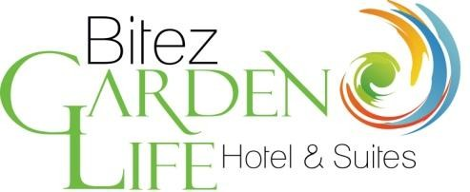

BITEZ GARDEN LIFE HOTEL & SUITES SUMMER 2024 FACT SHEET

Name of the hotel Bitez Garden Life Hotel & Suites
Category 4 stars
Pension All Inclusive

Introduction
Situated in the heart of history and nature, Bitez is the most preferred location for those who seeking peaceful surroundings. Modern interior design with a minimalist feel are complemented by the mandarin gardens all over the hotel area. Bitez Garden Life Hotel & Suites offers a lovely and friendly atmosphere which appeal to families, couples and groups who are looking for that little bit extra from their holiday.

Address Bergamut Street No: 52 Bitez-Bodrum
Telephone +90 252 313 11 11pbx
Fax +90 252 313 11 11
Website www.bitezgarden.com
E-mail sales@bitezgarden.com
Opening date 2006
Last renovated 2012 – 2017
Pets Not allowed
Languages Turkish, English, German
Beach 250 meter , Private (Foods&Drinks extra charge)

Transportation Dolmus: Bitez to Bodrum
Taxi: 24 hours / Bodrum-Milas Airport
Distance Bodrum City Centre 6 km Hospital 4 km
Airport 45 km
Historical Sights Bodrum castle, Amphitheater, Mausoleum
Dydime, Priene, Miletus, Ephesus, Aphrodisias, Pamukkale (Hierapolis)

Hotel amenities and services :

15.000 m² Landscape ground 24 hr Reception
Restaurant
- Bars
3 Swimming-Pools, 1 Pool has children section
Beach towels per Person will be obtainable free of charge every day at pool
Turkish Bath, Sauna, Steam room
Mini Market, Hairdresser, Photoshop, Children Playground
Wireless at all general area and all rooms
Internet terminal in Lobby
Laundry and Dry cleaning service 09:00 to 19:00 Nurse, Doctor on call

Reception :

24 hrs on service
English speaking personnel Exchange Service
Check-in at 14:00 at the earliest Check-out by 12:00 o’clock
Late departure: with charge until 17:00 maximum Luggage Service / Luggage Room
Credit cards: Visa, Master
Room key & payment card for extras

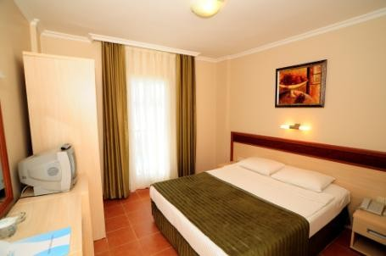

Accommodation :

Guest rooms are located in 2 storey block houses which are surrounded with olive and citrus trees and a colorful garden.

Total Number of Rooms | 183
Standard Rooms (15 – 21m²) | 155
Handicapped Rooms (21m²) | 2
Family Rooms(2+1) (40 m²- 45m²)  Family Rooms(1+1)( 25 m² -30m²) | 18  8

Room Facilities ;
In all rooms there are W-lan, telephone, mini-bar, hairdryer ,ceramics floor, lcd tv, Walk-in-shower and WC, split air- conditioning system, Luggage rack, Cots available, Balcony or french balcony.
Daily room cleaning, towel change – daily on demand and 2 times a week bedclothes change.
Room Capacity; Standard rooms 2-3 adults or 2 adults and 1 children Family rooms(1+1) 3 adults or 3 adults and 1 children
Family Rooms(2+1) 1 adults or 5 adults

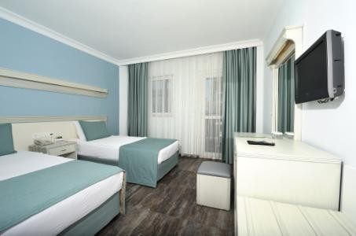

Food and Beverage :

Restaurant :

Main Restaurant

Bars :

Pool Bar / Offers non-alcoholic and alcoholic beverages
Garden Bar / Offers non-alcoholic beverages, snacks and coffee time Service Bar / Meal Times

Sports, Activities & Entertainment:

Soft animation, Daytime activities include pool games, darts, table tennis, billiard, aerobics and stretching. Mini Club from 4 to 12 years old in July & August. Several times a week a special show and live music.

ALL INCLUSIVE CONCEPT

Meals: | Hours: | Days: | Locations:
Breakfast | 07:30-10:00 | Daily | Main Restaurant
Late Breakfast | 10.00-10.30 | Daily | Main Restaurant
Buffet Lunch | 12:30-14:00 | Daily | Main Restaurant
Dinner | 19:00-21:00 | Daily | Main Restaurant
Snacks | 15:00-17:00 | Daily | Garden Bar
Coffee and Cookies | 17:00-18:00 | Daily | Garden Bar
Snacks (PİDE) | 12:00-14:30 | Daily | Snacks Bar

Bars: Hours:
Pool Bar 10:00-23:00
Garden Bar 12:00-18:00
Service Bar at Meal Times

** Local non-alcoholic and alcoholic beverages which are in our concept till 23:00. Mini-bar will be replenished with water only once at check in.

Sport & Entertainment Swimming pools (3), soft animation, aerobic & stretching,
pool games, table tennis, darts, billiard. Mini-club from 4 to 12 years old in July and August. Several times a week a special show and live music

Wellness Sauna, Turkish Bath, Steam Room

Extra Charge Imported Drinks, Energy Drinks, Fresh Juices, Turkish Coffee, Bottled Drinks, Massages & Peeling,
Laundry Service, Doctor, Shops

