p
Dear Valued Guest  Thank you for choosing our resort as a destination of your vacation Please allow us to share with you our Hard All-Inclusive Package especially created for your convenience  What is included?  Breakfast  Cascade&Panorama From 7.00 A.M Till 10.00 A.M  Late Breakfast  From 10.00 A.M Till 12.00 P.MServed Continental breakfast at Beach Bar And Aqua Park  Lunch  Cascade & PanoramaFrom 12:30 Till 15:00  Snacks  Snacks at the Beach Food Courtand in the Aqua ParkFrom 12:30 Till 17:00  Ice Cream  From 12.30.Till 15.00( at the Beach Bar )  During dinner in Panorama restaurant  Tea Time  From 16:00 Till 17:00 (Arena Food court)  Dinner  Cascade &PanoramaFrom18:30 Till 21:00  Late dinner from 23:00 till 1:00 in Arena food court  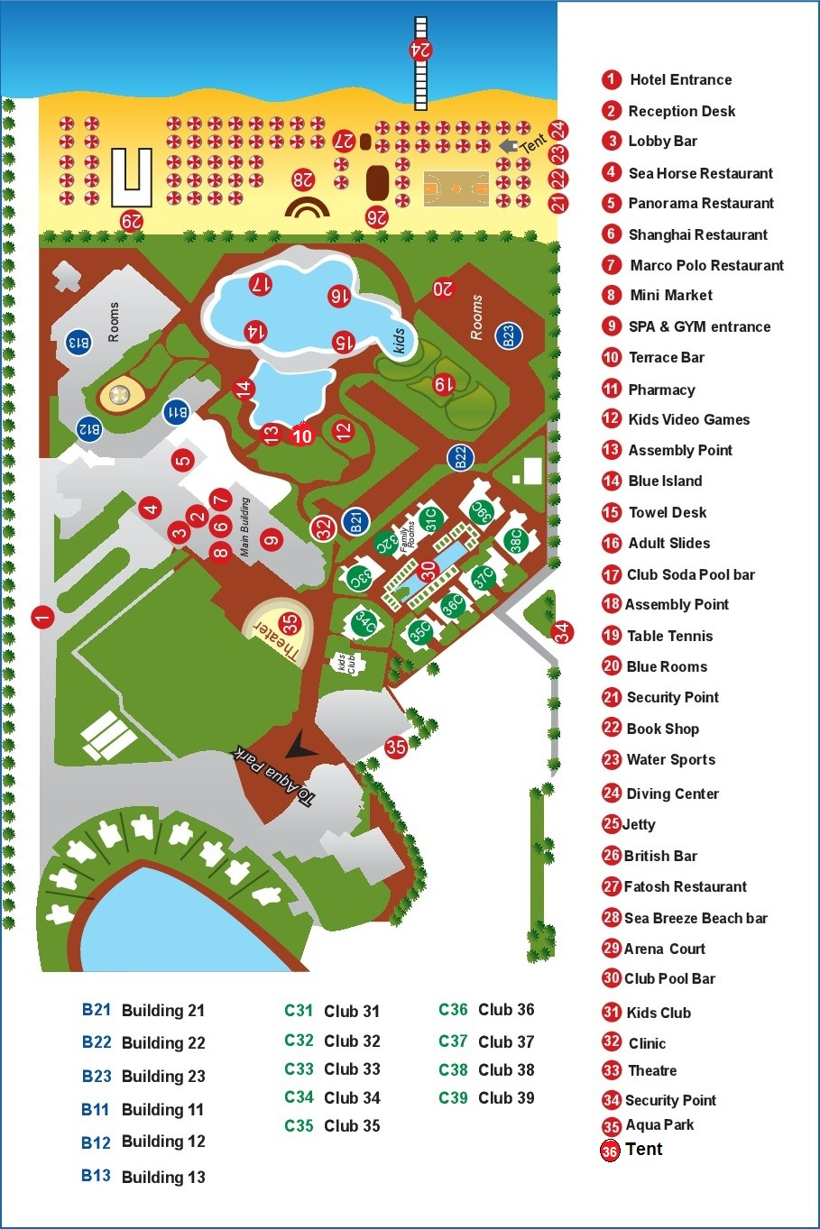 | Restaurants a la carte  One week stay includes one dinner in a la carte restaurant (Italian “Tuscany”, Indian “Taj Mahal or Grill Barbecue. Prior reservation is done by Guest Relation.  Vegetarians& Food allergic  For those who are vegetarians and those who has food allergy for any food items please contact Guest Relation, Front Office desk or Food and Beverage Manager  Beverages  Terrace Bar from 10.00 A.M till 23.00  Beach Bar from 10.00 A.M till 02:00  Aqua Park Bar from 10.00 A.M till 17:00  Club Bar from 10:00 till 17:30  Pool Bar From 10:00 till 17:30  Pasha coffee shop (Extra charge )  Lobby Bar served 24 hours (Extra charge )  Mineral water, soft drinks, juices, tea, coffee, local spirits, local beer (All beverages are served in glasses)  Items are not included  B Bar on the beach, Espresso, Cappuccino, fresh Juices, Turkish coffee, Shisha, Imported spirits, Any drinks by bottles, Mini bar, Room Service, Telephone, House doctor, Diving center, water sports, games, billiardtable, Spa, Sauna, Jacuzzi, Massage, Hairdresser and Beauty salon, Photographer , Laundry, shops  Telephone Directory  Reception & Operator 0  Guest relation 5  Concierge 4  Housekeeping 7017  Clinic through reception 0  limousine service: available at the lobby extra charge  MEDICAL SERVICE:  Doctor is available on call 24 hours call the operator (0), charges excluding the medicines, depends on guest medical insurance.  DIVING CENTRE & AQUA CENTRE  Located at beach area, open daily from 9:00 till 17:00  Internet –  free of charge in hotel area  ANIMATION & ACTIVITIES  Morning activities:  Daily animation activities from10.00 till17.00hr  Aerobics, water gym, beach volleyball, stretching, dancing  lessons, tournaments and other animation programs  KIDS CLUBfrom 10:00 to 13:00 AND from 15:00 to 17:00  GYM“Rock” from 09:00 to 13:00 AND from 15:00 to 19:00  Evening activities:  Mini disco & animation show from 20.30  till 23:00  A Q U A P A R K  Slides are operating DAILY FROM 10:00 Am till 13:00 and  from 15:00 till 17:00  Please follow the Aqua Park rules & make this adventure  Safe for You & Your children  Tel: (20) +2 0111 6937 222/333/ 444/ 666 - Fax: +2 069 3710276  E-mail: info@seabeachaquaparkssh.com  Web: www.seabeachaquaparkssh.com | WAKE-UP CALL  Dial “0” for Operator  To call room to room, dial 8 then the room number  R E C E P T I O N  Check-in time 14.00 Check-out time 12.00PM  Late check out charge  (upon availability on departure day)  Single room double roomtripleroom  from 13:00 till 15  including lunch 15$ 20$ 30$  from 13:00 till 18  including lunch 20$ 30$ 40$  from 13:00 till 22  including lunch 25$ 40$ 50$  and dinner  SAFE DEPOSIT BOX:  Available in all rooms free of charge.  The Management is not responsible for the loss of  any articles which have not BEEN LOCKED in the safe box.  KEY SYSTEM:  The key card is a power saver; it should be inserted in the slot next to your front door to connect the power.  We reserve the right to charge for LOST CARD $ 05.00 per room key card.  BEACH TOWELS:  In case of losing towel card you will be charged $10.00 per card. Please take your towels from Towel Center & get your towel card back before leaving.  YOUR BRACELET:  Return your bracelet back to the reception on your departure day maximum by 12.00 Non time  $10.00 charge for lost bracelet. Torn bracelet can be changed for free.  BANK: Cash machine is located in the lobby area  important: in case you have any kind of allergy, please inform our front desk  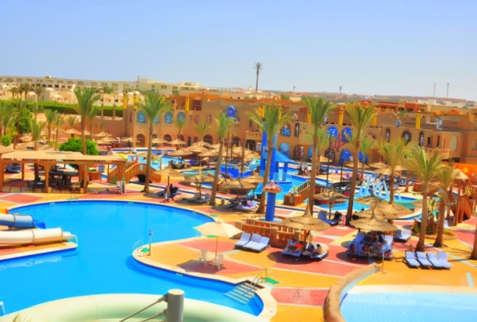  I M P O R T A N T NOTE  DO NOT PAY CASH IN ANY OUTLETS!  All checks for extras must be signed to your room account and to  be paid at the Reception one day prior to the check-out  For your safety, footwear is advised for stepping into the open  Sea, forbidden to touch the corals or step on them or take shells or  coral and feed fish  Swimming pool operation hours from 8.30 till sun set, children to be supervised by parents& Swimming after sun set is forbidden  Water Pipe is not allowed in hotel rooms  ALL INCLUSIVE IS VALID FROM 10.00 Am - 00.00 Midnight  