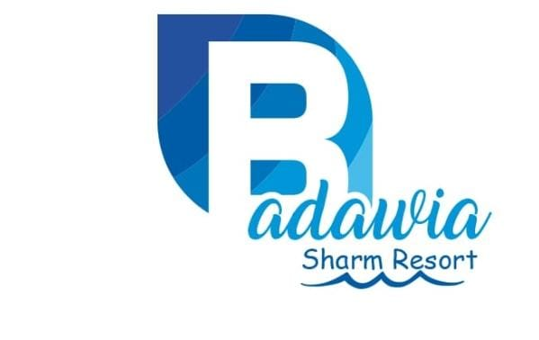

Badawia Sharm Resort

All Inclusive Guest’s Privileges

- Breakfast Buffet : From 07:00 to 09:00 hrs

- Lunch Buffet : From 13:00 to 15:00 hrs

- Dinner Buffet : From 19:00 to 21:00 hrs

- Beverage Service: From 10:00 AM TO 21:00 hrs
Local Wine during meals, Local Spirits, Soft Drinks, Tea and Coffee served in plastic cups at the following areas:

1- Las Palmas Bar "overlooking the Large Swimming Pool":
Open from 10:00 to 21:00 hrs
Guests to get their drinks at the Bar counter in plastic cups. Free

Guests to get their drinks at the Bar counter in plastic cups.
From 23:00 hrs onwards, any drinks order will be charged extra.

2-The Beach:
- No Alcoholics and no Food will be served at the Beach Area.
- BUS Beach 10.00 Till 14.00 PM
N.B.:
- Any Consumption of Full Bottles will be paid directly cash.
- No hot drinks served in the main restaurant during meals.
- No Room Service is included in this Package.
- Mini Bar service is not included in this Package.
- Fresh Juices are not included in the All Inclusive Package.
- All inclusive packages valid till 12 noon time on the day of the departure.
- All inclusive packages are available for you only and not allowed to invite anyone else.

**In case Of Damage or Lost:

-Room Key you will be charged 10 $.
-Towel card or Towel you will be charged 15$.

-Check in Time : 14:00.
-Check Out Time: 12:00.

- List of All Hotel Activities:
      - Water Ball : Free of Charge.
      - Billiard : L.E. 30 (05 $) / an hour
      - Animation Team

The Hotel Management wishes you a pleasant stay.

