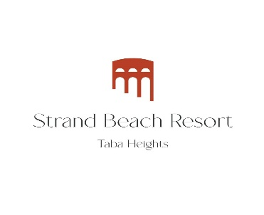
Dear Guest,
The management of Hotel Strand Beach Resort, Taba Heights would like to thank you for choosing our hotel to spend your vacation in holiday and wish you an unforgettable experience. The hotel management is honored to present an all-inclusive formula specially designed for you.

Restaurants & Bars

1-Main Restaurant
Located on the 2nd floor.
- Breakfast (Buffet with chef service) 07:00 -10:00
- Lunch (Buffet with chef service) 12:30-15:00
- Dinner (Buffet with chef service) 19:00-22:00
- In accordance with Covid-19 rules, cold / hot drinks are served in restaurants and bars in disposable cups.
- For early arrivals on the first day, breakfast will cost 240 Egyptian pounds per person.
- In case of having any food allergy, kindly, contact the restaurant manager.
- In case breakfast or lunch box is needed, kindly contact the tour representative or with reception desk prior 24 hours before the pickup time.

2-Lobby Bar (Cross Road.)
Located on the 3rd floor beside the reception.
- Open from 10:00 am to 23:00 (the all-inclusive system works from 10:00 to 22:00)
- From 22:00 to 23:00 (Extra Charge)
3-Splash Bar (pool bar) Located by the swimming pool.
- Open 10:00 AM till sunset.
- Ice cream from 15:30 till 17:00 for All-inclusive
- Light Snacks from 15:30 till 17:00 for All-inclusive
4- Lagoon Pool Bar, Located by the lagoon.
- Open 10:00 AM till Sunset.
- Late breakfast from 10:00 to 11:00 (Croissants, English cake, Danish pastry, Tea, and coffee) for all-inclusive

5- Arches Bar
- From 22.00 till 2.00 (Extra Charge – Adult Only)

Entertainment and activities
Fitness Center & Spa (as per Covid-19 regulations)
Located beside the main pool, on the 1st floor. Fitness room – open daily from 09:00 till 18:00. Free of charge.

Recreation Facilities and Animation (according to Covid-19 rules)
Daily entertainment by the pool animation team: bocce, darts, beach volleyball, table tennis.
Billiards - extra charge. (For more information, please contact the front desk).
Evening Performance in front of Reef bar every evening from 20:30 till 22:00 Evening Show start with Mini Disco for children at 20:30
Kids Club Open from 10:00 to 12:00 & from 15:00 to 16:00. The child is accepted from 7 years old to 11 years old.

Strand Beach Resort- Taba Heights – South Saini, Egypt
Tel: (20-65) 358 0300 Fax: (20-69) 358 0311
E-Mail: Reservations@tabaheights.com Website: http://strand.tabaheights.com
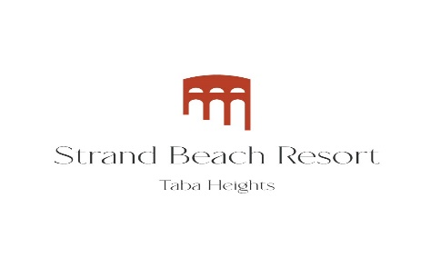

General Services
Safe  A safe is provided free of charge in the room. Please note that the hotel is not responsible for any loss of valuables outside the safe.  Room service  (ordering meals in the room). At extra charge. To order, contact the registration desk by dialing # 0. | Internet  Available for free throughout the hotel, network “Strand Tabaheights Wi-Fi / Strand Tabaheights Free  name: Room NO  password: Your first name “same as passport  The shops  Located on the 2nd floor next to the main restaurant.  Pharmacy, Bank, Shopping arcade are located on the territory of El Wekalla Up Town. You can get there using the free bus "Tuf-Tuf" on the territory of Taba Heights, for additional information, dial # 0 on the phone to contact the registration desk.

General information
- All Inclusive services are available at the hotel from 10:00 to 22:00.
- Wine & beer are served during lunch and dinner at the main restaurant. (For Hard All-inclusive system)
- Your All-Inclusive service ends on the last day of your stay at 12:00 noon.
- All services after 22:00 will be against extra charge.
- All-inclusive services are only valid for registered guests of our hotel and cannot be transferred to others.
- Hookah is provided with Extra Charge in the Oriental Corner only; hookah smoking in the room is prohibited.
- The hotel offers two free bottles of natural water, tea, and coffee facilities in the room daily.

Chargeable services
Fresh juice, room service (ordering meals in the room), Turkish coffee, all imported drinks, billiards, laundry service, medical treatment, all shops.

Dress Codes
Please comply with the general safety regulation by wearing the proper swimming wear for the usage of the hotel pools, swimming wear is not welcomed in all restaurants and the hotel lobby.

Sustainable Development Goals (Energy Saving)
Please, we need your help to protect the environment. When leaving the room, turn off electrical appliances, as well as remove the key card from the energy-saving switch.

Wishing you an unforgettable vacation!

Strand Beach Resort- Taba Heights – South Saini, Egypt
Tel: (20-65) 358 0300 Fax: (20-69) 358 0311
E-Mail: Reservations@tabaheights.com
Website: http://strand.tabaheights.com

