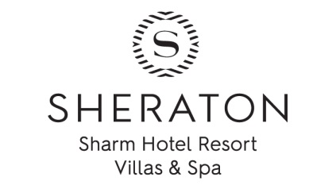
Preferred All-Inclusive Concept
MEALS
WHEN | WHERE | WHAT
06:30 – 10:30 | White Cruiser | Breakfast (buffet)
10:30 – 12:30 | Pool Bar, Lobby bar | Snacks
12:30 – 15:00 | White Cruiser | Lunch (buffet)
15:00 – 17:00 | Pool Restaurant | Snacks
19:00 – 22:00 | White Cruiser | Dinner (buffet)
19:00 – 22:00  19:00 – 22:00 | Portofino Restaurant (Italian cuisine) | Some items are included and some with extra supplements.  Reservation is required till 13:00.
 | Dar El Qamar Restaurant (Lebanese & oriental cuisine)
 | Pool Restaurant (International cuisine + sea food)

Beverage | Additional F&B services
Lobby Bar : 09:00 - 24:00 free  24:00 – 09:00 extra fees | Room service 24hours
Pool Bar: 10:00 till sunset  Free Ice Cream for children up to 14 years old at Pool Bar from 13:00 till 15:00 | Pool Restaurant (International cuisine, a la carte restaurant): 12:00 – 17:00
Hugo’s Bar: 10:00 till sunset
Cave Bar: 12:00 till 16:00

General Regulations:
- All Inclusive Package/ Privileges start from Lunch on the arrival day and end by Breakfast on the departure day.
- Check-in time is 15:00, and Checkout time is 12:00.
- In case you need to extend your room after 12:00, kindly contact the front desk in advance.
- Failing to return back the room key to the reception by 12:00 on the departure day will be subject to extra charge.
- Following beverage items will be served by glass from above designated outlets: Mineral Water, Soft Drinks, Juices, Tea and Coffee (Turkish coffee is subject to extra charge), local alcoholic spirits (Gin, Whisky, Vodka, Rum), Beer, Wine.
- Glasses, bottles, cans, any fruits and food are not allowed to be taken away from the restaurants and bars.
- All Inclusive benefits are not transferable to any other guest.
- Some ice cream brands are subject to extra charge.
- The hotel management reserves the right to stop serving any guest under the influence of alcohol.
- As we do have third party sellers on the beach, in case you are not interested to have an idea about products they sell while you are resting on the beach kindly refer to the towel center & get red flag (do not disturb sign).
- In case you have any special food request (diet, allergy, personal preferences) kindly inform the restaurant manager.
- The management reserves the right to modify or suspend the operation at any outlet due to the business levels.
For any additional information, please do not hesitate to contact Reception Ext: (0)

