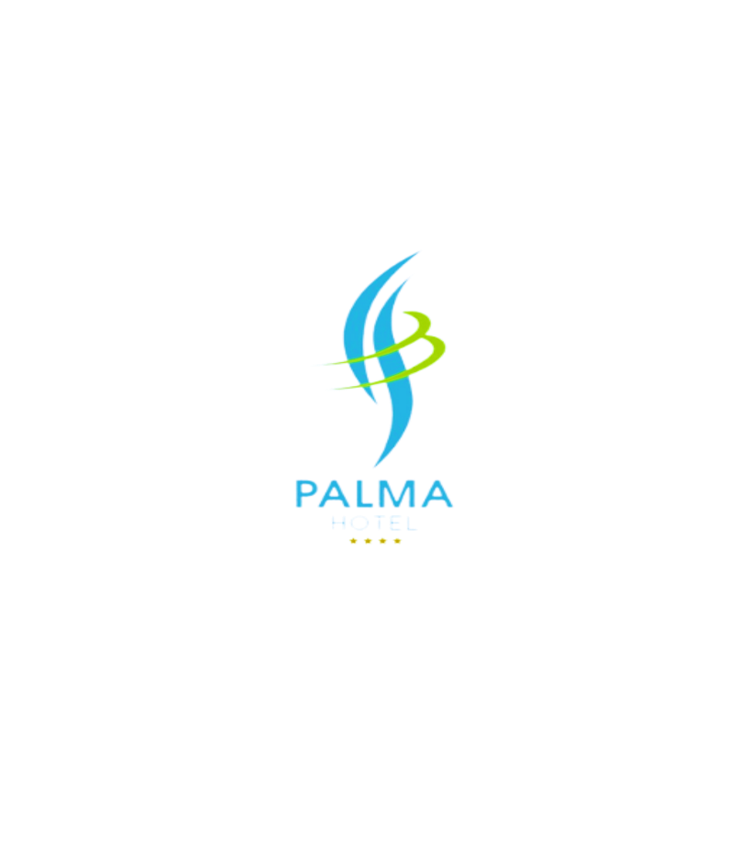
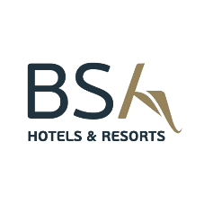

General information

The 4-star hotel “Palma” is located in a green and quit area, in the very center of Golden Sands, only 300 meters away from the beach, offering its guests excellent conditions for a comfortable vacation.
• All-Inclusive base • Main restaurant • Lobby Bar • Pool Bar • Free Wi-Fi access on the territory of the hotel and in the rooms
• Parking • Taxi and Rent-a-car service • Organization of transfers and excursions
• Beach – 300 m away • 18km away from Varna • Varna Airport – 30 km away
• We speak: Bulgarian. English, German and Russian • 24-hour reception service and 24-hour security

Paid services

• Parking – 15BGN/day • Safe ( at The Reception) • Imported drinks and packaged foods at the Lobby Bar • Transfers from/to Varna Airport • Late Check-Out – if possible, with prior request

Sport and entertainment

• 2 outdoor swimming pools • Gym • Multifunctional sports hall • Table tennis • Outdoor sports ground • Daily and evening animation – six days per week • Board games

For children

• Swimming pool with children section and water slide • Outdoor mini club next to the pool • Outdoor playground • Children animation and mini disco • High chairs for babies ( in the restaurant )

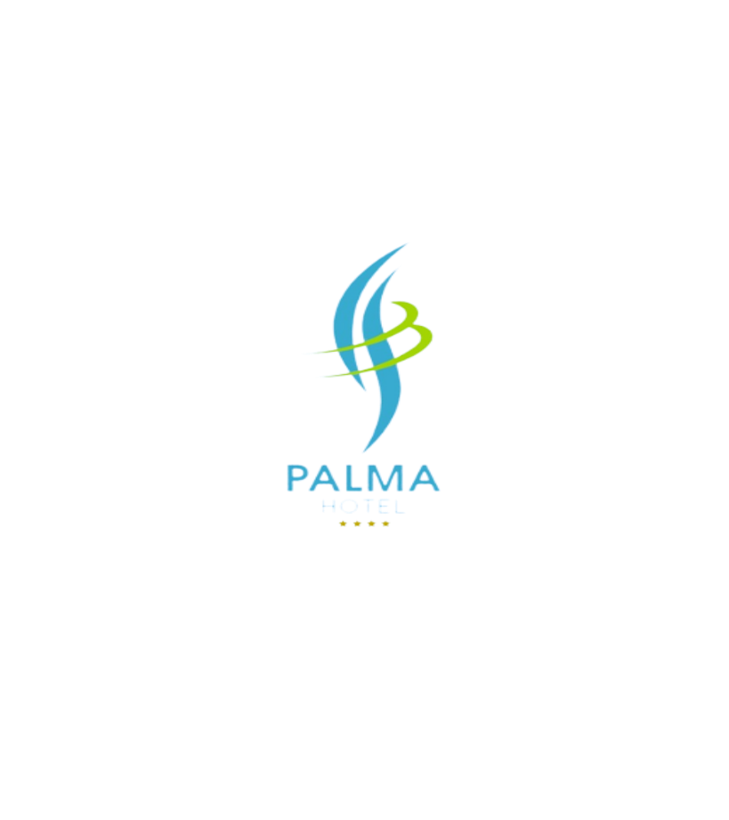

Accommodation

◊ Check – in time: from 14:00h ◊ Check-out time: until 12:00h

• Cozy and spacious rooms • Daily cleaning • Central air conditioning • Hair-dryer • Telephone • Electric kettle • Refrigerator • TV SAT in each room • Free Wi-Fi access

- Economy room – capacity 2+0 30m²
- Double standard room – capacity 2/2+1/3+0 30m²
- Studio – capacity 2/2+1/2+2/3+1/4 35-45m2
- One – bedroom apartment – capacity 3/3+1/3+2/3+3/4+1/4+2/5+1/6 70m²
- Two – bedroom apartment – capacity 4/4+1/ 4+2/ 4+3/ 5+1/5+2/6/6+1/7 85m²
Early check – in and late check – out are subject to hotel occupancy and at an additional cost!

All – Inclusive accommodation
Main Restaurant
Buffet breakfast* from 7:30h until 10:00h
Buffet lunch* from 12:30h until 14:30h
Buffet dinner* from 18:30h until 21:00h

*local soft drinks, tea and coffee, draft wine and beer are available the main meals
* feeding people with food allergies included

Afternoon snacks from 16:00 until 17:00 Main Restaurant
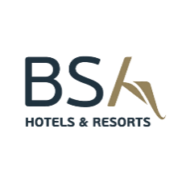
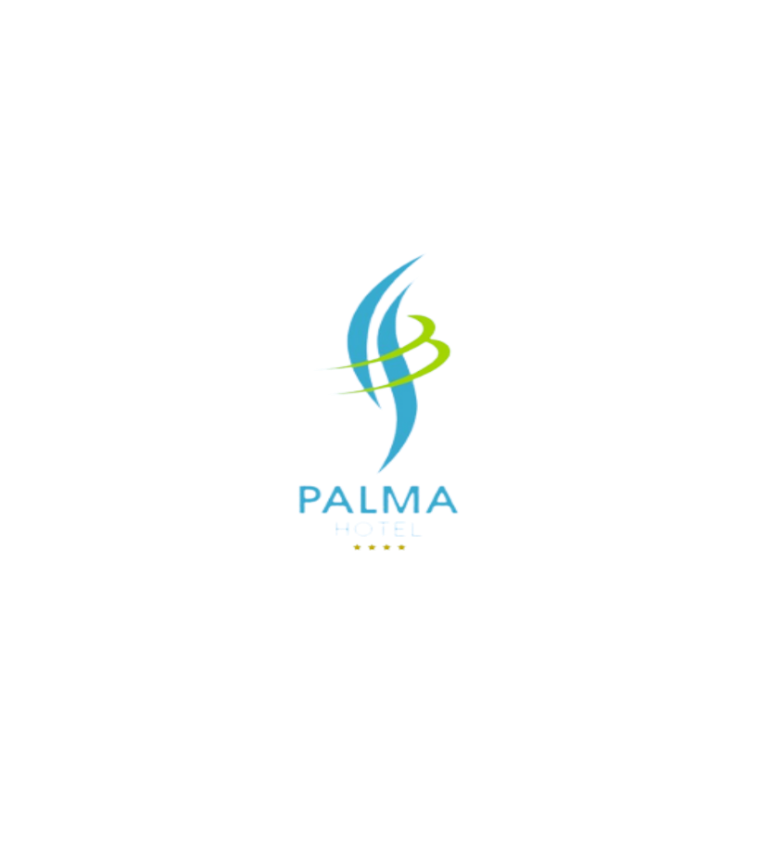

Bars
Lobby Bar from 8:00h until 00:00h
*All inclusive drinks are available from 10:00h until 22:00h

The menu with All-Inclusive non-alcoholic drinks includes: Bulgarian soft drinks, table and sparkling water, cocktails, coffee and tea.
The menu with All-Inclusive alcoholic drinks includes: draft beer, Bulgarian alcoholic drinks, cocktails with Bulgarian alcohol, draft wine.

Pool Bar
The menu with All-Inclusive alcoholic and non-alcoholic drinks includes: coffee, tea, juice from cold ring, Bulgarian draft alcohol and soft drinks.

Other
If necessary, the hotel reserves the right to change the described information!
Pets are not allowed.
Guests must provide a valid photo ID upon check – in.
According to Bulgarian legislation, smoking is not allowed in the closed parts of the hotel – lobby, bars and restaurants.

