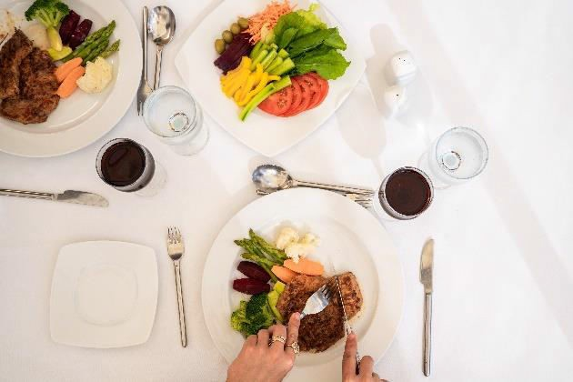
Dear Guest,

Welcome to

Novotel Sharm El Sheikh is a premium resort that became a landmark in the destination through unique location, services and facilities. Peaceful atmosphere and warm hospitality make any stay an unforgettable experience.

Please be informed that you will enjoy the following during your stay on all Inclusive basis and our team will be at your disposal at any time to answer your specific requests.

RESTAURANTS & BARS:
- LA PALMA Restaurant:
Located in the main building of the Palm resort. Open buffet (Breakfast, lunch and dinner).

Breakfast : from 06:30 to 10:00
Lunch : from 12:30 to 15:00
Dinner : from 18:30 to 21:30
Food to be consumed only inside the restaurant and dishes not be taken out of the venue
-meals at coral restaurant (Beach side) will be with extra charge with amount of 3 USD per person per meal

A-la-carte Restaurants:
(AL Dente Italian & Al Sharqi Oriental Restaurants) located directly on the beach. (Against Charge)
Open from 12:30 to 17:30 and from 19:00 to 23:00.

Bubbles BAR:
Located in front of La Palma Restaurant. Open from 09:00 until 23:00

BEACH BAR:
Located directly on the hotel beach. Open from 09:00 till sunset

SNACKS:
Food and beverages refreshers are presented at the beach area and at Bubbles Bar from 15:30 till 17:00

Happy Hour: from 16:30 to 18:30

BEVERAGES:
Mineral water, soft drinks, canned juices (by glasses), Nescafe, Tea, Hot chocolate

Local Beer, Local Spirits (Gin, Vodka, Rum, Brandy) served by Glass

Local wine served by glass in La Palma restaurant during lunch and dinnertime.

Espresso coffee, freshly squeezed juices, all local and imported alcohol, imported wines and Champaign- are available against charge

KIDS’ MEALS:

Kids are enjoying their kid’s menus with its rich and varied items (Pizza, mini burger, chicken fillets) at the same operating hours of LA PALMA Restaurant.

Service/ Activates available at charge:
  - Room Service 24 hours
  - Al Dente Italian & Al Sharqi Oriental Restaurants (Lunch and dinner)
  - Mini Bar upon request
  - Laundry and press service

Room notes: Due to the status Quo and for our guest’s safety, a complimentary branded hygiene related amenities have been placed in the room once per stay.
  - Free coffee tray offered with a daily replenish in all guest rooms.
  - Three complimentary water bottles per Room replenished daily.
  - Digital safe box is available in all guest rooms
  - Iron and ironing machine is available upon request.

Entertainment:
  - Movie nights besides Sports matches broadcasting are available in the pool bar terrace on daily basis.
  - Gym is working 24/7
  - Spa from 08:00 to 21:00
  - Tennis (against Charge ) for booking please contact reception

Kids Club

Located at the Novotel Palm Area. Welcome all children from 04 to 12 years old

Handcraft activities, pool and beach games, accrobranching. Rollers, drawing and painting, circus school, origami, bingo, etc.

Open from 09:00 to 12:00 and from 14:00 to 16:30

Mini disco at 20:30 daily at Novotel Beach in the pool bar area and Novotel Palm

Medical Service:
Hotel doctor is available on call 24 hours at reception. Doctor visit for charge excluding medicine

All Inclusive program starts at 14:00 (Check in time) and ended at the departure day 12:00 noon (Check out time), the bracelet has to be handed out to the reception at 12:00 noon on your departure

