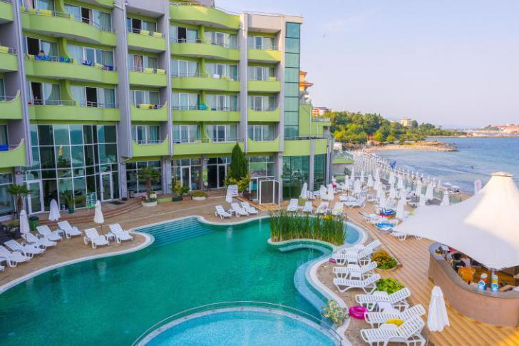

MPM Hotel Arsena ****

Address: Bulgaria, www.mpmhotels.bg GPS coordinates:

Longitude 42. 39404° Latitude 27. 42972°

MPM Hotel Arsena – on the

edge of the fine sandy south beach of Nessebar.

MPM Hotel Arsena welcomes its guests in 130 decorated in bright colors rooms. Participate in the leisure activities for all ages, kids entertaining club and animation, as well as variety of evening entertainment shows for all tastes.

MPM Hotel Arsena operates on Ultra All inclusive Basis. Our guests enjoy daily meals in the main restaurant with an open air terrace. Refreshing drinks are served in the Lobby and Pool bar, which also takes care of the snacks 3 times daily. Stay in touch with family, friends and business with the complimentary WIFI provided in the reception area.

For Your comfort in MPM Hotel Arsena, there is an outdoor swimming pool with kids section, sun lounges, parasols by the pool. Stay fit with our fitness, sauna and steam bath. In addition to, treat yourself and beloved ones in our beauty and body treatment area.

Parking is also available at extra charge.

MPM Arsena Hotel operates on Ultra All inclusive Basis .

Catering facilities:

- Main restaurant with an open air terrace

- Pool bar

- Lobby bar

- Beach bar

For Your comfort at Hotel MPM Arsena:

•Outdoor swimming pool with children section; •Indoor swimming pool;

•Sun lounges and parasols by the pool;

Sun lounges and parasols on the beach

•Sun terrace of the hotel overlooking the sea;

•Complimentary WIFI – lobby, reception and pool area; •Kid’s play room;

•Mini club;

•Entertainment evening programs;

•Performance and entertainment stage with seating area; •Fitness, sauna, steam bath;

•Aerobics and aqua gymnastics, Pilates, darts, table tennis •Parking – charged locally

•MPM ARSENA BEAUTY and BODY treatment area /extra charge/ •Safety deposit boxes /extra charge/
