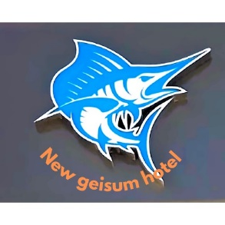**All - Inclusive Formula**

Everywhere inside the hotel (Lobby Bar – S.Pool Bar – Main Restaurant).

Bars

▪ S. Pool Bar from (11:00 till 17:00 )

▪ Beach Bar From (11:00 till 17:00)

▪ Lobby bar from (18:00 till 23:00)

▪ Main Restaurant:

▪ Breakfast 07:00 H. until 09:30 H.

▪ Lunch 13:00 H. until 15:00 H.

▪ Dinner 19:00 H. until 21:30 H.

▪ Snacks 16:00 H. until 17:00 H on pool bar

Beverage allowed

▪ Cola – Fanta – Sprite – Soda –2 kind powder juice & M. Water.

▪ Tea – Coffee – Hot Chocolate & Herbs

▪ Local Beer–Local Whiskey –Local Rum – Local Ouzo-Local Vodka

- Coffee Break from 4-5 PM daily,

- Water ball . Darts