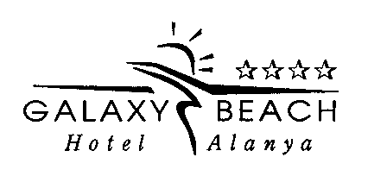
Dear Guests,
The Hotel Galaxy is situated 14 km to Alanya and 135 km to Antalya Airport.The Hotel has 116 rooms.The front block has 75 rooms with a direct or side sea view.
All our rooms have a minibar,satellite TV,air conditioning,constant hot and cold water,direct telephone,safe and a hair dryer.The Hotel also offers a bar,market,laundry,24 hours room service, security and hot water, generator,table tennis,billards,open pool,child pool,sauna,Turkish Bath,fitness center,massage facility,doctor,animation services and two lobbies for our valuable guests.The Hotel also has a private beach reached by a private road(30 meters).
We invite you to relax and enjoy yourself.
ALL INCLUSIVE
Hotel check-in time is 14:00 Check-out time is 12:00
FOODS
Breakfast : 07:30-09:30 open buffet Roof Restaurant
Late Breakfast : 09:30-10:00 open buffet Roof Restaurant
Lunch : 12:30-14:00 open buffet Roof Restaurant
Coffee Break : 17:00-17:30 Lobby&Pool Bar
Dinner : 19:00-21:00 open buffet Roof Restaurant
DRİNKS
Galaxy Pool Bar : Local drinks ( beer,wine,rakı,votka,cin) are free between 10:00-23:00. (12:30 to 13:30 and from 18:30 to 20:00 hours bar is close for preparation and cleaning generally)Export drinks,fresh orange juice,fruit juice with bottle,cocktail,Türkish Coffee,wine bottle are with extra payment.All drinks are with price after 23:00.

Galaxy Terrace Bar : During the lunch and dinner time open
Room Service : With extra payment.
Minibar : With extra payment.
Beach Bar : Soft drinks,tea,coffee free.Other drinks with extra payment.
ACTIVITIES WITH PRICE
Health service(doctor), massage, billiard, safe box (ın the room 20€), telephone, mattres (on the beach),export drinks, drinks with bottle, minibar, fresh orange juice, cocktail, Turkish Coffee, laundry, ironing, market,internet (room 3euro pd), Turkish Bath, sauna, beach towel rental (Fees are available at the reception.3euro).Late c-out 30€.
FREE ACTIVITIES
Beach volleyball, beach football, , fitness center,backgammon,chess, dart, chaise langue, umbrella, table tennis,internet (lobby)
SWİMMİNG POOL
Our pools are open between 08:00 and 19:00. Pool chlorine spraying is done at 20:00.
Outdoor pool depth 1.40-1.55 m. Children's pool depth 0.35 m.
CLEANİNG SERVİCE
Rooms are cleaned every day between 09:00 and 16:15 in our hotel. Room towels and linens are changed once in three days. You are kindly requested not to take the towels out of the rooms. Our hotel is not responsible for valuables in the rooms.
Best regards…

