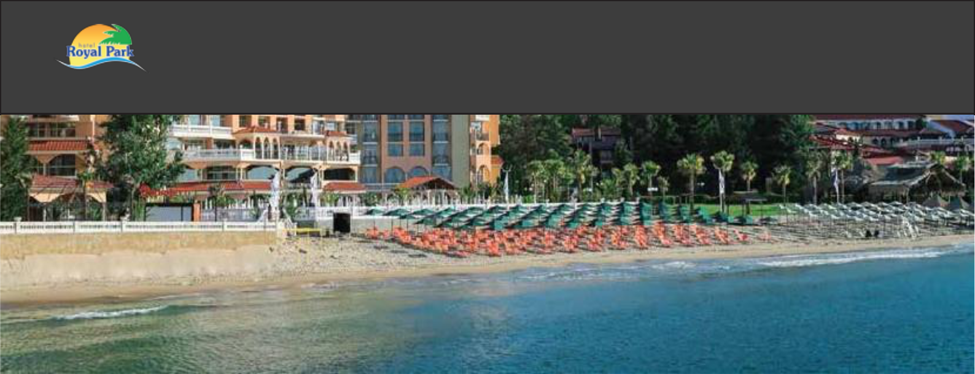
Hotel Royal Park

LOCATION & DISTANCE

- GPS coordinates| 42.704520, 27.817700

- Airports| Burgas - 36 km | Varna - 107 km | Sofia - 423 km

- Bus station | Sunny Beach - 7 km | Elenite Bus Stop - 1 km

- Beach| 50 m from Beach Elenite ( on first line)

HOTEL DETAILS

- Categorization | 4 stars

- Area| 4500 м2

- Year of building | 2004

- Number of floors | 11, 1 building

- Number of elevators | 4

- Bord | All Inclusive

RECEPTION

- Working hours | 24 h

- Check-in | After 14:00 h

- Check-out | By 12:00 h

- Early check-in | Upon availability

- Late check-out | Upon availability | Extra charge

- Lugage storage | Free

- Payment | Cash or Credit Card

- Credit Cards| | Visa и MasterCard

INTERNET

- Price | Free

- Lobby & reception only

- Speed| Base

PARKING

Price | 15.00 BGN per day, per car. ♦ Parking spaces | Subject to availability

- Info | It is located at the entrance of the complex. No cars are allowed inside ♦ Reservations | Not possible

OTHER SERVICES | Extra charge |
^{Resort} ♦ Shops| General & souvenirs

♦ Medical services
♦ Currency exchange

CHILDREN

- High chairs in restaurant | Free| Upon request

- Baby cot | Free | Uppon request

- Children club | Free | Resort

- Outdoor playground | Free | Resort

PET POLICY

- Dogs | up to 5 kg| Price| 25.00 BGN, per day, per pet

RESTAURANTS

- Main restaurant ♦ Italian à la carte restaurant | Resort

BARS

♦ Lobby bar ♦ Pool bar

POOL
♦ Outdoor pool| 120 m3 | ♦ Aqua park | Resort
♦ Sunbed and umbrella by the pool /subject to
 | ♦ Beach | 50 m from the hotel, public and unguarded
availability/

SPORT

♦ Tennis | Resort | ♦ Mini golf | Resort

- Gym and Table Tennis | Resort

*More detailed information about the locations and services, as well as their working hours - please see the description of the All Inclusive Package at: https://victoriagroup.bg/hotel-packages-descriptions/?lang=en

Version: 16.01.2023 |The hotel reserves the right to make changes. |Please, always double-check if you are using the latest version at www.victoriagroup.bg/fact-sheets-hotels/?lang=en

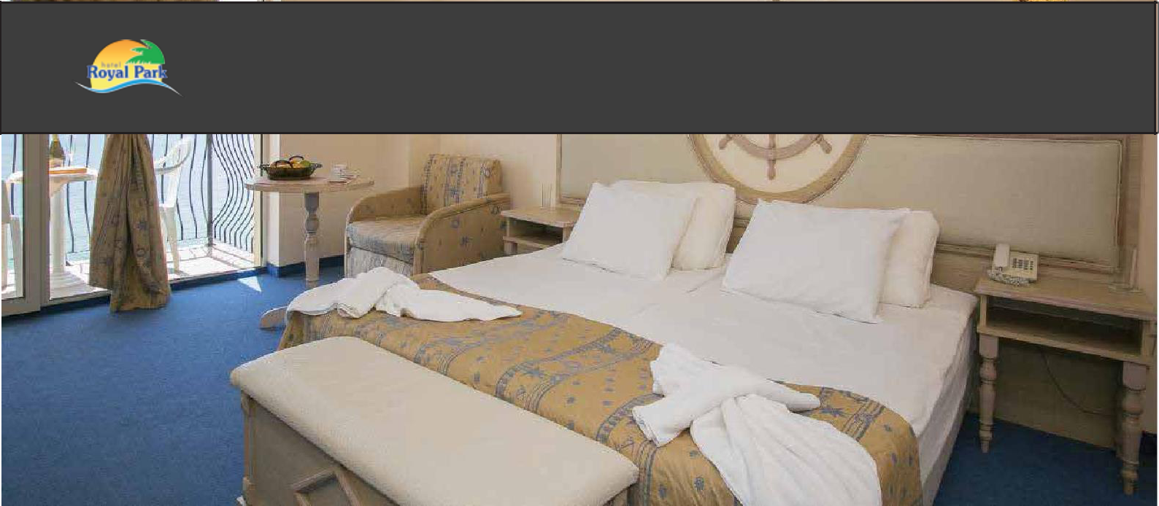
Hotel Royal Park

ROOM FACILITIES
♦ Air Conditioning | Self-management ♦ Hair-dryer

♦ Phone ♦ Private bathroom | Shower or bathtub

♦ TV ♦ Toiletries | Single time

♦ Cable TV ♦ Iron | Upon request at reception

♦ Safe box ♦ Room cleaning | Daily

♦ Floor | Carpet ♦ Towel change | Daily

♦ Mini fridge ♦ Towel change | Every two days

DOUBLE ROOM

- Number | 382

- Size | 30 sq.m

- View | Sea or Park

- Min. capacity | 2

- Max. capacity | 2 +2

- Premises | 1 bedroom and

1 bathroom

- Type of beds | two single beds (separated or connected as double bed) and a sofa bed
and / or extra bed

- Terrace

STUDIO

- Number | 62

- Size | 42 sq.m

- View | Sea or Park

- Min. capacity | 2

- Max. capacity| 3 + 2

- Premises | 1 bedroom with living room area, 1 bathroom

- Type of beds | two single beds (separated or connected as double bed) and a sofa bed

and / or extra bed

- Terrace

TWO-BEDROOM STUDIO

♦ Number | 47 ♦ Type of beds | 2 x two single

♦ Size | 52 sq.m beds (separated or

♦ View | Sea or Park connected as double bed)

♦ Min .capacity | 4 and a sofa bed

♦ Max .capacity | 4 + 1 and / or extra bed

♦ Premises |2 bedrooms| ♦ Terrace

Living room area & 1

bathroom

ALL INCLUSIVE PACKAGE DESCRIPTION
Please check and All-Inclusive Package Description at : www.victoriagroup.bg/hotel-packages-descriptions/?lang=en. Always use both files

HIGH-RESOLUTION PHOTOS
Download high resolution photos at: www.victoriagroup.bg/media//?lang=en

@royalclubvictoriaelenite

Version: 16.01.2023 |The hotel reserves the right to make changes. |Please, always double-check if you are using the latest version at www.victoriagroup.bg/fact-sheets-hotels/?lang=en

