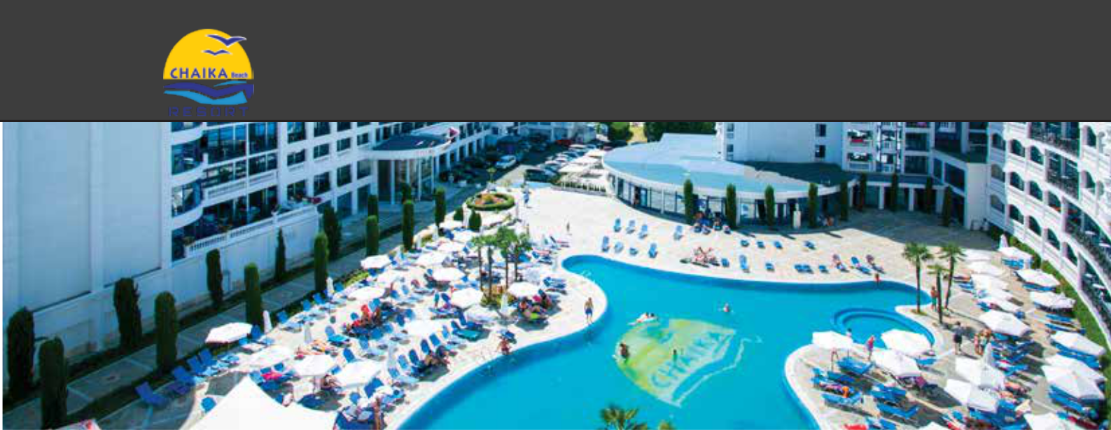
CHAIKA BEACH RESORT
/

LOCATION & DISTANCE

- GPS coordinates | 42.698965, 27.717091
- Airports | Burgas - 28 km| Varna - 98.4 km|Sofia - 414 km
- Bus station | Bus station Sunny Beach - 1.5 km
- Beach | Hotel is located on first line| Beach Chaika : 0,1 km| Beach Dune - 0,3 km|

HOTEL DETAILS

- Categorization | 3 stars

- Area | 19000 м2
- Year of building | 2000
- Bord | All Inclusive

- Buildings | 3 | Chaika | Arcadia | Metropol

- Floors | 9 Chaika |6 Arkadia | 12
Metropol

- Elevators |3 Chaika | 2 Arkadia | 2

Metropol

RECEPTION

- Working hours | 24 h
- Check- in | After 14:00 h
- Check-out | By 12:00 h
- Early check-in| Upon availability

- Late check-out | Upon availability | Extra charge
- Lugage storage | Free
- Payment | Cash or Credit Card
- Credit Cards| Visa & MasterCard

INTERNET

- Price | Free
- Lobby & reception only
- Speed| Base
- High-speed Internet | Price- 7.20 BGN per day, per device

PARKING

Price | 20.00 BGN per day, per car. ♦ Parking spaces | Subject to availability ♦ Reservation | Not possible

OTHER SERVICES | Extra charge

♦ Rent-a car | ♦ Shops| General & souvenirs
♦ Medical services
♦ Currency exchange

CHILDREN

- High chairs in restaurant | Free| Upon request

- Baby cot | Free | Uppon request
- Outdoor playground | Free |

PET POLICY

- Dogs | up to 5 kg| Price| 25.00 BGN, per day, per pet

RESTAURANTS

♦ Main Restaurant ♦ Snack restaurant Metropol ♦ Mediterranean a la carte restaurant Metropol | Minimum 4 nights

BARS

♦ Pool bar Arcadia ♦ Irish Bar

POOL & BEACH

♦ Beach | Хотела се намира на 1-ва линия | Обществен плаж ♦ Sunbed and umbrella on the beach |External service |

♦ Outdoor pool | Преден 350 м3 , Заден 520 м3 Extra charge
♦ Sunbed and umbrella by the pool | subject to availability/

*More detailed information about the locations and services, as well as their working hours - please see the description of the All Inclusive Package at: https://victoriagroup.bg/hotel-packages-descriptions/?lang=en

Version: 20.05.2021 |The hotel reserves the right to make changes. |Please, always double-check if you are using the latest version at www.victoriagroup.bg/fact-sheets-hotels/?lang=en

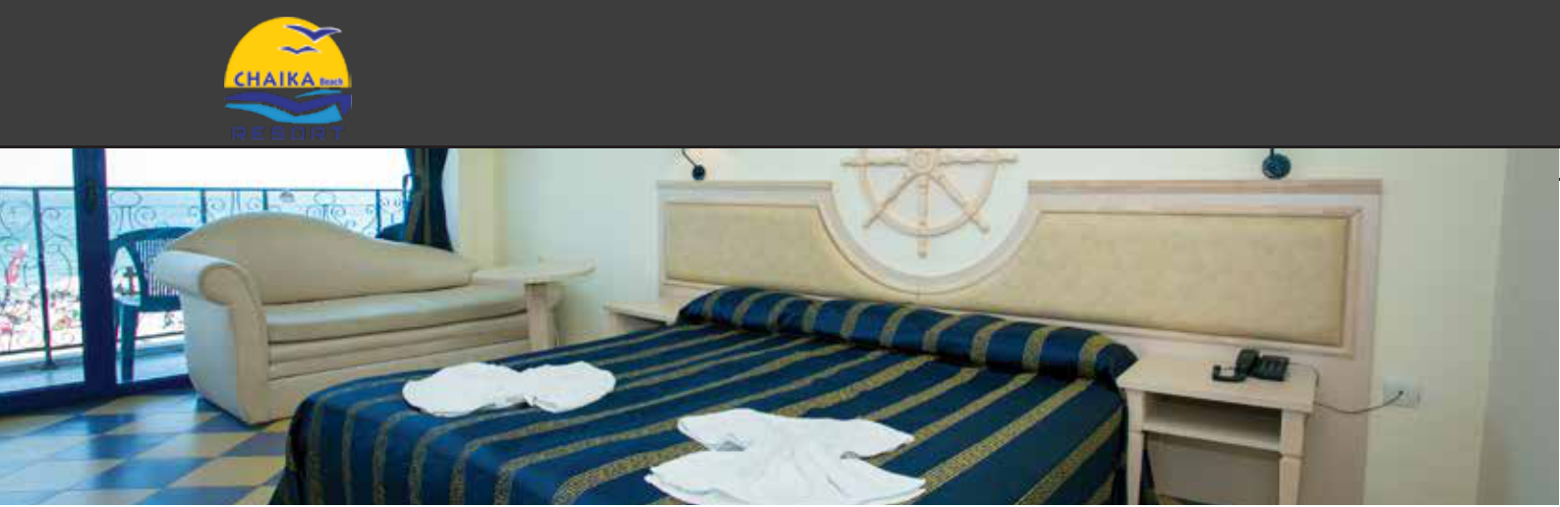
CHAIKA BEACH RESORT

ROOM FACILITIES
♦ Air Conditioning | Self-management | ♦ Hair dryer
♦ Phone | ♦ Private bathroom | Shower or bathtub
♦ TV | ♦ Toiletries | Single time
♦ Cabple TV | ♦ Iron | Upon request at reception
♦ Safe box | ♦ Room cleaning | Daily
♦ Floor | Metropol - Carpet | Chaika & Arcadia - tiles | ♦ Towel change | Daily
♦ Mini fridge | ♦ Towel change | Every two days

DOUBLE ROOM METROPOL NO BALCONY

♦ Number| 65 | ♦ Type of beds | two single
♦ Size | 22-28 sq.m | beds (separated or
♦ View | Park | connected as double
♦ Min. capacity | 2 | bed) and a sofa
♦ Max.capacity | 2 +1 | armchair / sofa bed
♦ Premises | 1 bedroom and
1 bathroom

DOUBLE ROOM METROPOL

♦ Number| | 127 | ♦ Type of beds | two single
♦ Size | 22-28 кв.м | beds (separated or
♦ View | Парк | connected as double bed)
♦ Min. capacity | 2 | and a sofa armchair /
♦ Max.capacity | 2 +1
 | sofa bed
♦ Premises | 1 bedroom and
 | ♦ Terrace
1 bathroom

DOUBLE ROOM CHAIKA

♦ Number| | 407 | ♦ Type of beds | two single
♦ Size | 22-28 кв.м | beds (separated or
♦ View | Парк или Море | connected as double bed)
♦ Min. capacity | 2
 | and a sofa armchair / sofa
♦ Max.capacity | 2 +2
 | bed
♦ Premises | 1 bedroom and
 | ♦ Terrace
1 bathroom

♦ There is 1 disabled room with Sea view

DOUBLE ROOM ARCADIA |  |  | STUDIO CHAIKA |  |  | STUDIO ARCADIA | ♦ Type of beds | two single
 | ♦ Type of beds| two single |  | ♦ Number| | 29 | ♦ Type of beds | two single |  | ♦ Number| | 29
♦ Number| | 210 |  |  |  |  |  |  | beds (separated or
♦ Size | 22-28 кв.м | beds (separated or |  | ♦ Size | 38-45 кв.м | beds (separated or |  | ♦ Size | 38-45 кв.м | connected as double bed)
♦ View | Парк | connected as double |  | ♦ View | Море | connected as double bed) |  | ♦ View | Парк | and a sofa armchair / sofa
♦ Min. capacity | 2 | bed) and a sofa |  | ♦ Min. capacity| 2 | and a sofa armchair / |  | ♦ Min. capacity| 2 | bed
 |  |  | ♦ Max.capacity| 2 +2 |  |  | ♦ Max.capacity | 2 +2
♦ Max.capacity | 2 +1 | armchair / sofa bed |  |  | sofa bed |  |  | ♦ Terrace
♦ Premises | 1 bedroom and |  |  | ♦ Premises | 1 bedroom, |  |  | ♦ Premises | 1 bedroom,
 | ♦ Terrace |  |  | ♦ Terrace
1 bathroom |  |  | living room area and 1 |  |  | living room area and 1
 |  |  | bathroom |  |  | bathroom

SUITE ARCADIA |  |  | TWO BEDROOM SUITE CHAIKA |  |  | MAISONETTE CHAIKA
♦ Number| | 2 | ♦ Type of beds | two single |  | ♦ Number| | 7 | ♦ Type of beds | 2 two single |  | ♦ Number| | 1 | ♦ Premises | 1 1 bedroom,
♦ Size | 50-55 кв.м | beds (separated or |  | ♦ Size | 60-70 кв.м | beds (separated or |  | ♦ Size |100 кв.м | living room area and 1
♦ View | Парк | connected as double |  | ♦ View | Море | connected as double bed) |  | ♦ View | Море | bathroom
♦ Min. capacity | 2 | bed) and a sofa |  | ♦ Min. capacity | 3 +1 | and a sofa armchair / sofa |  | ♦ Min. capacity | 2 | ♦ Type of beds | Round double
♦ Max.capacity | 2 +3 |  |  | ♦ Max.capacity | 4 +0 |  |  | ♦ Max.capacity | 2 | bed
♦ Premises | 1 bedroom, | armchair / sofa bed |  | ♦ Premises | 2 bedrooms, | bed |  |  | ♦ Terrace
 | ♦ Terrace |  |  | ♦ Terrace
living room area and 1 |  |  | living room area and 1
bathroom |  |  | bathroom

ALL INCLUSIVE PACKAGE DESCRIPTION

Please check and All-Inclusive Package Description at : www.victoriagroup.bg/hotel-packages-descriptions/?lang=en. Always use both files

HIGH-RESOLUTION PHOTOS

Download high resolution photos at: www.victoriagroup.bg/media//?lang=en

COVID-19 MEASURES

Additional rules and anti-epidemic measures for prevention and control on the territory of the complex and the adjacent sites, all compliant and in accordance withthe guidelines of the health authorities : www.victoriagroup.bg/covid-19-measures/?lang=en

@chaikabeachresort

Version: 20.05.2021 |The hotel reserves the right to make changes. |Please, always double-check if you are using the latest version at www.victoriagroup.bg/fact-sheets-hotels/?lang=en

