Amar El Zaman Boutique Resort
Fact Sheet

Category | Four Star 4*
Location | Nabq Bay, Sharm El-Sheikh
Telephone | +20 69 3710700/1 - +201007004151
Web site: | www.palmyraresorts.com
Rooms Facilities:
 | Garden View | Pool View
Total Number of Rooms | 174
Standard Rooms | 24 | 132
Family Rooms | 18 | N/A
Total No. of Beds | 304
Extra Bed | Available Up on Request (Price as per deal)
Baby Cot | Available Up on Request
Linen | Changing Day By Day

Standard Rooms: Size 34 m²
Double: Twin beds or Queen Size bed,
Triple : 3 Twin beds Or 1 Queen size bed & twin bed
Mini bar (soft drinks refilled daily against charge). TV (Sat), hair dryer, bathroom, toilet, split air condition (cold/warm), tea & coffee making, safe (free of charge), tiled floor, balcony or terrace. Garden or Pool View, Maximum: 3 Adults
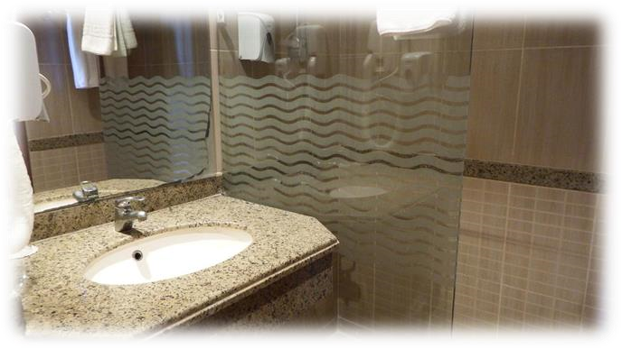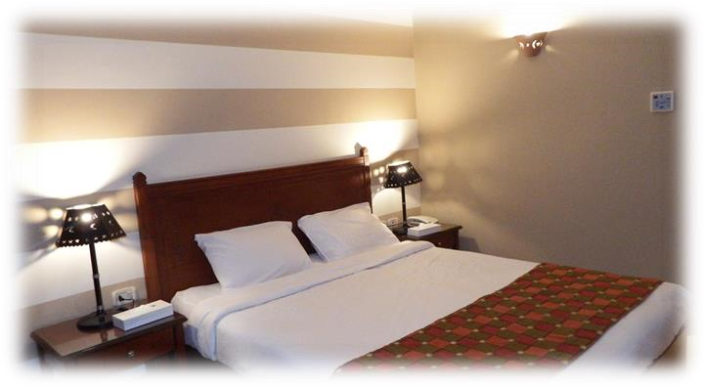

Family Room: Size 60 m²

Two bedrooms non separated one with Queen bed other with twin beds, Mini bar (against charge), TV (Sat), hair dryer, bathroom with split air condition (cold/warm), tea and coffee making facilities, safe (free of charge), balcony or terrace. Garden View. Maximum 4 adults.
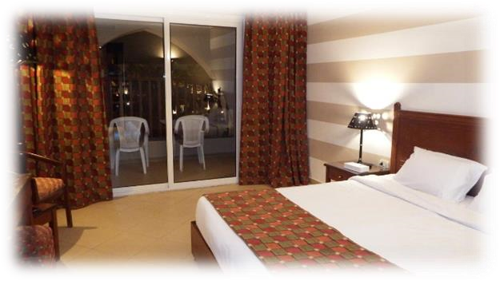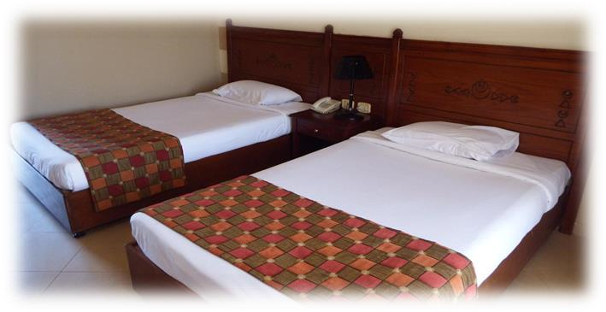

Recreation & Facilities:

Name | Outdoor | Heated | Fresh Water | Details
Relax pool | Y | N | Y | 125 C.M, Life Guard Available.
Main Pool | Y | During Winter | Y | 160 C.M , Life Guard Entertainment available
Aqua pool | Y | During Winter | Y | 125 C.M, Life Guard Available.
Kids Pool | Y | Winter Months | Y | 50 C.M, Life Guard Available.
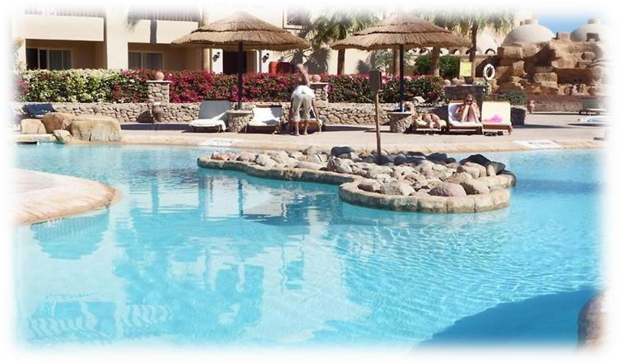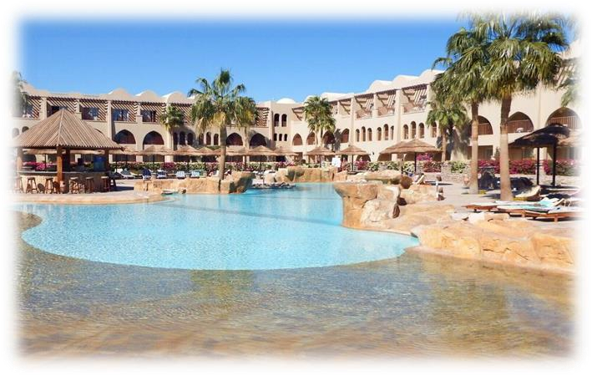

Water Slides & Aqua Park:
.
Name | Heating | Fresh Water | Water Depth | Notes
Adults Water Slide | Y | Y | 125 cm | Adults & Kids

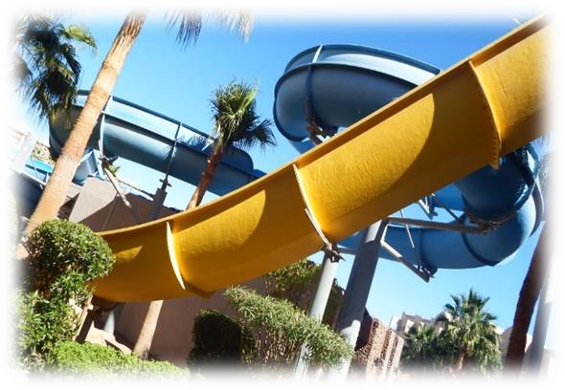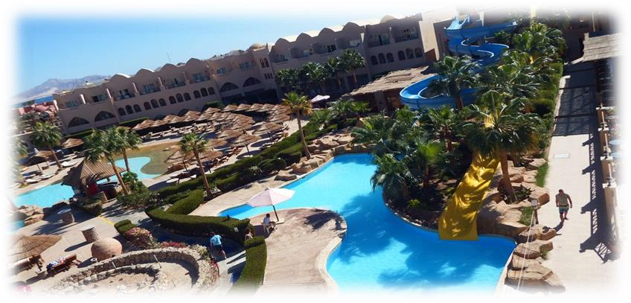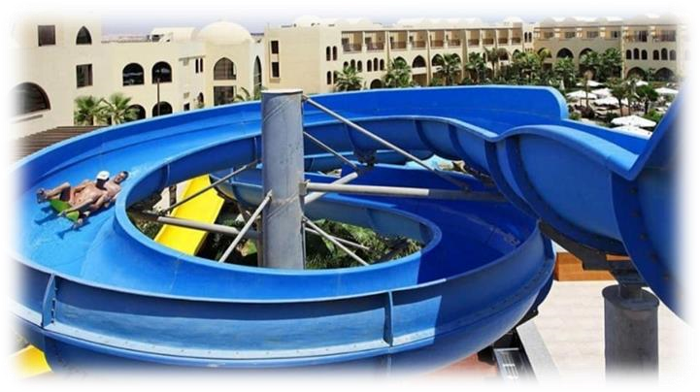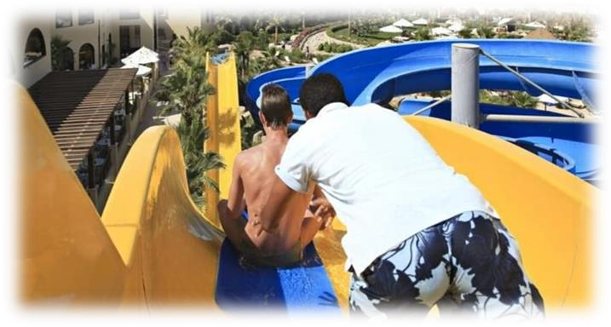

Food
&

B
everages

Upon arrival:

Welcome drink with face towel with selection of dry fruits, nuts and sugar candy.

Food:
Early Breakfast | Main Restaurant | 5:00 till 7:00 | According to number of guests who makes early checkout it will be choice of Open buffet or preparing breakfast box
Breakfast | Main Restaurant | 07:00 till 9:00 | Big variety and selections of delicious international dishes at the buffet, with our famous traditional oriental corner, fresh salad station, and fresh lives bakery station, with selection of tea, herbs, coffee. And fresh squeezed citrus juices by glass.
Late Breakfast | Cocktail lounge | 10:30 till 11:30 | Selection of bakery station with tea and coffee selection.
Fruit sticks | Pool area | 11:30 | To be served to each sunbed around the swimming pool, with cocktail drinks and face towels.
Lunch | At swimming pool | 12:00 till 16:00 | With a big variety selection open sandwiches.
Ice cream | Pool bar | 16:00 till 17:00
Tea time | Cocktail lounge | 16:00 till 17:00 | Tea and coffee selection served & homemade cakes & bakery Selection.
Dinner | Main Restaurant | 19:00 till 21:00 | Starts from with two optional dinner between :  - Main Restaurant – Open Buffet  - PizzarelliAla-carte Italian restaurant : with reservation in advance at reception one day before
Light dinner | Cocktail lounge | 1:00 till 3:00 | With some selection of cheese and cold cuts sandwiches.

Beverages

Cocktail lounge (21 hours beverages service) | 10:00 till 7:00 | Includes valuable menu of alcohol cocktails, non-alcohol cocktails, with soft drinks and juices
Pool Bar | 10:00 till sunset | Serving all kinds of alcohol cocktails, non-alcohol cocktails, with soft drinks and juices and beer by glass
Service bar  (main restaurant) | During Lunch &Dinner Time | Main restaurant during meals (lunch and dinner) serves alcohol cocktails, beer & all kinds of soft drinks & juices by glass.
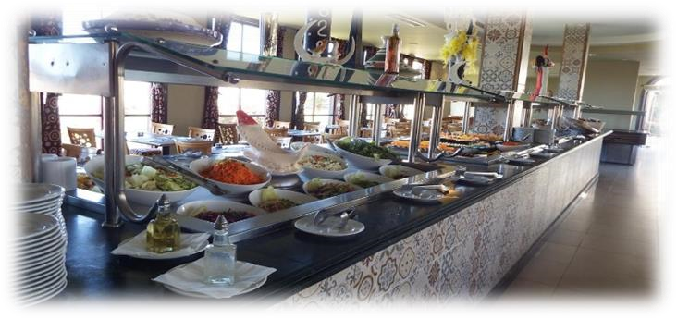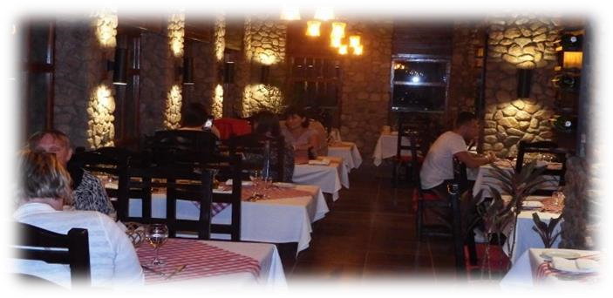

Entertainment:
Daily Activities
Animation programs | 10:00 AM | Includes daily schedules starts at with animation radio introduction Sports activities, gymnastics, water sports activities, darts, guests’ competitions, Olympic Games, yoga, stretching, dance lessons
Kids’ Activities | 10:30 till 12:30 | kids daily programs starts at ends with kids’ lunch at main restaurant accompanied with Professional and special kid’s girl animator caring of guests kids
Evening activities | at 20:30 at 21:00 | Kids disco starts  Evening shows starts
