BULGARIA 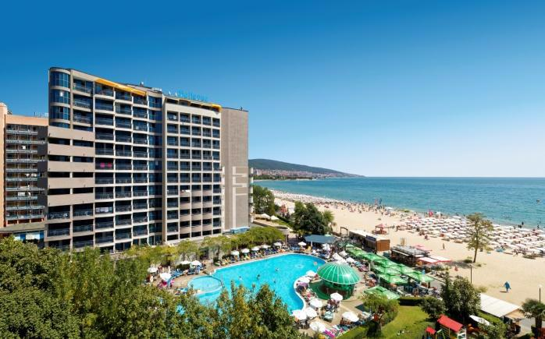
8240 Sunny Beach

LOCATION
On the South Bulgarian Black Sea coast, 30 km from Burgas airport (BOJ) In the northern part of the famous and biggest Bulgarian resort Sunny Beach, only a few minutes away from the resort centre, first line, directly on the fine sandy beach - Blue Flag award winner. Amazing panoramic view over the Gulf of Sunny Beach. Regular mini-train and a bus to Nessebar. Old town with small cobblestone streets and beautiful fish harbour, only 5 km away, world heritage protected by UNESCO. Regular bus-service to the city of Burgas.
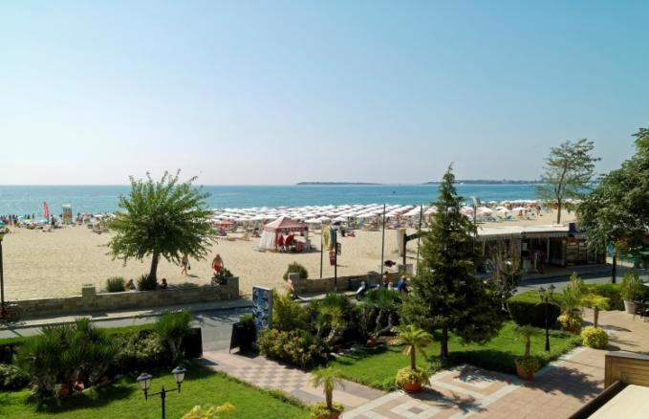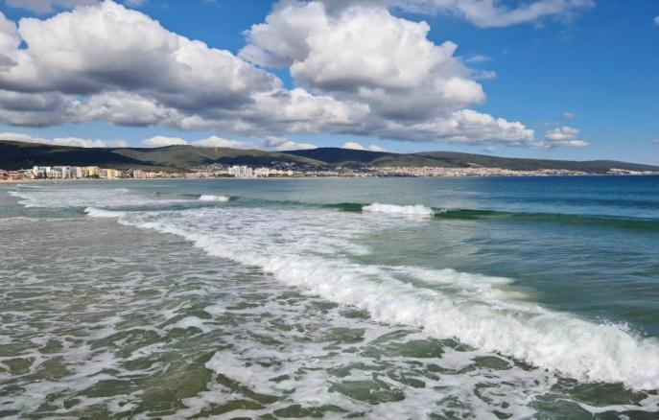
FACILITIES
This modern, fully air-conditioned, 4 Star establishment has 254 double rooms, 16 family rooms with interconnecting doors on 12 floors, 4 passenger lifts, lobby with reception and safety deposit boxes, lobby bar, 1 main restaurant with panoramic sea view terrace and 1 à la carte restaurant. Free Wi-Fi. In the well-kept grounds there is a swimming pool (shared with the guests of the neighboring hotel) with pool-bar, sun terrace, sun loungers and parasols included. Money exchange office in the lobby area, Car parking.
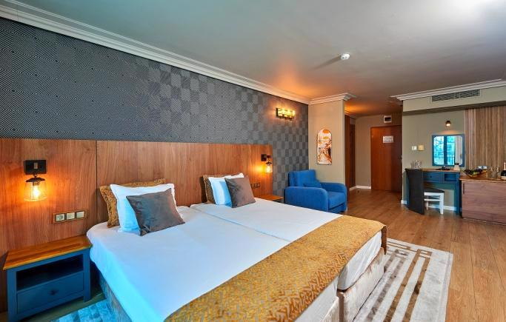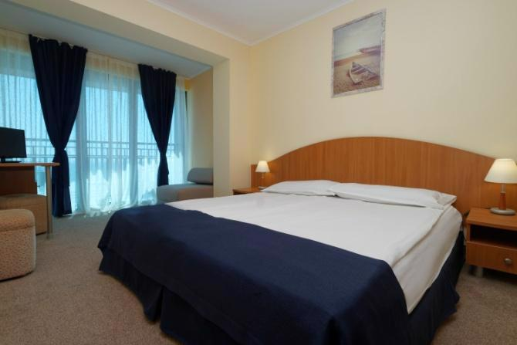
ACCOMMODATION
254 Double Rooms with Side Sea View - 20 m²-24 m² /min.1 and max. 3 pax/
Twin bed, carpet /laminate floor, telephone, central air-condition, hairdryer, cable LCD TV, mini- bar, balcony, bathroom with shower, Wi-Fi. Extra bed /sofa bed/
16 Family Rooms - 48 m²/min. 2+2/2 Double rooms with interconnecting door, carpet floor, telephone, central air-condition, hairdryer, Cable LCD TV, mini-bar, balcony, bathroom with shower, Wi-Fi.
RESTAURANTS AND BARS
1 main restaurant with varied buffets for breakfast, lunch and dinner
1 A-la-Carte Restaurant “Bendita offering specialities from Bulgarian and International cuisine. Lobby bar
Pool bar
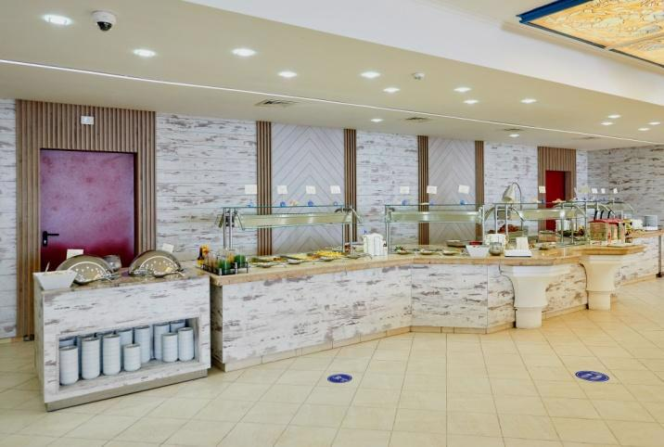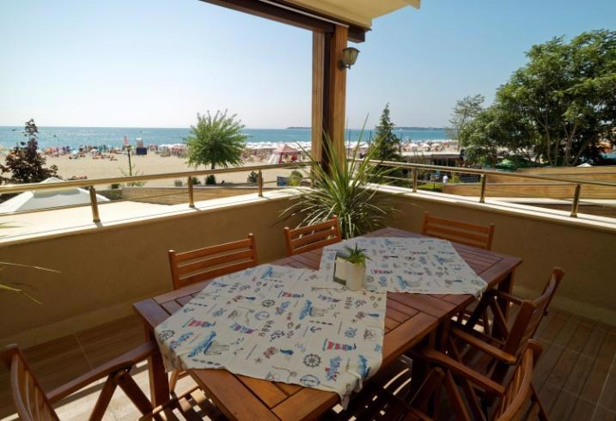
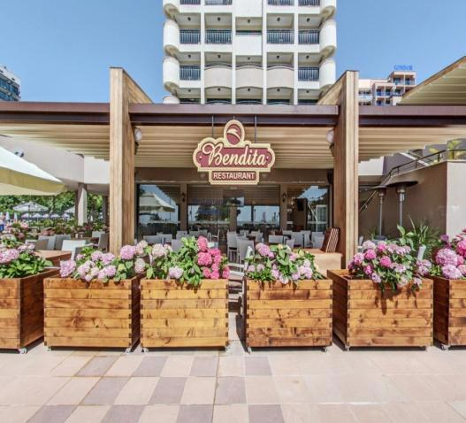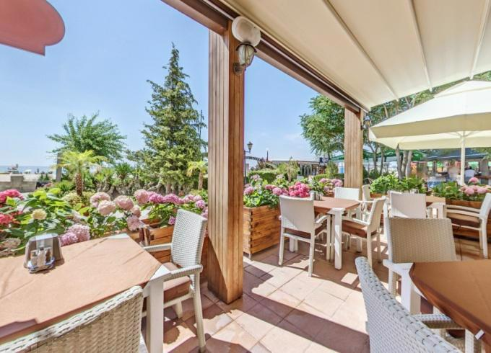

SPORTS AND ENTERTAINMENT:
Hairdresser, a wide variety of massages, fitness area and table tennis - free of charge, billard. Various water sports on the beach – sailing, surfing, jetski, paragliding, mini-golf. Also available upon request: horse riding, bicycle- tours. Sunny Beach offers an extensive variety of day and night entertainments including bars, restaurants and casinos.
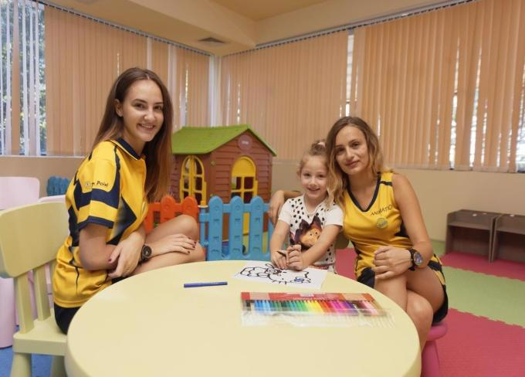
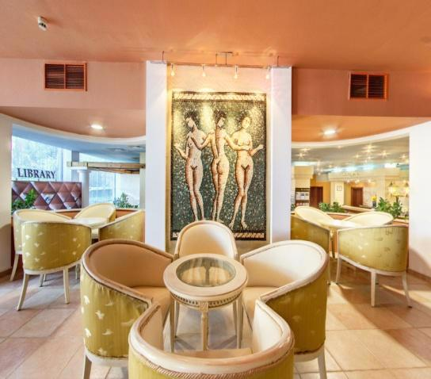
CHILDREN:
Kids Buffet; Highchairs ; Kids club /4-12y/; Integrated children’s pool in the outdoor pool.
Baby cot/extra charge/
OTHER SERVICES: rent-a-car, laundry service, money exchange.

