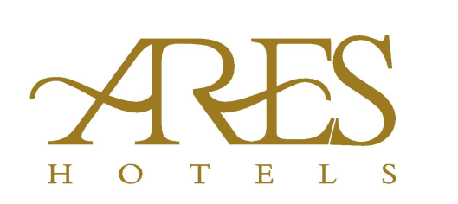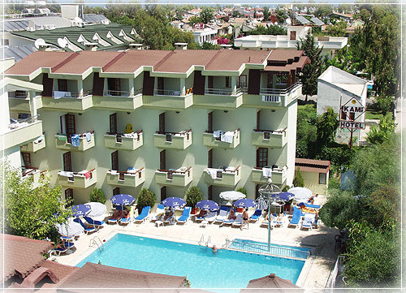

Adres : ARES CITY HOTEL
Atatürk Cad. No:5 - 07980 - Kemer / Antalya
Tel. : +90.242.606 12 90
Mail : reservation@areshotels.com.tr
Web : www.areshotels.com.tr

ROOMS
Our Hotel's Halls and Room facilities; Our hotel consists of 3 blocks and 4 blocks and consists of 2 blocks and totally 73 standard rooms.
In our rooms; TV, WC, Shower, Safe box, Split air condition and 24 hours hot water.

Our hotel; Located in the center of Kemer, it is a secret garden that will lead you to a peaceful holiday. Our hotel is situated in our garden where the beauty of the natural beauty is dominant. Even though you are in the center of the city, you will have a chance to stay away from it. Our hotel is located in the center of Kemer, 50 km to Antalya Airport, 35 km to Antalya city center. Plaja is 200 meters away. Hotel facilities and equipment; Our hotel consists of 3 floors and 4 floors and consists of 2 blocks and totally 73 standard rooms. TV, WC, Shower, Safe box, Split air condition and 24 hours hot water. Domestic animals are not allowed.
Our hotel offers guests with Red and White Wine, and Soft drinks options between 08:00 - 21:30 hours with our all inclusive system.
Our Free Services; Deck chairs, umbrellas by the pool, alcoholic and non-alcoholic beverages in the pool bar.
Massage, Hookah, Turkish Coffee, Bottle of beer and beverages to be taken in the pool after 21:30, beach, beach chairs, umbrellas at the beach.
Our Paid Services ; Wifi. Safe box.

Restaurant

We have 1 open and closed restaurant and we serves you with our rich open buffet.
Our hotel offers guests with Red and White Wine, and Soft drinks options between 08:00 - 21:30 hours with our all inclusive system.

Restaurant & Bar Clocks;
* BREAKFAST 08:00 - 10:00
* LUNCH 12:30 - 14:00
* DINNER 19:00 - 21:00
* POOL BAR 10.30 - 21:30

Pool and Beach

There is 1 outdoor swimming pool and 1 child swimming pool and you can sip on our pool bar and enjoy your drink in summer. Plaj is 200 meters away. . The beach is open as of May

