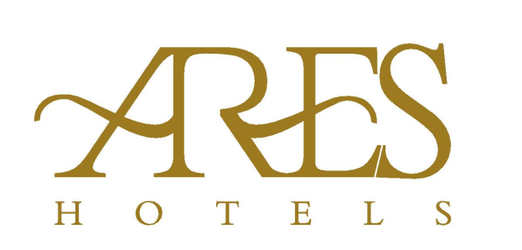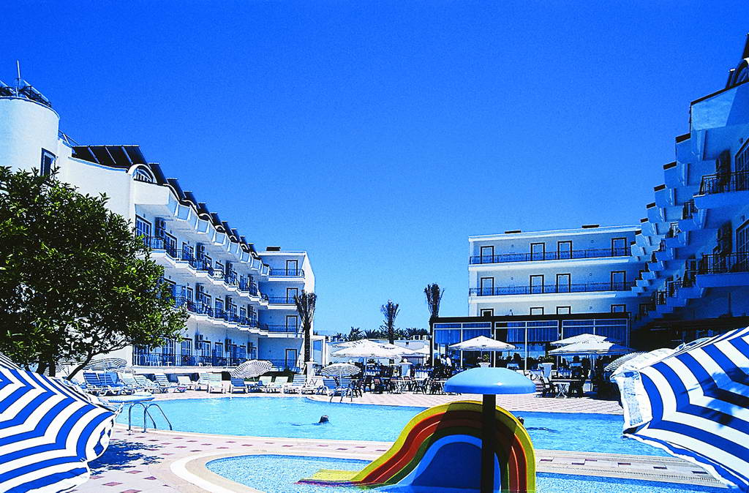

ARES BLUE HOTEL ALL INCLUSIVE

Adres :
Kiriş Sahil Cad. No :1
07980 Kemer / ANTALYA
Tel. : +90.242.606 12 90
Mail : reservation@areshotels.com.tr
Web : www.areshotels.com

Welcome to Ares Blue Hotel where you will find peace of mind, comfort, nature and beautiful faceted service ... Our hotel; flowers and orange trees on a 4 acres of land and is located in the center of Kemer and will lead you to a peaceful holiday .It is located in our garden where our natural beauties dominate our hotel. Located in the center of Kemer, our hotel is 50 km from Antalya Airport and 35 km from Antalya city center. Plaja is 350 meters away. . The beach is open as of May The Hotel provides 4 star service.

ROOMS

Hotel facilities and equipment; In our rooms; TV, WC, Shower, Wifi and Split Air Condition and 24 hours hot water.
There are 1 outdoor swimming pool and 1 children swimming pool. You can sip your drinks in our pool bar and you can enjoy your summer drink. We have 1 open and 1 indoor restaurant and we serve you with our open buffet. Our hotel offers guests with Red Wine, White Wine, Beer and Soft Drinks options between 08:00 - 22:00 hours with all inclusive system.

Restaurant
We have 1 open and 1 closed restaurant and we serve you with our rich open buffet.Our hotel offers guests with Red Wine and White Wine, Beer and Soft Drinks options between 08:00 - 22:00 hours with all inclusive system.
Our Free Services; Safe box , Deck chairs, umbrellas by the pool, alcoholic and non-alcoholic beverages in the pool bar.
Our Paid Services:
Internet: in the open areas and in the rooms, Turkish Bath, Hookah, Turkish Coffee, and beverages from the poolside after 22:00, Beach chairs, umbrella.

Restaurant & Bar Clocks;
* BREAKFAST 08:00 - 10:00
* LUNCH 12:30 - 14:00
* COFFEE BREAK 16:30 - 17:00
* DINNER 19:00 - 21:00
* POOL BAR 10.00 - 22:00

Bar
You can sip on our pool bar and enjoy your drinks in summer.
Our Free Services; Sun beds, umbrellas by the pool, alcoholic and non alcoholic beverages in the pool bar. Our hotel offers all-inclusive service between 08:00 - 22:00 hours and our guests are provided with Red Wine, White Wine, Beer and Soft Drinks.
Paid Services:
Internet: in the open areas and in the rooms, Turkish Bath, Hookah, Turkish Coffee, ,umbrella.

Pool and Beach
There are 1 outdoor swimming pool and 1 child swimming pool. You can sip your drinks in our pool bar and you can enjoy your summer drink. The pool is 350 m away.

Animation
01.05.2024 – 30.09.2024

