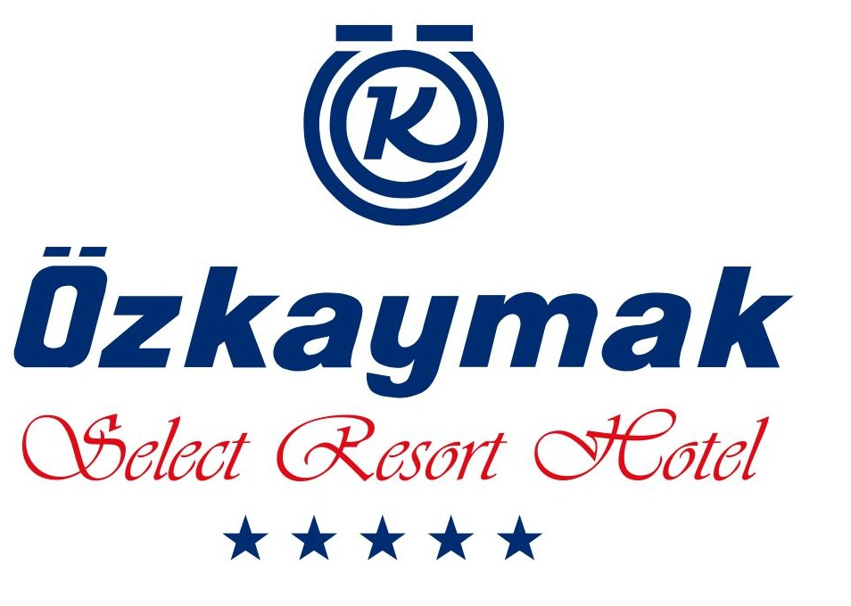
ULTRA ALL INCLUSIVE
SUMMER CONCEPT - 2024

BREAKFAST 07:30 -- 10:00 MAIN RESTAURANT OPEN BUFFET
LATE BREAKFAST 10:00 -- 10:30 MAIN RESTAURANT MINI OPEN BUFFET

LUNCH 12:30 -- 14:00 MAIN RESTORANT OPEN BUFFET
DINNER 19:00 -- 21:00 MAIN RESTAURANT OPEN BUFFET
MIDNIGHT SOUP 23:00 -- 24:00 MAIN RESTAURANT BUFFET
SNACK SERVICE (LUNCH) 12:00 -- 16:00 SNACK RESTAURANT DAILY MENU
A’LA CARTE RESTAURANT 19:00 -- 21:00 SEAFOOD - FİX MENU- WITH RESERVATION
ICE CREAM 15:00 -- 16:00

BARS

ALCOHOLIC BEVERAGES :LOCAL RAKİ, WINE, VOTKA, GIN, BEER, WHISKY.
SOFT BEVERAGES :COLA,LIGHT COLA, FANTA,SPRITE, MIN.WATER, TONIC, MILK, CONCENTRATE JUICE.
HOT DRİNKS ; TEA, HERBAL TEA,COFFEE,FİLTER COFFEE.

LOBBY LOUNGE BAR 24 HOURS ALL LOCALS AND CONSEPT IMPORT DRINKS
RESTORAN & SERVİS BAR 10:00 -- 21:00 ALL LOCALS AND CONSEPT IMPORT DRINKS
BEACH/POOL BAR 10:00 -- 23:00 ALL LOCALS AND CONSEPT IMPORT DRINKS
DISCO &NIGHT CLUB 24:00 -- 02:30 ALL LOCALS AND CONSEPT IMPORT DRINKS
MINI BAR; (BY ARRIVAL FULLWITH SOFT DRINK) DAILY FILLING WITH WATER AND MIN.WATER

FREE OF CHARGE SERVICES:
SAFE,WiFi,BEACH TOWEL AT SPA WITH DEPOSIT (10€)
TURKISH HAMAM&SAUNA,UMBERALLA,DECKCHAIRS AT THE POOL&BEACH, FITNESS CENTER
ALL ANIMATION ACTIVIETIES. WATER&STEPGYM, WATER SLIDES, BEACH VOLLEY, BOCCIA, DART.

WITH AN EXTRA CHARGE SERVICES:
ALL DRINKS OUT OF CONCEPT.
ROOM SERVICE,LOUNDRY, DOCTOR,TELEFON&FAX.
SPA MASSAGE,PEELING, COIFFEUR, HOPPING CENTER, PHOTO, WATERSPORTS.

**************************************************************************************************
- AT BREAKFAST TIME NO ALCOHOLIC DRINKS SERVICE..
- ALL ALCOHOLIC AND SOFT DRINKS ARE SERVED IN GLASS IN THE ULTRA ALL INCLUSIVE CONSEPT
- ALL BOTTLE DRINKS WILL BE CHARGED.
- ROOMS SERVICE IS WITH EXTRA CHARGE.
- PLEASE PUT YOUR VALUABLE ITEMS IN THE SAFEBOX. THE HOTEL MANAGEMENT TAKES NO RESPONSIBILITY FOR THE LOSS OF VALUABLES THAT ARE NOT IN THE SAFE.
- THE ROOMS ARE CLEANED DAILY. IF THIS IS NOT WANTED OR IF YOU DO NOT WANT TO BE DISTURBED, PLEASE PRESS THE SWITCH AT THE HEADEND OF YOUR BED. THIS WILL ACTIVATE A RED LAMP ABOVE THE ROOM NUMBER IN THE HALLWAY, PROVIDING THE APPROPRIATE ADVICE TO THE ROOM STAFF.
- DO NOT LEAVE YOUR CHILDREN UNATTENDED AT THE POOL AND ON THE BEACH. ENSURE THAT CHILDREN DO NOT DRINK ALCOHOL.
- ALCOHOL WILL BE NOT SERVED TO PERSONS UNDER AGE OF 18.
- HOTEL MANAGEMENT CAN CHANGE THE TIME AND LOCATION OF ALL SERVICES & ACTIVITIES
- RESERVATION FOR A’LA CARTE RESTAURANT A DAY BEFORE.
- HOTEL C/IN TIME 14:00 ,C/OUT TIME MAX.12:00. LATE C/OUT CHARGED.
- PETS ARE NOT ALLOWED*****

ÖZKAYMAK SELECT HOTEL
WE WISH YOU A NICE HOLIDAY

