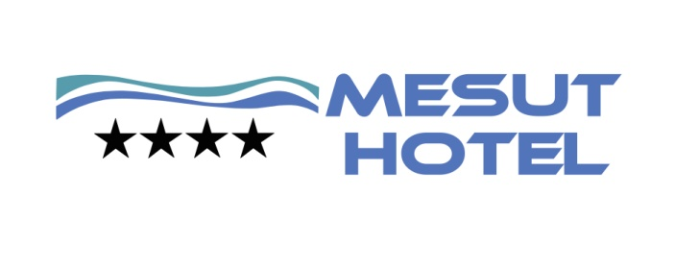

FACT SHEET Summer 2018

Name of the Hotel :MESUT HOTEL 4*+
Address :Obagöl Mevkii / Alanya / Antalya
Tel : 0 -242- 514 05 01
Fax : 0 -242- 514 04 86
Mail Address :info@alanyamsuthotel.com
Web page :www.alanyamesuthotelhotel.com

Opening :May 1976
Concept :All Inclusive
Area located :1.712 sqm
Nearest city centre :Alanya Distance : 2 km
Nearest Airport :Antalya Airport Distance : 120 km
Nearest country :Oba Distance : 100 m
Position :On seashore

Total number room/bed capacity : 131 rooms / 341 beds
Number of blocks : Main building and 1 Anex
Stories : 7 stores
Lifts : 1 in the Main building and 1 in the Anex
Payment : Visa, Master Card
Pets : Pets unacceptable
Languages spoken : English, German, Russian

ROOM CATEGORIES and DETAILS

Standard Room : Total 64 standard rooms vary from 20 sqm. It is the room category with twin bed formed by a room and a Bath / Wc. Maximum capacity of the rooms is 2 persons.

Standard Triple Room : Total 53 Standard triple rooms vary from 30 sqm. It is the room category with French bed and 1 sngl bed formed by a room and a Bath / Wc. Maximum capacity of the rooms is 3 persons.

Large Family Room : Total 7 Large rooms vary from 33 sqm. It is the room category with French bed ,1 sngl bed and 1 sofa bed formed by a room and a Bath / Wc. Maximum capacity of the rooms is 4 persons.( 3+1 / 4 )

Fam.Suite :Total 5 Family Suit rooms vary from 40 sqm and have been designed with laminated solid as 1 bedroom with French bed and 1 sngl bed and other bedroom with twin bed and a 1 Bath / Wc. Maximum capacity of the rooms is 5 persons. ( 3+2 /4+1 / 5 )

Rooms for Disabled : Totally 1 disabled rooms are evaluated under the standard room and connected with standard room category and designed specially.

General characteristics of the rooms: All the rooms decorated in modern style, modern and highly luxurious have laminant, balcony, bathtub, wc, hair dryer, telephone line, minibar (empty), TV (satellite), safe, air condition

Linens: Change in every 3 day Towels: Change in every 2 day
Rooms: Are checked every day Minibar:Empty

FOOD and BEVERAGE PRESENTATION

BREAKFAST ALTERNATIVES | HOURS | PLACE | PRESENTATION
Breakfast (main restaurant ) | 07.00-09.30 | Main Restaurant | Open Buffet
Late breakfast (main restaurant) | 09.30-10.00 | Main Restaurant | Open Buffet

lunch ALTERNATIVES | HOURS | PLACE | PRESENTATION
Lunch Buffet (main restaurant) | 12.30-14.00 | Main Restaurant | Open Buffet
Snack Bar | 11:00-16.00 | Snack bar | Fast Food
Coffee Time | 11:00-17.00 | Snack bar

DINNER ALTERNATIVES | HOURS | PLACE | PRESENTATION
Dinner (main restaurant) | 19.00-21.00 | Main Restaurant | Open Buffet

MİDNİGTH SERVICE | HOURS | PLACE | PRESENTATION
Midnight Soup (main restaurant) | 23:00-23:30 | Main Restaurant | Soup

BARS

BEVERAGE SERVICE | HOURS | PLACE | PRESENTATION
Pool Bar | 10.00-23:00 | Pool | All inclusive Concept
Services Bar | Lunch and Dinner | Restaurant Area | All inclusive Concept
Beach Bar | 10.00-17.00 | Beach | All Extra charged

HOTEL SERVICES and SPORT ACTIVITIES

Free Beverage : All soft & hot drinks, local alcoholic drinks,

Beverage (charged) : İmported drinks, local and import special wines, champagne and fresh juices, Turkish coffee

Free Hotel Services : Outdoor parking area , Fitness room, Hamam ,Free Wi-fi at the Lobby,restoran,pool,teras area

Hotel Services (charged) : Fax, telephone, renting car, laundry, dry, doctor and nurse (24 hours available), photograph services,sauna, Spa wellness massage, theraphy,Safe

Free Sport Activities : Fitness room, Turkish Bath, Dart game

Sport Activities (Charged) : Banana, parasailing, jet-ski, catamaran (licensed), water ski, yacht tour, diving school and all other water sports with motor

SPA

SPA Services (Charged) :Different type of Masages,Sauna, rubbing with bath glove
Free SPA Services :Turkishbath

COAST LINE

Coast Line :Sand and gravel
Length of the coast :80 m
Width of the coast :30 m
Umbrella, chaise lounge :Charged
Steg :in our beach
There is no beach towel service!!!!

POOL

 | AREA / sqm
Outdoor pool | 140 sqm
Outdoor pool for kids | 7 sqm
LOCATİON
- 120 km to Antalya
- 2 km to Alanya
- 100 mt to the center
- 50 mt to Beach

ROOM İNFORMATION
- Total rooms 131
- Wc,Shower&bath,Hairdryer,Telephone,Sat-TV,Airconditioner,Mini Refrigerator (empty),Safe and Balcony

