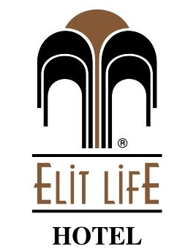

Elit Life Hotel concept in the summer season 2017
between actual (01.01.2017 - 31.12.2017)
area : Camyuva - Kemer / Antalya
location : Camyuva Kemer center 5 km
category : 4 stars
Distance to airport : 60 км
distance to the city center : Kemer center

company name : ELİT LİFE OTEL TAYYİBET EREN
address : Çamyuva Mah.Necmican cad.No:4 Kemer/Antalya-TÜRKİYE
tax Service : Kemer
tax number : 632 004 5128

phone : 0 242 824 70 71-72 (pbx)
fax : 0 242 824 70 73
web address :

Concept: : All Inclusive
Hotel Information
Standard rooms : 73
1. open pool : 350 m2
3. Children's swimming pool : 20 m2
water slides : 1 Adet

Restaurants
indoor restaurant : 170 Kişilik
outdoor restaurant : 170 Kişilik

The meal
Breakfast : 07:30 – 09:00
late breakfast : 09:00 – 09:30
Lunch : 12:30 – 14:00
coffee break : 17:00 – 17:30
Dinnr : 19:30 – 21:00

The concept of all-inclusive at 10:00 / 22:00.
_________________________________________________________________
Çamyuva Mah.Necmi can cad.No:4 Kemer /Antalya-TÜRKİYE Tel: +90 0242 824 70 71-72Fax: +90 242 824 70 73

Bars
restaurant bar : 07:30 – 09:30 09:00 – 09:30 12:30 – 14:00 19:00 – 21:00
terrace Bar : 10:00 – 22:00
poolside bar : 10:00-12,00-14,30 – 18:00

The number consists of
individual air-conditioning
shower cabinet
balcony
direct phone
safety deposit boxes
hairdryer

Beach
180 mt from the hotel
Umbrella
Sunbed
Mattress

Paid services
imported drinks in the minibar
safe deposit boxes in the rooms
billiards
foam massage in the Turkish bath
photo
water sports
fresh fruit juices
Turkish coffee

Free services
mattress, sunbed ,umbrella
Dart
Parking
Amphitheater

The animation from 10:00 / 22:00
________________________________________________________________
Çamyuva Mah.Necmi can cad.No:4 Kemer /Antalya-TÜRKİYE Tel: +90 0242 824 70 71-72Fax: +90 242 824 70 73

