MERHABA HOTEL
İNFO SHEET SUMMER 2018 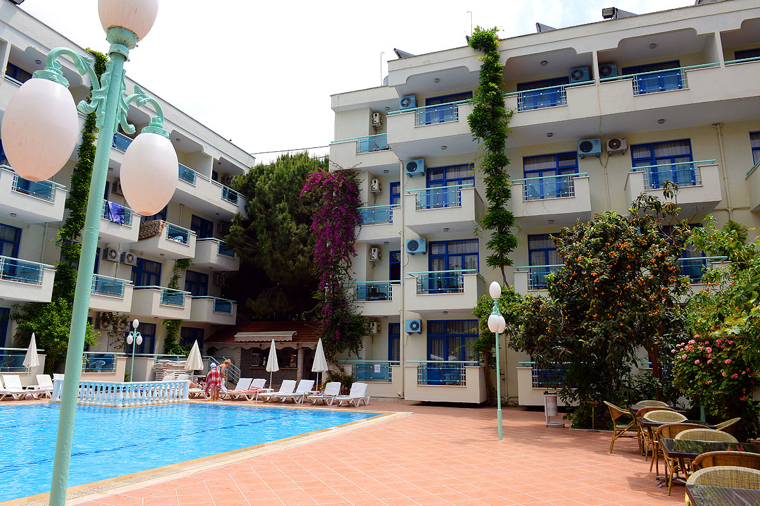

GENERAL
NAME: MERHABA HOTEL
LOCATION: The Hotel is 1 km from the city center and shopping areas.
BUILT:1988
LAST RENOVATED :2017
CATEGORIE : 3* HOTEL
ADRESS:CUMHURİYET MH.AHMET TOKUŞ BL.NO:163 ALANYA/ANTALYA
AIRPORT: GAZİPAŞA 40 KM - ANTALYA 138 KM

GENERAL
CENTRUM: 1KM
BEACH:30M
RECEPTION:24 HRS
TELEPHONE:+90 242 513 12 51
FAX: +90 242 512 98 26
WEP SİTE:www.merhabahotel.com
E-MAİL: info@merhabahotel.com
C/İN :AFTER 13:00
C/OUT:12:00
PETS: NO ALLOWED

ROOMS

Total 108 rooms
The standart 89 hotel rooms 40(m2)
The family 4 hotel rooms 50(m2)
Led screen tv
Local, turkish,russian and europian channels
Aircondition (cold and hot)
Mini fridge in all the rooms
Safe box (paid)
Hair dryer
Wireless network connection (paid)
Manual cart system
Make up mirror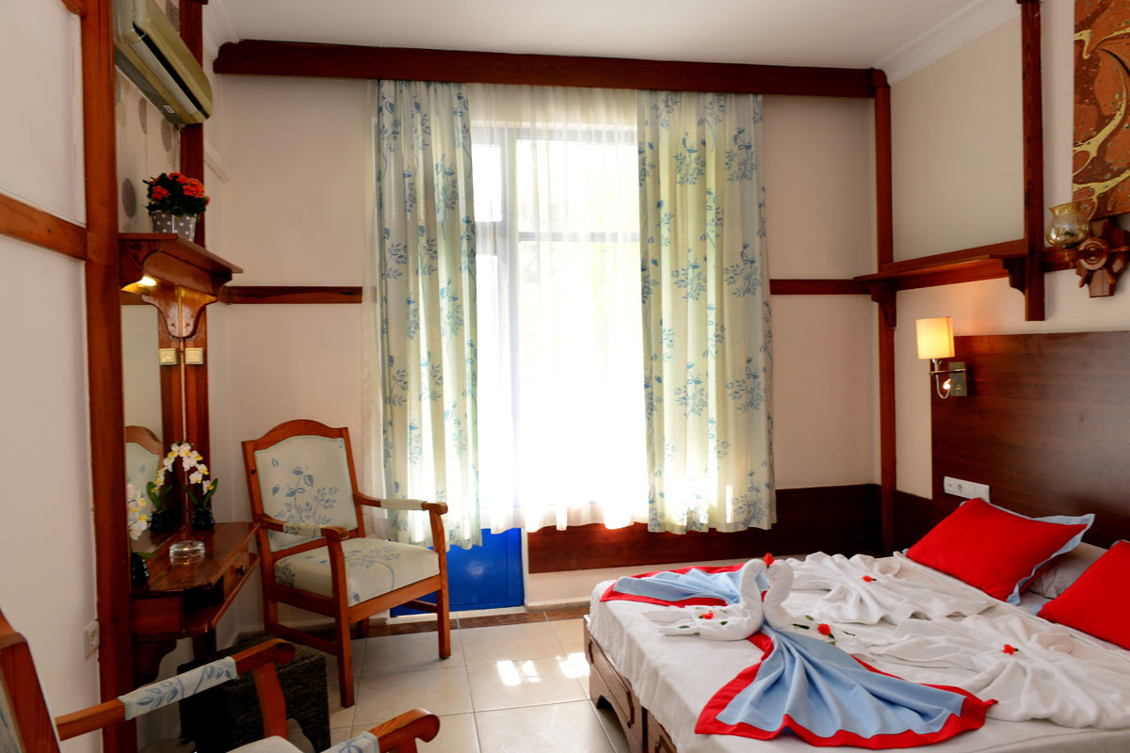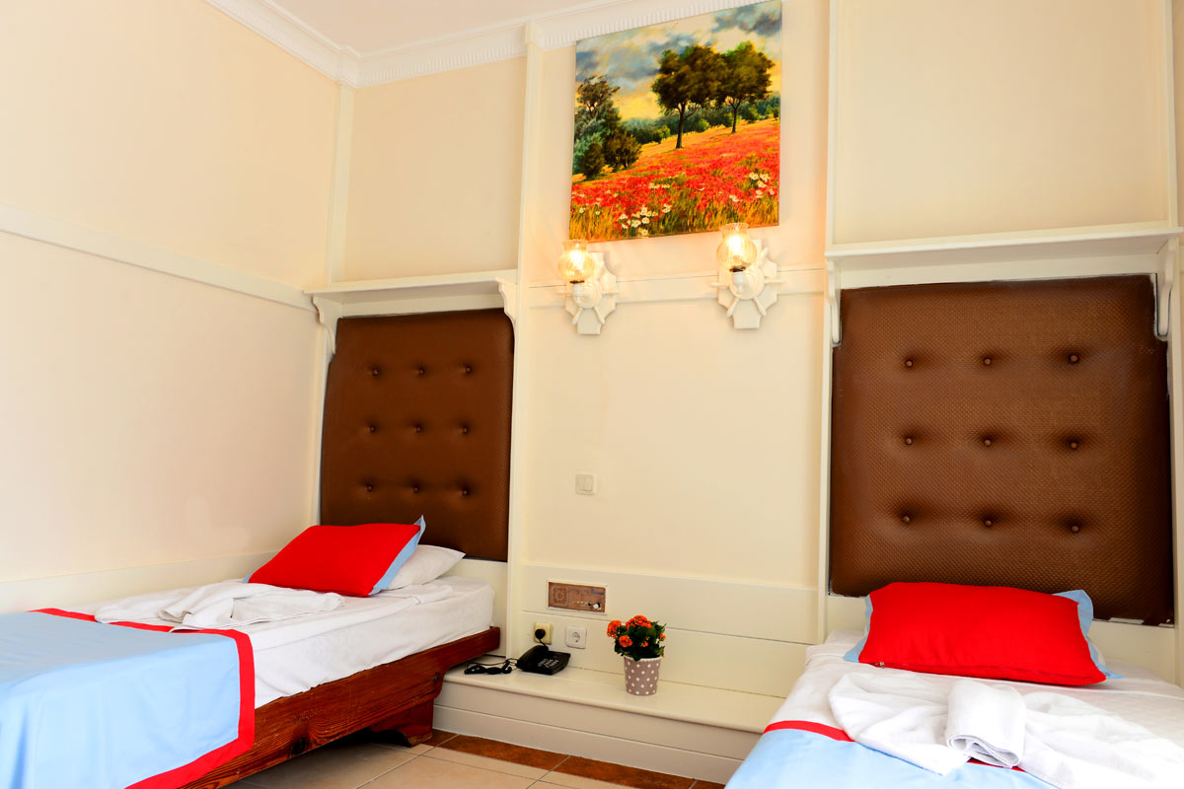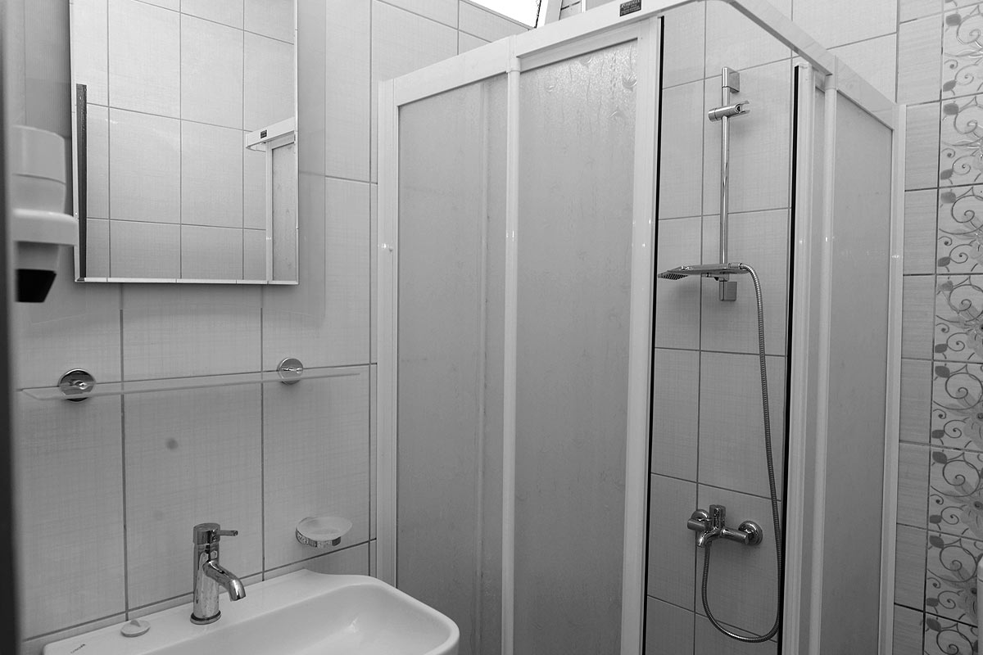

All non-smoking rooms
Balcony
220W elekricity
Partly pool, sea and mountain view rooms
Single and frecnh beds
Shower & wc
Daily cleaning
Baby cot
Services And Activities 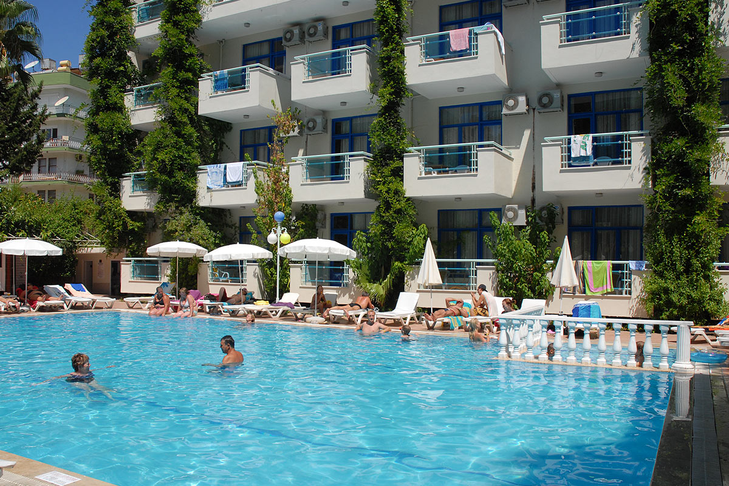
The fallowing services and activities are free of charge
24 Hrs open reception
Wake-up calls
Baby cot in the room
Sun beds and umbrellas by the pools
Baby chairs in restaurants
1 Pool and 1 childeren’s pool (open air)
Kids play ground
The fallowing services and activities are chargable
Photographer* Mini market* Hair dresser* Tattoo* Doctor* Room service* Loundry* Masage* Spa & turkish bath* Airport transfer* Safe box*wi-fi
Food and Bevarage
Breakfast from 07:30 to 10:00
Lunch from 12:30 to 14:00l
Cofee break from 16:00 to 17:00
Dinner from 18:30 to 20:00 