**Rixos Alamein**

**Soft All Inclusive SUMMER 2017 CONCEPT**

**Welcome to Rixos Alamein. Our aim is to ensure you feel the Rixos Touch during your holiday. This Information Guide has been prepared to assist you in making the most of our facilities and experiencing an unforgettable holiday. Rixos Alamein operates on Soft All inclusive.**

**Our guests can enjoy all facilities in our hotel.**

**Enjoy our services**

**Soft All inclusive facilities**

**DINING**

Including soft drinks, ice cream, local beer and wine

[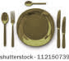](http://www.google.com.eg/url?sa=i&rct=j&q=&esrc=s&frm=1&source=images&cd=&cad=rja&docid=9xZDiG9wvj5k0M&tbnid=Hk4X49X_GB_FTM:&ved=0CAUQjRw&url=http://www.shutterstock.com/pic-108425567/stock-photo-white-empty-plate-with-fork-spoon-and-knife-on-white.html&ei=EkavUvLXJqrV0QX-9YHgDQ&bvm=bv.57967247,d.ZG4&psig=AFQjCNHC0i06FOsQWxMLcGztqZmo0nVO-w&ust=1387304727005361)**Breakfast (Alamein Restaurant) 07:00 to 10:30**

**Late breakfast (Layali Restaurant) 11:00 to 12:00**

**Lunch (Alamein Restaurant) 13:00 to 16:00**

**Snacks (La Taverna Restaurant) 16:00 to 18:00**

**Dinner (Alamein Restaurant) 19:00to22:30**

**BARS**

Including soft drinks, ice cream, local beer and wine

**Lobby Bar 24 Hours**

**Obelisk Terrace Bar 09.00 to midnight**

**Pool Bar 09.00 to Sunset**

**La Taverna 09:00 to Sunset**

*\*Mini bar in the room stocked free of charge once upon arrival*

**EXTRA CHARGE FACILITIES**

**A` la Carte restaurants**

**Hotel guests who want to use the A` la carte restaurants instead of eating at the buffet restaurant will get a credit of 150 LE / 10 $ per paid adult.**

**Guest relation will issue a voucher which can be used by the guest to reduce the A’ la carte check.**

**Lalezar (Turkish) Dinner 19:00 – 22:30**

**La Taverna (Seafood) Dinner 19:00 – 22:30**

*\*Reservations for a la carte can be made via the Guest Relation Team desk at the Lobby – subject to availability*

***Extra Charges for:***

* **Baby sitter (200 L.E per hour upon availability)**
* **Tennis Court ( night time / trainer )**
* **Movenpick ice creams**
* **Beach or Pool use at 500 EGP per person**
* **All kind of the imported beverages**
* **Shisha**
* **Fresh Juices**
* **Outside guests & visitor with extra charge 150 EGP minimum charge per person, at the lobby / terrace**
* **Beach / pool use EGP 600 L.E per person for outside guest in week days and 750 L.E in weekends. (Including soft drink).**

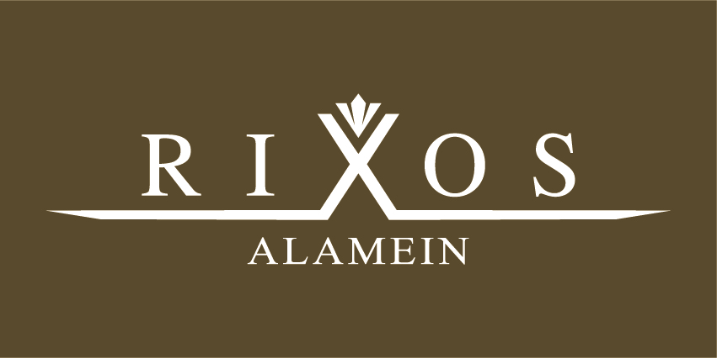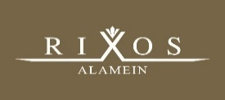

Twitter: @RixosAlamein Instagram: #RixosAlamein

Facebook: Rixos Alamein

www.tripadvisor.co.uk

www.holidaycheck.com

**ROOM SERVICE**

**Room service is available 24 hours with charge. Choose from a wide variety of International dishes and beverages.**

**Please select from the room service menu situated in your room – this includes prices and full details of this service**

**CABANA HIRE**

**Our cabanas are specially designed for your relaxation and comfort providing: mini bar, fruit basket, safe, fan and some with Jacuzzi**

**Please, contact with Guest Relation Team who can advise prices and packages.**

**Cabana with Jacuzzi 1,350 LE / 85 $**

**Cabana without Jacuzzi 900 LE / 60 $**

**With a maximum of 4 person per cabana.**

**ENTERTAINMENT**

**Sportive activities like darts, billiards, tennis table and tennis court during the day time**

**are all available on your holiday; our exclusive Rixy Kids Club is great for the little ones looking to have fun, face painting, play areas, games rooms and so much more.**

**RIXOS ROYAL SPA**

**You have use of a very well equipped modern fitness center for free, in additional to chargeable facilities such as steam room, saunas, Jacuzzi, resting rooms, spa bath supplies towel, shampoo, slippers and bathrobe.**

***\*It is not permitted for children under the age of 12 to enter or use the Spa & Fitness Facilities***

**USEFUL & IMPORTANT INFORMATION**

**Check In & Check Out Procedure:** Check in at 14:00 and Check Out is 12:00 midday. Please leave your luggage outside your room and our Concierge will collect them and bring to reception. You must return your key card and towel cards at check out. Your key card will deactivate at midday on your departure day, if you require a late checkout please reactivate your card before midday with the Reception. Please check availability and prices with our Reception Team 1 day prior to departure.

**Phone** – All rooms are supplied with phones – to call another room please dial 5 followed by the room number – this is free of charge.

To call an outside line please dial 9 followed by the number – this is with charge.

**Laundry Service** – All rooms are provided with laundry bag and price list – price is per item

***The Hotel Management does not accept any responsibility for the loss of personal items, valuable or money which is left in the room or public areas.***

***Please keep your belongings in the safe box provided in your room.***

***Please contact with our Guest Relation Team if you have any allergies or special dietary requirements***

***Please ask for DND Flags from Towel Desk at the beach/pool if you do not want to be disturbed by any hotel staff. Our Guest Relation Desk is situated in the Reception 09:00-22:00***

***Please do not make any cash payment for any extra charge service, please sign your cheque and pay your bill one day before or during check-out.***

***For any assistance during your stay please contact you Guest Relation Team situated in the Reception or Contact 222 via phone***

***09:00-22:00***



Twitter: @RixosAlamein Instagram: #RixosAlamein

Facebook: Rixos Alamein

www.tripadvisor.co.uk

www.holidaycheck.com

Twitter: @RixosAlamein Instagram: #RixosAlamein

Facebook: Rixos Alamein

www.tripadvisor.co.uk

www.holidaycheck.com